Using a spirometer to investigate human lung function

Introduction
A spirometer is the standard equipment used to measure the capacity of the human lungs. There are several versions of this laboratory apparatus available, but all consist of a chamber (of capacity approximately 6 dm³) suspended freely over water and counterbalanced so that gas passed in or drawn out makes the chamber rise or fall. You can make a permanent record of the movements of the chamber either by attaching a pen to it and allowing it to write on a drum revolving slowly (kymograph) or by attaching a motion sensor which will convert movement into electronic signals that are then interpreted by your datalogging software.
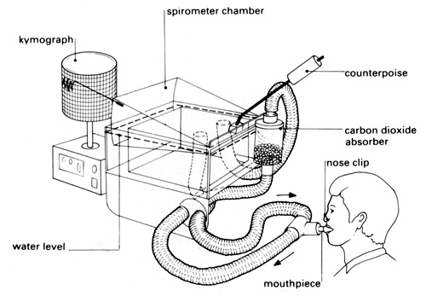
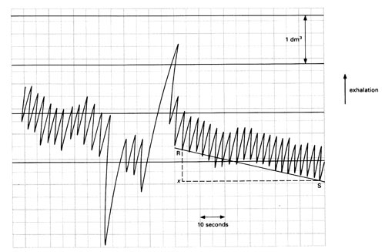
Typical spirometer trace

Interpreting the trace
The depth of breathing is determined by measuring the vertical movement of the pen (or motion sensor) from one peak to the next trough on the trace and comparing this with the initial volume calibration.
The rate of breathing (breaths per minute) may be determined with reference to the time scale. From a kymograph trace, you would need to know the speed of rotation of the drum (in mm s⁻¹) to calculate the horizontal displacement equivalent to 10 or 60 seconds.
Our normal resting breathing moves only a small percentage of the air contained in our lungs. The lungs are highly elastic and can move significantly more air when we take exercise than we normally move at rest.
• The volume of air that a human breathes into and out of their lungs while at rest is called the tidal volume. This is a relatively small volume of air (around 500 cm³) and provides enough oxygen for a human’s resting needs.
• The maximum amount of air that may be inspired, above tidal inspiration, is called the inspiratory reserve volume. The typical adult value is 2 to 3.2 dm³.
• The maximum amount of air that can be breathed out, above tidal expiration is called the expiratory reserve volume. The typical adult value is 0.75 dm³ to 1 dm³.
• The vital capacity is the sum of all three of these volumes.
Tidal volume, inspiratory reserve volume and expiratory reserve volume can all be calculated from the trace made by the spirometer in the above procedure.
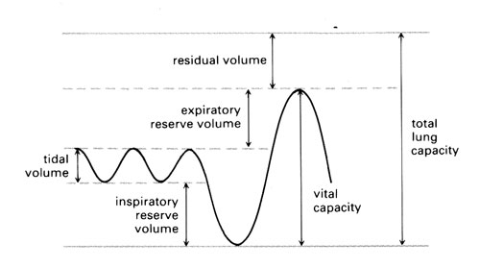
Standard trace showing how to read off residual volume, expiratory reserve volume, tidal volume, inspiratory reserve volume, vital capacity and total lung capacity
Even in dead mammals, the lungs are never completely empty of air. The air that we cannot expel from the lungs, even with the hardest effort of expiration, is called the residual volume. (The typical adult value is around 1.2 dm³.)
Estimate the total lung capacity by multiplying the expiratory reserve volume by six. (Typical adult human value is around 5.5 to 6 dm³.) Then calculate the residual volume by subtracting the vital capacity.
Under the slightly unusual circumstances of the investigation, the subject may be breathing abnormally. If the subject is breathing ‘high up’ or ‘low down’ in the lungs, calculated values of vital and total lung capacity may appear unnaturally large or small.
A normal inspiration brings the tidal volume of air into the lungs, where it mingles with the air already there. However, not all of the air in the tidal volume is available for gas exchange. Some of the tidal inspiration never reaches the alveoli, but remains in the trachea and other tubes in the system. The lining of most of the bronchial trees is unavailable for gas exchange, and is known as the ‘dead space’. The dead space of a subject’s lungs is roughly in proportion to their total body mass. A mass of 0.45 kg is roughly equivalent to 1 cm³ of dead space.
Therefore: 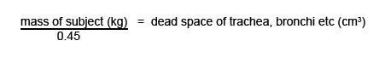
Using the spirometer to investigate cellular respiration and metabolic activity
The amount of oxygen consumed is found by comparing the lowest point of a trace at the start of a time period with the lowest point of the same trace at the end of this period. Compare this vertical distance with the initial volume calibration.
If a line drawn through all the peaks of a trace in any one period is straight, this shows that the subject consumed oxygen at a constant rate.
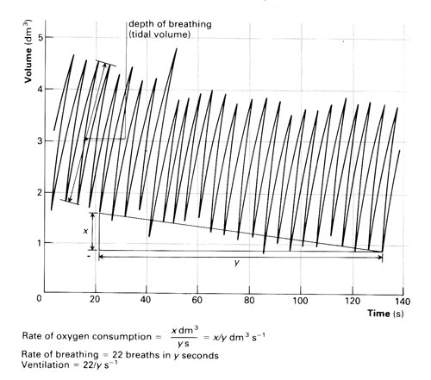
Reading oxygen consumption from a spirometer trace
Oxygen consumption gives a measure of metabolic rate. Humans can release approximately 20.18kJ of available energy for every dm3 of oxygen consumed. The calculation for resting metabolic rate is:
resting metabolic rate (kJ h⁻¹) = 20.18 x oxygen consumption per hour (dm³)
If the exercise is anything more than very light, the subject will incur an oxygen debt, and therefore oxygen uptake during or immediately after exercise will not give an accurate picture of energy usage during exercise.
A subject who has just finished some vigorous exercise usually feels hot. The expired air may be at a higher temperature than previously which would affect the volume of the gas in the spirometer. Measure the temperature of the air in the spirometer on both occasions to make sure this is not the case. If it differs considerably, make a correction when calculating the volume of oxygen. (Use the formula derived from Boyle’s Law).

