Article from The Buddhist News by The Knowing Buddha Organisation.

**Dos with regard to Buddha**

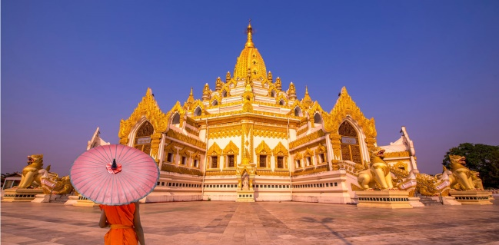

IN a country where Buddhism is the main religion there will be many temples and Buddha statues both inside and outside the temples or in people’s homes. Buddhists have the images of Buddha to pay gratitude and to pay respect to and to remind them of his teachings. To know what is appropriate and to whom one should pay respect is a common sense and basic morality.

The world has gone too far in using Buddha images wrongly, with lack of consideration. This summary aims help explain how to treat the Buddha image appropriately. Simple respect will bring good feelings and a harmonious heart for us all.

**1. Respect**

To pay respect to Buddha doesn’t mean you must be a Buddhist. If you act with respect to a prophet or founder of other religions, you should treat the Buddha the same way as he is worshipped as the spiritual Father of Buddhism. If you don’t want to pay respect at all at least do not look down on the Buddha.

**2. Correctness**

If you see a picture, an image, or a statue of Buddha in inappropriate places such as on the floor, in a toilet, or on a chair, please help to place it in a proper place up high such as on a shelf or higher.

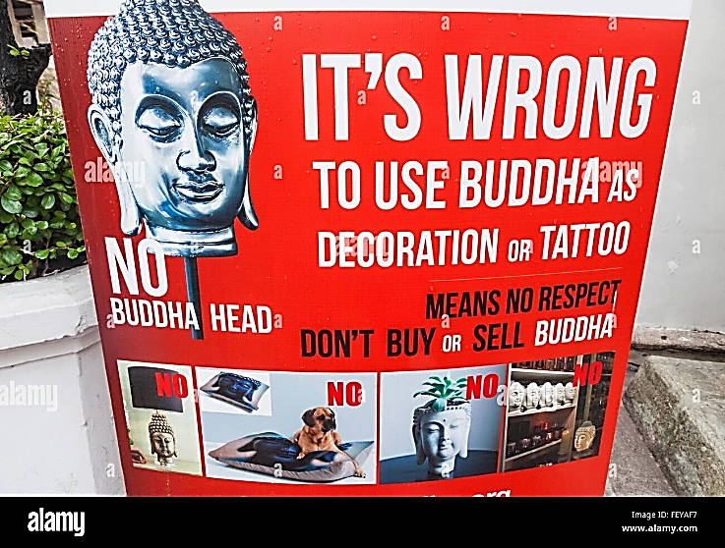

**3. Knowledge**

If you are a Buddhist, inform those who have the wish to know about Buddha. If you are not a Buddhist, and someone asks “Who is Buddha?” the simple answer can be, Buddha is the enlightened one who taught Buddhists to do good deeds the same way prophets and founders of religions do.

**Don’ts with regard to Buddha**

​

1. Please do not treat Buddha’s symbols, statues or images badly

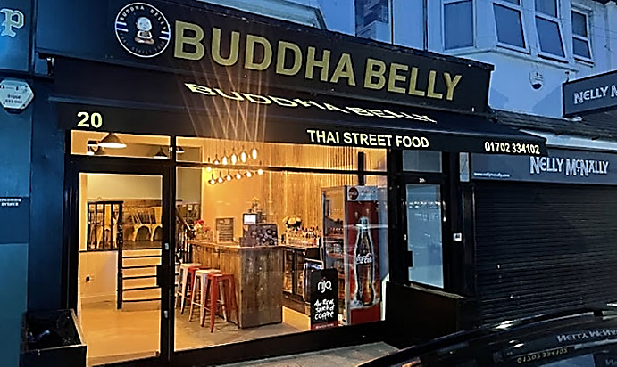 If you cannot pay respect to Buddha at least do not treat the image of Buddha badly. Buddhists respect Buddha as the religious father. All leaders of religions are regarded with respect. This should also be applied to Buddha.

2. Please do not use Buddha’s name in commercialization or without respect Such as naming a dog “Buddha” a restaurant “Buddha Belly” or a bar called “Buddha Bar”.

3. Please do not place Buddha images in inappropriate objects or places

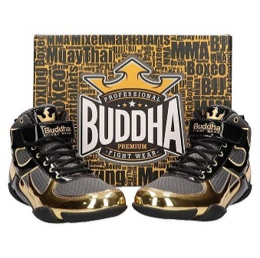 Buddha images should be placed away from objects of daily use such as handkerchiefs, napkins, towels, rags or cleaning item. Also do not use for the lower part of the body shoes, underwear, skirts including all sorts of toys and furniture etc.

True Buddhists who see a Buddha image placed as objects in inappropriate places will feel very unhappy.

4. Please do not place images or statues of Buddha as if they are furniture or decoration item.

Buddha symbols and images are not furniture or decoration, they are to be revered. Devoted Buddhists will know this.

You might wonder why there are businesses even in some Buddhist countries who treat Buddha statues or images without respect and sell them like decoration items. That is a reflection of human nature. In every society there are good and bad people. Bad people don’t care about anything except their own benefit: but the true Buddhist will feel ashamed of that.

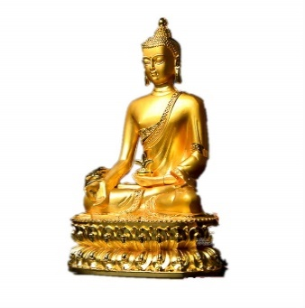 Buddha is the spiritual father to more than 500 million Buddhists around the world. His images and statues are not meant to be used for decoration or as tattoo under any circumstances. Those who create the object with Buddha images intend to inspire people to think of Buddha.

If you feel that Buddha images help you feel peace and harmony, please place the Buddha statue properly with respect, by placing the statue or image, at a high level from the floor and not use his symbols as decoration.

1. Buddha was a person who was clean from the inside out. His mind is free from illusion and impurities. He is respected by all Buddhists around the world. Someone once said that he had the Buddha tattoo on his body because he loved the Buddha and wanted to stay close to him. This idea is not proper and a misunderstanding. The best way to stay close to him is to follow his teaching.

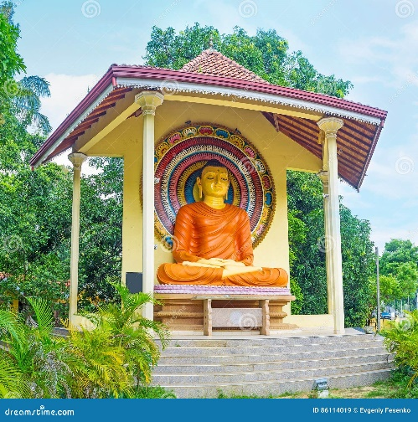2. We don’t practice sexual abstinence. However, to tattoo his image on a body that still indulges in sexual acts is considered a serious lack of respect.

3. The Buddha statue needs to be placed in a proper place.

Always put the Buddha statue in a high place, way above the head as a respectful act to him.

**The following is from Dhamma Wheel – a Buddhist discussion forum.**

We often find that Buddha is not treated with respect. Many people overlook the feelings of millions of Buddhists around the world.

Why is the image of Buddha so important?

When Buddha was still alive he never asked his followers to make statues or worship him in images. Instead he taught us to not have any attachment to anything – not even himself. Buddha said that the best way to worship him was to follow his teachings. And that after he passed away, after his “Nirvana”, his teachings would take his place.

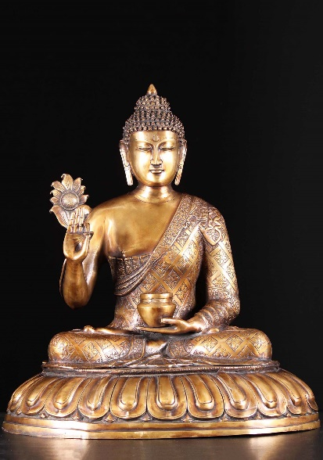100 years later some of his followers wondered how Buddha looked. They prayed to an angel who used to meet Buddha. Then the angel appeared in Buddha’s image, and so the first Buddha statues were created. Since then Buddha statues have become a key element for most Buddhists around the world are reminded of his compassion, kindness and his teachings and feel the highest regard for him.

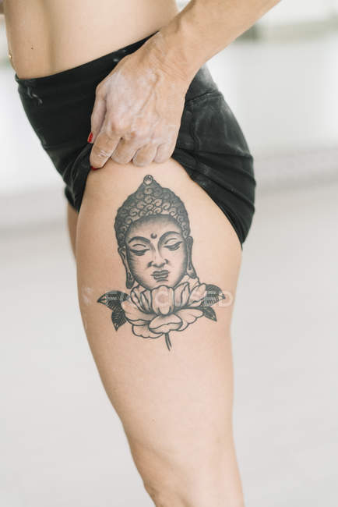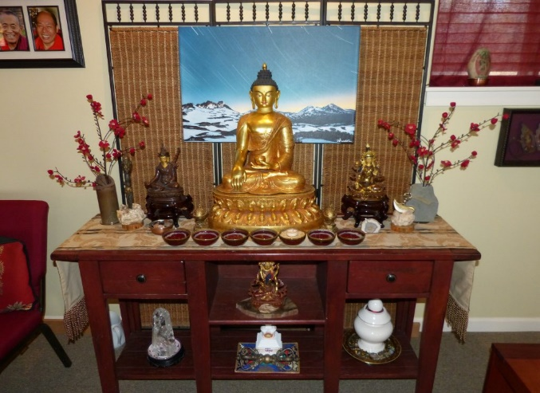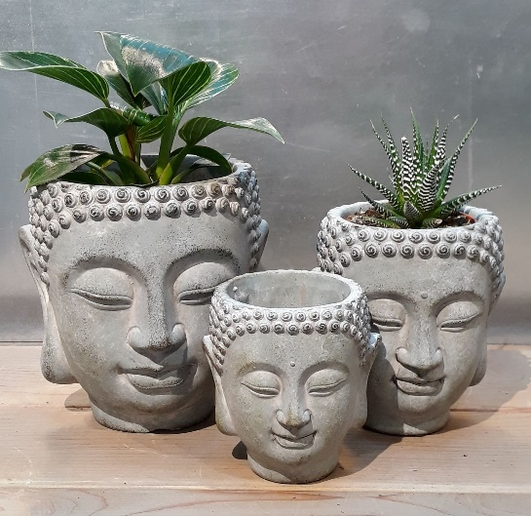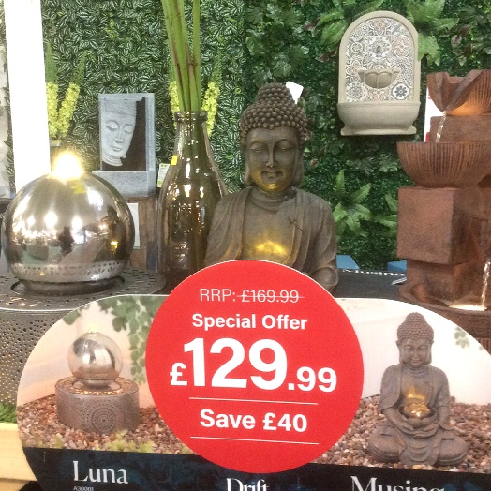

**Use of Images of Buddha**

Why do you think people have tattoos of Buddha?

What would a Buddhist think?

What do you think of the use of images of Buddha in ‘non-religious’ ways? Explain your answer.

Where might you see a statue of Buddha like the one in this picture?

What would it be used for?

What would a Buddhist think?

Why do you think garden centres etc sell statues of Buddha?

Why do you think people buy such statues?

What would a Buddhist think?

Considering what you have read, what do you think about these, Buddha planters’?

What would a Buddhist think?