Buddhism – the basics.

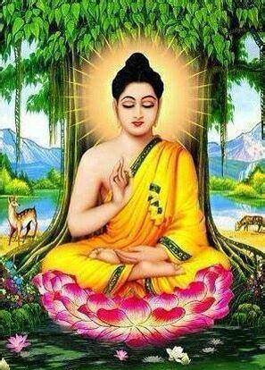
Buddhism is a faith that was founded by Siddhartha Gautama—who later became known as “the Buddha”—more than 2,500 years ago in India. With an estimated 500 million to one billion followers, Buddhism is considered to be one of the major world religions. It is a non-theistic faith with no god to worship.
Many of the beliefs and practices of Buddhism revolve around the concept of suffering and its causes and relieving suffering. Buddhism has historically been most prominent in East and Southeast Asia, but its influence is growing throughout the West. Many Buddhist ideas and philosophies overlap with those of other faiths.

Buddhism Beliefs

Some key Buddhism beliefs include:

- Followers of Buddhism don’t believe in a supreme god. They instead focus on achieving enlightenment—a state of inner peace and wisdom. When followers reach this spiritual height, they’re said to have experienced nibbana.

- The religion’s founder, Buddha, is considered an extraordinary being, but not a god. The word Buddha means “enlightened.”

- The path to enlightenment is attained by good moral actions, meditation and wisdom. Buddhists often meditate because they believe it helps awaken truth.
- There are many philosophies and interpretations within Buddhism, making it a tolerant and evolving religion.

- Buddhism encourages its people to avoid self-indulgence but also self-denial – taking a ‘Middle Way’, between extremes.

- Buddha’s most important teachings, known as The Four Noble Truths, are essential to understanding the religion.
- Buddhists embrace the concepts of karma (the law of cause and effect) and rebirth.

- Followers of Buddhism can worship in temples, viharas or in their own homes.

- Buddhist monks and nuns, (bhikkhus and bhikkunis) follow a strict code of conduct, which includes celibacy.
- There are numerous Buddhist symbols that represent Buddhist beliefs, including the lotus flower, the eight-spoked dharma wheel, the Bodhi tree and the swastika (an ancient symbol whose name means "well-being" or "good fortune" in Sanskrit).

Founder of Buddhism

Siddhartha Gautama, the founder of Buddhism who later became known as “the Buddha,” lived during the 5th century B.C.E.
Gautama was born into a wealthy family as a prince in Northern India. Although he had an easy life, when Siddhartha witnessed suffering for the first time, he felt compassion and wanted to bring suffering to an end.
He gave up his lavish lifestyle, almost all food and lived a life of extreme poverty. When this didn’t help him discover why we suffer and how to end suffering, he promoted the idea of the “Middle Way,” which means existing between two extremes. He then lived and promoted a life without social indulgences but also without deprivation.
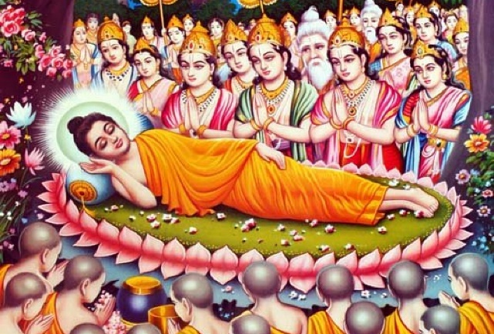
After six years of searching, Buddhists believe Gautama found enlightenment while meditating under a Bodhi tree. He spent the rest of his life teaching others about how to achieve this spiritual state.

When Gautama passed away around 483 B.C.E., his followers began to organize a religious movement. Buddha’s teachings became the foundation for what would develop into Buddhism.
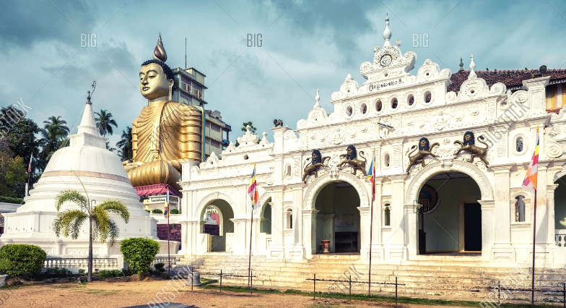
In the 3rd century B.C.E., the Indian emperor Ashoka, made Buddhism the state religion of India. Buddhist monasteries were built, and missionary work was encouraged.
Over the next few centuries, Buddhism began to spread beyond India. The thoughts and philosophies of Buddhists became diverse, with some followers interpreting ideas differently than others.

Types of Buddhism

Today, many forms of Buddhism exist around the world. Theravada Buddhism remains focused on the teachings of Buddha himself whereas Mahayana, and other forms of Buddhism may also use scriptures from other key Buddhist teachers.

- Theravada Buddhism: The tradition of the Elders. Widely practiced in Thailand, Sri Lanka, Cambodia, Burma etc.
- Mahayana Buddhism: ‘The Greater Vehicle’. Prevalent in China, Japan, Taiwan, Korea, Singapore and Vietnam
- Tibetan Buddhism: Prevalent in Tibet, Nepal, Mongolia, Bhutan, and northern India.
- Zen Buddhism is a form of Mahayana Buddhism that’s practiced in many of the same areas. It emphasizes simplicity and meditation—the word “zen” means meditation – there is less focus on religious scripture, ceremonies or doctrines and much more on meditation.

The Dharma

Buddha’s teachings are known as “dharma.” He taught that wisdom, kindness, patience, generosity and compassion were important virtues.
Specifically, all Buddhists live by five moral precepts, which are:
- Refrain from harming and killing living things
- Refrain from taking what is not given
- Refrain from sexual misconduct
- Refrain from harmful and false speech
- Refrain from intoxicants that cloud the mind (no harmful drugs or alcohol).

Four Noble Truths

The Four Noble Truths, which Buddha taught, explain that suffering is inevitable but that it can end:

- The truth of suffering (dukkha)
- The truth of the cause of suffering (samudaya)
- The truth of the end of suffering (nirhodha)
- The truth of the path that frees us from suffering (magga)

Eightfold Path

The Buddha taught his followers that the end of suffering, as described in the fourth Noble Truths, could be achieved by following an Eightfold Path.
The Eightfold Path of Buddhism teaches the following ideals for ethical conduct, mental disciple and achieving wisdom:
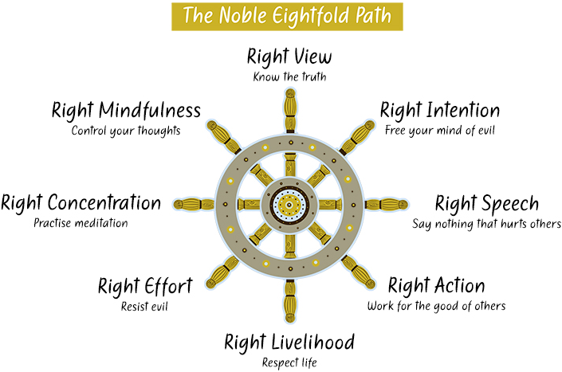
- Right understanding
- Right thought
- Right speech
- Right action
- Right livelihood
- Right effort
- Right mindfulness
- Right concentration (meditation).

Buddhist Holy Books

Buddhists revere many sacred texts and scriptures. Some of the most important are:

- Tipitaka: These texts, known as the “three baskets,” are thought to be the earliest collection of Buddhist writings and include Buddha’s own teachings such as the Dhammapada and Jataka Tales (stories of Buddha’s past lives).

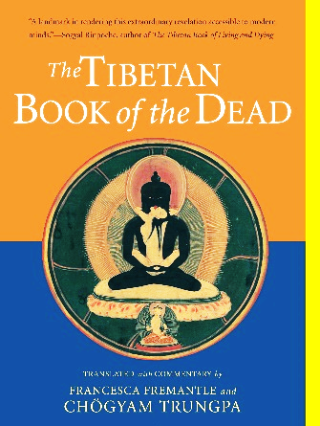
- Sutras: There are more than 2,000 sutras, which are sacred teachings used mainly by Mahayana Buddhists as most of them were written after Buddha’s death. They include works such as the Heart Sutra and Lotus Sutra.
- The Book of the Dead: This Tibetan text describes the stages of death in detail.

Dalai Lama
The Dalai Lama is the leading monk in Tibetan Buddhism and an inspiration to many Buddhists. Followers of the religion believe the Dalai Lama is a rebirth of a past lama (teacher) that has agreed to be born again to help humanity. There have been 14 Dalai Lamas throughout history.
The Dalai Lama also governed Tibet until the Chinese took control in 1959. The current Dalai Lama was born in 1935. He is world famous for his peace and human rights campaigns and has won the Nobel Peace Prize.

Buddhist Holidays
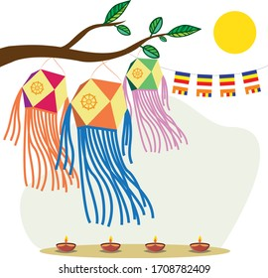
The biggest Buddhist festival is Wesak, a festival that commemorates Buddha’s birth, enlightenment and death. It is also seen as Buddhist New Year.

During each quarter of the moon, followers of Buddhism participate in a ceremony called Uposatha. This observance allows Buddhists to renew their commitment to practicing their teachings.
Parinibbana Day, a day to commemorate the passing away of Buddha.
What is Buddhism all about?
Read the information and then design an information poster (no more than 2 sheets of A4) that informs other people of the essentials of Buddhism.

