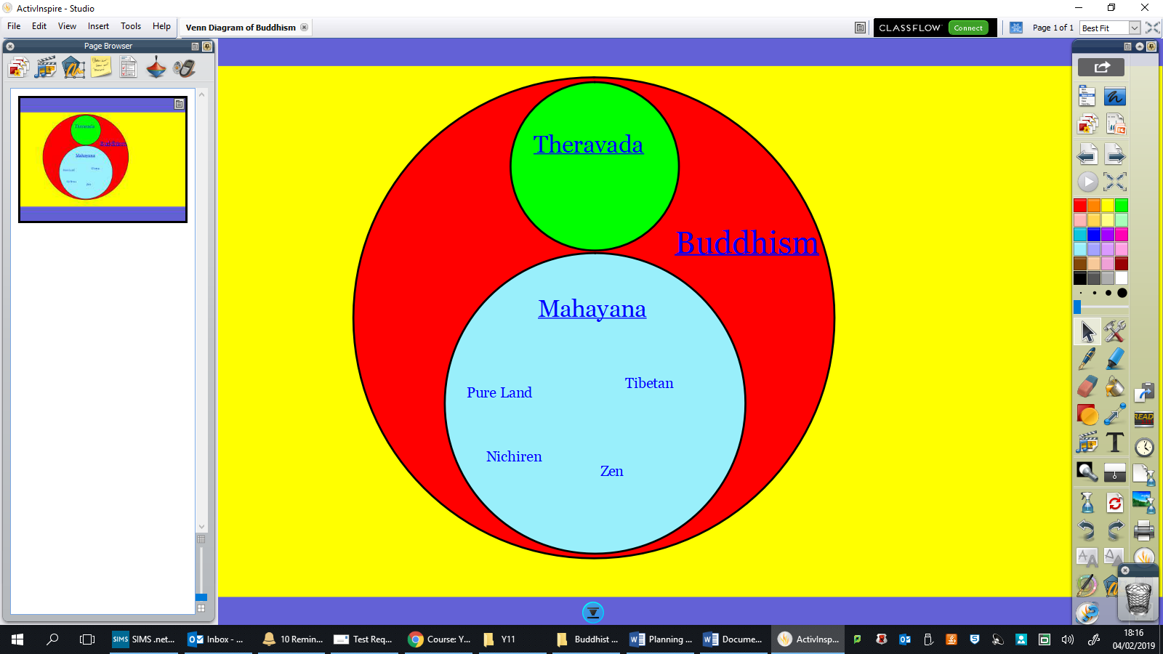

Triratna

Vajrayana

Madhyamaka