The Guardian:
Religion: why faith is becoming more and more popular?

Faith is on the rise and 84% of the global population identifies with a religious group.

How many believers are there around the world?

If you think religion belongs to the past and we live in a new age of reason, you need to check out the facts: 84% of the world’s population identifies with a religious group. Members of these religious groups are generally younger and produce more children than those who have no religion, so the world is getting more religious, not less – although there are significant geographical variations.

According to 2015 figures;

- Christians form the biggest religious group, with 31.2% of the total world population.
- Next come Muslims 24.1%
- Then Hindus 15.1%
- And Buddhists 6.9%

In addition to the above, people who practise folk or traditional religions; number 6% of the global total. Followers of lesser-practised religions, including Sikhism, Baha’i and Jainism add up to just below 1%. The number of Jews in the world is about 0.2% of the global population.

But the third biggest category of people in the world, around 16%, said they have no religious affiliation at all. This does not mean all those people are committed atheists; some – perhaps most – have a strong sense of spirituality or belief in God, gods or guiding forces, but they don’t identify with or practise an organised religion.
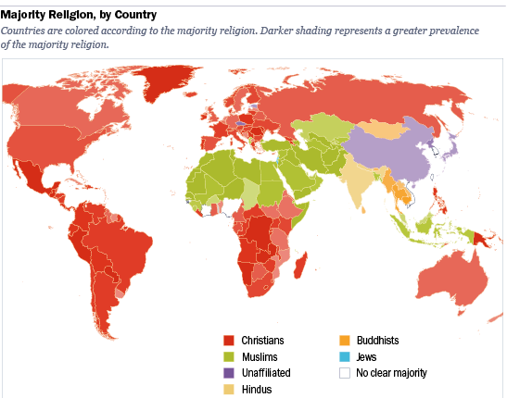
Geography is important in religion. Asia-Pacific is the most populous region in the world, and also the most religious. It is home to 99% of Hindus, 99% of Buddhists, and 90% of those practising folk or traditional religions. The region also hosts 76% of the world’s religiously unaffiliated people, 700m of whom are Chinese (where the government is officially atheist).

Three-quarters of religious people live in a country where they form a majority of the population; the remaining quarter live as religious minorities. For example, 97% of Hindus live in three Hindu-majority countries: India, Mauritius and Nepal, while 87 % of Christians live in 157 Christian-majority countries. Three-quarters of Muslims live in Muslim-majority countries. Among the religiously unaffiliated, seven out of 10 live in countries where they are in the majority, including China, the Czech Republic and North Korea (where religion is banned).
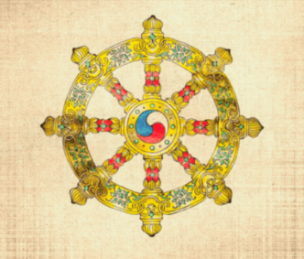
In contrast, most Buddhists (72%) live as a minority in their home countries. There are seven countries where Buddhists form the majority of the population: Bhutan, Myanmar, Cambodia, Laos, Mongolia, Sri Lanka and Thailand.

Which religions are growing, and where?

The short answer is religion is on the wane in western Europe and North America, and it’s growing everywhere else.

The median age of the global population is 28. Two religions have a median age below that: Muslims (23) and Hindus (26). Other main religions have an older median age: Christians, 30; Buddhists, 34 and Jews, 36. The religiously unaffiliated come in at 34.
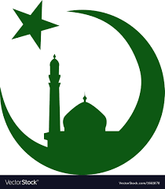
Islam is the fastest-growing religion in the world – more than twice as fast as the overall global population. Between 2015 and 2060, the world’s inhabitants are expected to increase by 32%, but the Muslim population is forecast to grow by 70%.

Numbers of Christians will increase by 34%; Hindus are set to grow by 27%, and Jews by 15% mainly because of the high birth rate among the ultra-Orthodox. The religiously unaffiliated will see a 3% increase.

It’s mainly down to births and deaths, rather than religious conversion. But 23% of American Muslims say they are converts to the faith, and in recent years there has been growing anecdotal evidence of Muslim refugees converting to Christianity in Europe.

China has seen a huge religious revival in recent years and some predict it will have the world’s largest Christian population by 2030.
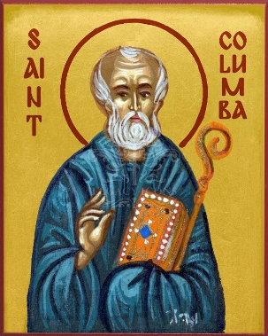
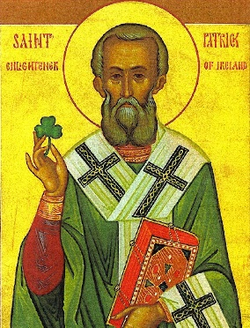
In contrast, Christianity is in decline in Western Europe. In Ireland, traditionally a staunchly Catholic country, the proportion of people identifying with Catholicism fell from 84.2% to 78.3%. In Scotland, another country steeped in religious tradition, the majority of people, 59%, now identify as non-religious.
What about theocratic states?

The Islamic Republic of Iran has a political system based on Islamic beliefs. Iran is one of only two countries in the world that reserves seats in its parliament for religious clerics (the other is the UK). Other Islamic theocracies are Mauritania, Saudi Arabia, Sudan and Yemen.
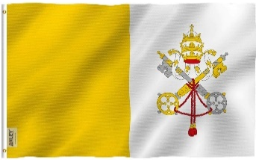
The only Christian theocracy is Vatican City, the tiny but powerful centre of Roman Catholicism, where the Pope is the supreme power and heads the legislative and judicial branches of the Vatican government.

Thirteen countries (including nine in Europe) designate Christianity as their state religion. In England, the Church of England – is recognised as the official “established” Church of the country with important roles relating to state occasions. Twenty-one bishops sit in the House of Lords by right.

Israel defines itself as the “Jewish state”, with an 80% majority Jewish population. However, the government is secular.

Does religion have an impact on the world?

Of course – there are consequences to religious belief and practice. Firstly, conflicts have sometimes had a religious dimension throughout history right up to the present day. In the past few years, we’ve seen conflict between Islamic extremists in the Middle East, the persecution of Rohingya Muslims in Myanmar, violent clashes between Christians and Muslims in Central African Republic. Women are discriminated against and LGBT people are persecuted in some countries.

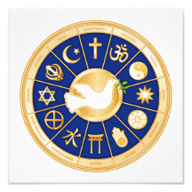
But it’s not all bad news. There are millions of people of faith across the world engaging in social action projects to help the poor and marginalised. Look at the involvement of churches, mosques and synagogues in food banks and projects to support refugees, the Sanctuary Church movement in the US, the extraordinary sums raised by Islamic charities for relief work in some of the world’s most desperate places. Many charities are affiliated to or directly linked to religious faiths, in England and Wales this is 23% of all charities.
Things to do;

- Look up (in a dictionary) the words in bold italics. Note down definitions of the words on your key terms sheets.

- How many people identify with a religion in the world (percentage)? What percentage of these are Christian?

- What percentage of people in the world have no affiliation to a religion? Does this mean all of those people are atheists? Explain your answer.

- Where in the world is religion the most popular? Where is religion growing and where is religious affiliation reducing?

- What is the growth in religion largely due to, according to the article? What might be another reason for the growth in religious faith?

