Constantine and Augustine

The rise of Christianity from a persecuted sect to a global religion is a remarkable story of guts, faith, chance, politics and fate.
In the 1st Century CE, the peoples of Britain had a variety of religious Pagan and Roman gods. Into this superstitious and violent world came a modern cult from the east: Christianity.

The arrival of Christianity in Britain is often associated with St. Augustine in 597 CE. But in fact, Christianity arrived long before then, going back to the 1st Century CE.

It began when Roman traders arriving in Britain spread the story of Jesus along with stories of their Pagan gods. Christianity was just one cult amongst many, but unlike the cults of Rome, Christianity demanded its followers worship only the one God. It was this intolerance of other gods, that rattled the Roman authorities and led to repeated persecutions of Christians. Christians were forced to meet and worship in secret.

But a single religion with a single God appealed to the Roman Emperor Constantine. He saw that Christianity could be harnessed to unite his Empire and achieve military success. From 313 CE onwards, Christian worship was tolerated within the Roman Empire.

During the 4th Century, Christianity in Britain became more visible but it had not yet become universally popular. Pagan beliefs still more common and Christianity was a minority faith.

It looked as if Paganism would remain bigger than Christianity because after the Romans left Britain, new invaders arrived: Angles, Saxons and Jutes, all with their belief systems. Yet somehow Christianity survived on the Western edges of Britain. Missionary activity (spreading and teaching Christianity) continued in Wales and Ireland, and in Western Scotland Saint Columba helped bring Christianity to mainland Britain.

It could be argued that it was St. Augustine's mission in 597 CE from the Pope in Rome to King Aethelbert of Kent that really set up the future of Christianity in Britain, creating a strong alliance between Christianity and Kingship. The Venerable Bede (a great Anglo-Saxon writer of the 6th & 7th centuries), wanted to see it this way believing a Christian England was part of God's master plan. It was God’s will that meant it was the destiny of the Anglo-Saxons to become Christians, united in a single Christian nation.

In the account of the Synod of Whitby (664 CE) in Bede’s ‘Ecclesiastical History of the English People’, he describes tension between the Irish Christianity of Saint Columba and the international Roman Christianity of Augustine. Bede ends his ‘History’ bemoaning the Anglo-Saxons who he saw as half-hearted Christians still holding onto Pagan practices. There was still no organised and disciplined parish life to regulate the beliefs and behaviour of the British people.
Alfred and the Normans
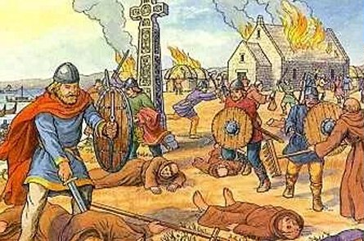
Christianity had proved that it was able to survive invasion and attack. But just as Christianity's rise looked to be unstoppable, the Viking invasion of Lindisfarne in 871 CE marked the start of a series of attacks which threatened to destroy the Christian church. Monasteries and churches were plundered, and priests fled for their lives. It looked as if Paganism would again crush Christianity.

It was Alfred, the Christian King of Wessex, who turned things round. Alfred saw the Viking attacks as punishment from God. Once Alfred had secured a victory over the Viking warrior Guthrum at the Battle of Eddington (878 CE), he set about creating a new system of Christian learning that would reach the illiterate country people. It was Alfred's hope that this would enable Christianity to begin to capture the imagination of the ordinary people.

In the 10th Century, lords began to provide small chapels on their land where local people could use the services of a priest. This sowed the seeds of the parish system, still in existence today.

It was the Norman Conquest that really cemented the power of the church in England. William the Conqueror implemented a colossal building project at both monastic and parish level. Old Saxon Churches made way for a new Norman buildings. These new stone churches continued to play a central role in community life, acting as schools, market places and entertainment venues.

The medieval period in Britain is really a story of how Christianity came to dominate the lives of the ordinary people, both at home and on the long, perilous journeys of pilgrimage. But it would be wrong to think of medieval Christians as devout church-goers who flocked to church every Sunday, on average people would go to church just a few times a year, when there was a real spectacle to take part in.

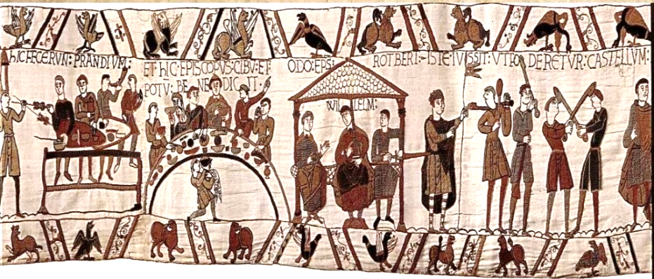
But even those who weren't regular churchgoers could not escape regulation by the Church. You could argue that Christianity had an impact on every single aspect of every member of the population's lives. The Church regulated lives by controlling what people did during the day, from the cradle to the grave, and every stage in between, the Church could be your ally or your foe, and ultimately your passport to heaven or hell.
The Reformation
At the beginning of the 16th Century there was nothing inevitable about the Reformation in England. England was not bound to turn Protestant like its Northern neighbours. No one could predict what was to happen over the next 150 years, least of all the king who started the process.

Reform movements in Europe were influencing their governments to bring about change. In England, people who wanted changes in the medieval Catholicism that had dominated for centuries were in the minority.

There was talk of corruption and money-making that had distorted the true and simple meaning of the gospels and the supposed ‘magic-like’ rituals getting in the way of the relationship between God and the people.

These criticisms were not, however, the cause of Henry VIII's decision to break from Rome. Henry wanted to divorce and re-marry in order to try and secure an heir, but in those days even the King had to get permission from the Pope for a divorce and the Pope refused.

So in 1534 Henry divorced England from the Pope instead! He was happy to allow a few religious changes so that his decision to split from the Catholic Church didn't look too blatantly driven by self-interest.

Religious changes under Henry were minimal in comparison to those wanted by the reformers wanted but they made a big difference to the individual believer. Until then the Bible had been in Latin, the priest told people what it meant, suddenly there was to be an English Bible in every Church. There would be no more pilgrimages to shrines with hospitality laid on by the Church, no more relying on prayer to the appropriate saint for ailments and grievances. The monasteries, a very wealthy and influential symbol of medieval Catholicism, were closed and their lands sold off.

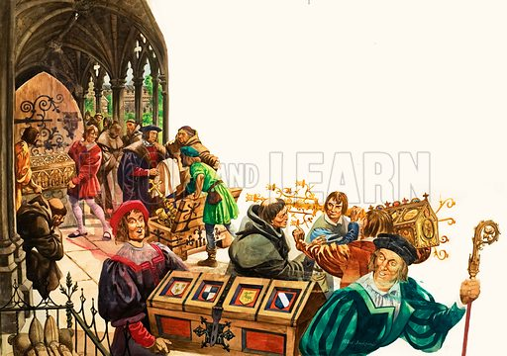
Reformation really took off under Henry's Protestant educated son, Edward VI (1547). He changed the ritual of the mass, declared that Purgatory no longer existed and prayers for the dead were written off as useless; God alone decided whether you were saved or damned. Churches were stripped of their artefacts and priests no longer had to be celibate.

By the end of Edward's reign (1553) the Reformation was much more than political: it was becoming deeply ingrained into people's habits and beliefs. Dissent was punishable by death.
Mary and Elizabeth
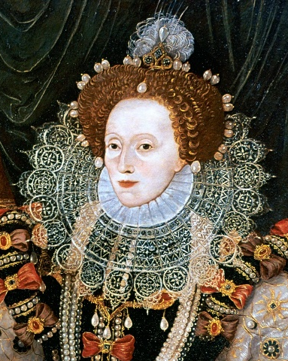
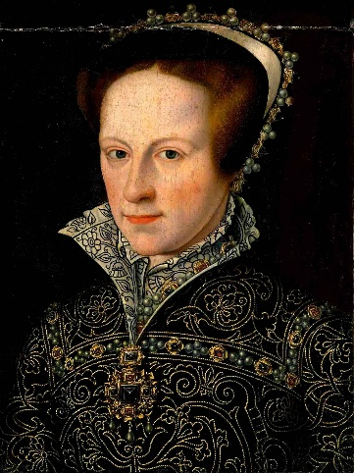
Six years after his coronation Edward VI died and his Catholic half-sister, Mary, set history into reverse. England once again became Catholic. English Bibles were removed from churches, the Latin mass said again. Priests who had married were suddenly banned from seeing their wives without a chaperone.

For those who did not want to slip back into the Catholic fold the only road was persecution and martyrdom. Under Mary's orders hundreds of Protestants were burned at the stake. Then after five years the unexpected happened again. The queen died. She had no heir and her sister Elizabeth took the throne (1558). The nation once again became Protestant and the Protestant simplicity of the churches was restored by force.

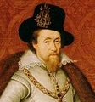
By the end of Elizabeth's reign (1603) a stunning transformation had occurred. By now, the majority of the population had only known Protestantism because the generation baptised into Catholicism had died. For the first time the majority of the nation felt Protestant. To be Protestant was to be English and those stubbornly remaining Catholic were traitors. Elizabeth refused to abolish bishops - disappointing the more extreme Protestants, the Puritans, but keeping the vast moderate majority on side. The balancing act was maintained by her successor, James I.
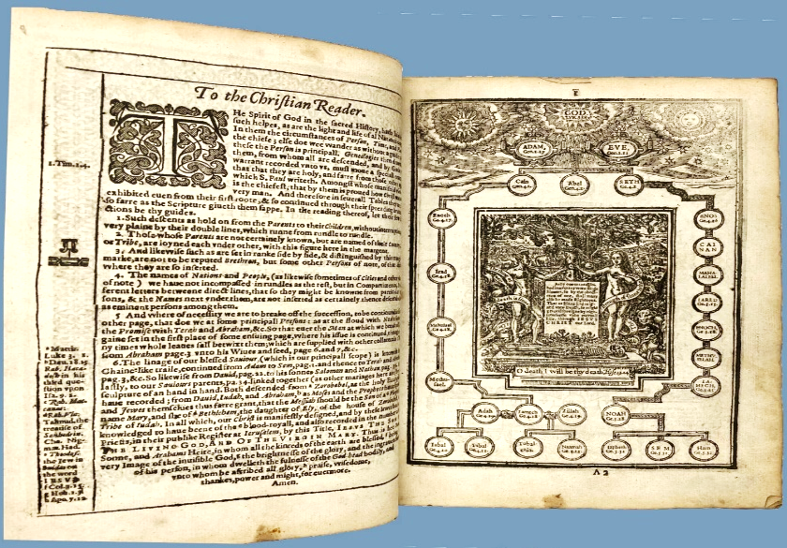

The King James Bible, introduced in 1611, defines the nation and encapsulates its religion. The Protestantism had finally won over. From school children to soldiers, each citizen was expected to know the core Protestant teachings and practices. The old religion (Catholicism) had by and large been flushed out and the new one (Protestantism) successfully implanted. The Reformation has been sold to the English and it looked like nothing could challenge it.

English Civil War

In 1625, when Charles I came to the throne, church and kingdom were in good working order; loyalty to King meant loyalty to the Reformation and Protestantism. There was a Catholic minority but it was subdued and reduced to worshipping in secret.

The only danger to the Protestant order was from the other end of the spectrum: the Puritans, Protestant extremists who wanted the Reformation to go much further.

Within a short time, however, Charles got into trouble with the Protestants. He appointed an unpopular bishop known to be sympathetic to Catholicism. Charles then appeared to start looking for real trouble.

Scots Protestantism was more extreme and far reaching than Protestantism south of the border. In 1637, Charles introduced the New Anglican Prayer Book to Scotland sending a signal to the Scots that their Reformation was to be brought into line with the English.

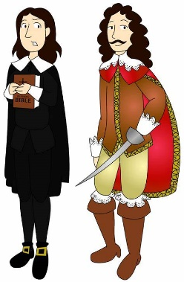
Charles had deeply underestimated the passion with which religious doctrine was held by the Scots and had at a stroke made himself an enemy of his Scottish people. The king opted for a show of force, but parliament was reluctant to help him raise an army. Charles' response was staggeringly tactless. He turned to Catholic Ireland in search of men for his army. The very idea of Catholic Irish against Protestant Scots was dynamite.

Protestantism was based in prophecy. They believed the battle between good and evil was always close at hand, and now Puritans saw the moment as fulfilling the most dramatic prophecy: the Day of Judgement was upon them.
Puritan Beliefs

- Religion is a personal inner experience
- Humans were ‘damned’ due to the sin of Adam and Eve and they had to work hard to become pure – hence ‘Puritan’.
- God rewards the good and punishes the wicked
- Interpret the Bible literally
- No excess in worship – no singing, no rituals, stained glass or cushioned pews.
- Kept worship etc simple so they could focus on God.
- No separation of Church and State – Church leaders led the government.

The religious battle lines had never been so clearly defined and parliament took up the Puritan cause. The vast majority of moderate Britons had no alternative but to take sides; back their Catholic-leaning King, or Puritan-leaning Parliament. Within months the English Civil War, England's War of Religion, had begun (1642).

Oliver Cromwell
Oliver Cromwell wanted to wipe out Catholicism. It took 7 years for the king to be defeated and executed (1649), opening the way for the first and only 'religious' government.

Cromwell, was determined to install nothing less than an Assembly of Saints on earth. They were to be chosen according to the intensity with which they experienced God. Their task was to institute a programme of moral regeneration and education.

Oliver's army of saints were fighting God's battle on earth. Any traces of Catholic worship were removed once and for all. Now only the utmost simplicity would be tolerated. A New Order was indeed being established - God's order.

It was not long before this New Order resembled exactly what it had fought to replace: the monarchy with Cromwell adopting the title Lord Protector (1653).

The Assembly of Saints had decided it was not society that needed to be reformed but the sinners within it. But by the time Cromwell died, the sinners had not reformed. When new elections were called in 1660, people rejected the New Order Cromwell had established and Charles II was recalled. Cromwell had failed.

With the accession of Charles II, the Puritan way of life ended. Festivities resumed, theatres reopened and Christmas reappeared on the calendar. The Church of England was re-established.

Then came Plague, the Great Fire and the Dutch War and euphoria turned to depression. Then depression turned to anxiety as it became clear that the heir to the throne James II (1685) was a fully-fledged Catholic. James believed that once Catholics were allowed to worship publicly and evangelise openly hundreds of thousands would surely return to the faith.

When his queen gave birth to a son there was horror at the thought of a dynasty of Catholics. James had to go. The next plausible and Protestant heir to the throne, William of Orange, was in effect encouraged to invade England. James took flight and William assumed the throne.

The 1689 Bill of Rights said that no Catholic could become king or queen and the Act of Toleration (1688) granted freedom of religious worship to all denominations - though not to Catholics. The state gave up on trying to impose one faith on its people, recognising there was not one faith within the nation but many. In accepting this, the door from many faiths to no faith had been opened.
Christianity in 18th Century England

In the early 18th century England was noted for its lack of religious enthusiasm. However, in the mid-18th century, things began to change. In 1739, John Wesley began preaching. He eventually created a new religious movement called the Methodists.
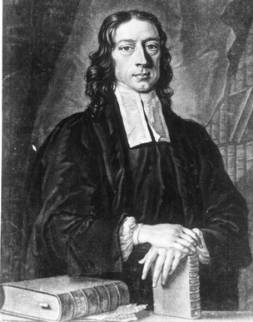
John Wesley travelled all over the country, often preaching in open spaces. Some people jeered at his meetings and threw stones but Wesley persevered. John Wesley never intended to form a movement separate from the Church of England. However, the Methodists did eventually break away.

From the 1780s, a group of Evangelical Christians called the Clapham Sect (as many of them lived in Clapham) was formed, William Wilberforce among them. They campaigned for an end to slavery and cruel sports. Meanwhile, in the late 18th century religious enthusiasm began to revive in England.

In 1700s England, it was generally agreed that something must be done about children's poverty and ignorance. The Society for the Promotion of Christian Knowledge (SPCK, 1698) established 1,500 charity schools for such students, and the Wesleys preached to them.

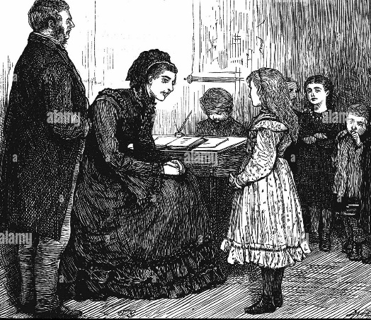
Raikes a newspaper publisher and committed member of the Church of England, first puts his efforts to live out his Christian convictions into prison reform, but then decided children must be put on the right path before evil habits were formed. After a shocking encounter in the Gloucester slums, he set up schools on a Sunday to teach the children, the Bible was the basis of instruction. Sunday schools grew dramatically. By 1787, there were 250,000 Sunday school students.

Christianity in 19th Century England

The popularity of Sunday Schools grew rapidly, by 1831 there were 1.25 million students and had spread to America and Europe. In 1833 the government began subsidizing the schools. During the 19th century, Britain was transformed by the industrial revolution. In 1801, at the time of the first census, only about 20% of the population lived in towns. By 1881 about two-thirds of the population lived in towns.

During the early 19th century religious revival continued. The Church of England regained its energy and many new churches were built.

Meanwhile, in 1829, the Catholic Emancipation Act was passed. Since the Reformation Catholics had been unable to become MPs or hold public office. The Act restored those rights to them.

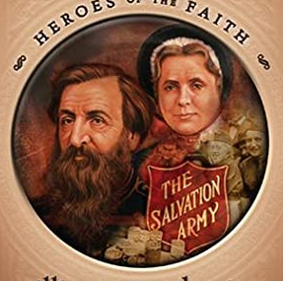
Organised religion was much more important in 19th century England than it is today. In 1851 a survey showed that about 40% of the population were at church or chapel on a given Sunday. Which meant that around half the population did not go to church. Certainly, many of the poor had little or no contact with the church. In 1881 a similar survey showed only about 30% of the population was at church on a given Sunday. In the late 19th century organized religion was in decline in England. In 1865 William and Catherine Booth founded a new movement to reach the poor and fight a ‘war’ against poverty. In 1878 it was named the Salvation Army – Christian groups are becoming more and more involved in social justice.

The Church of England has always been concerned with education and the history of Church schools began when the National Society for the Promotion of Education was founded in 1811. Long before the government became involved in providing education for everyone in our country, the Church of England had a vision that it wanted every parish to have a school for the education of poor children. By 1900, there
were 5,700 state-funded schools and 14,000 schools funded by the Church of England.

Christianity in 20th Century England

During the 20th century, church-going declined in England and by the end of the 20th century, fewer people attended church regularly. Nevertheless, many people continued to believe in God, and in the late 20th century there was a lot of interest in the New Age Movement.
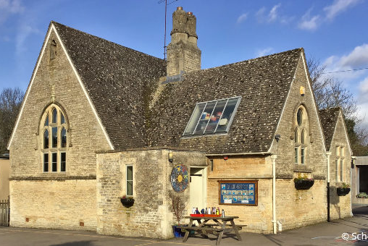
In the early 20th century, Pentecostal churches were formed. They practiced the gifts of the Holy Spirit. In the 1960s use of the gifts of the Holy Spirit spread to mainstream churches. In the 1970s and 1980s charismatic or, ‘house churches’ became common. At the end of the 20th century, the Alpha Course (1977) became an effective method of introducing people to Christianity.

Religiously-affiliated schools continue to play a large part of the British state school system, with 37% of primary schools and 18% of secondaries classes as faith schools.
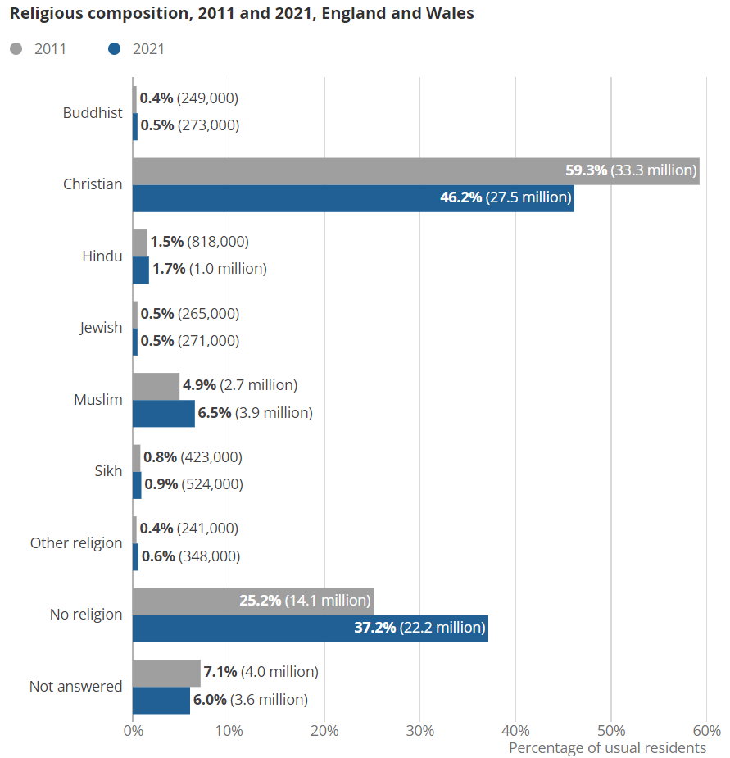

Religion in the 2020s.

Above are the 2021 census figures for religious belief. A census is done every 10 years in the UK, it tracks the population of the UK. It is compulsory to complete the questionnaire except the question about religion.

- Note down the percentage of Christians in the UK.
- Note down the percentage of people who are not religious.
- Explain what has happened to the numbers of (a) Christians and (b) other religions between 2011 and 2021.
- What do the figures suggest about how many people in the UK are religious compared to those who are not? Explain why this might be.
- Are the figures reliable? Explain your answer considering different points of view.

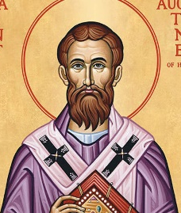
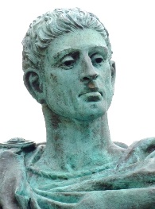
Constantine and Augustine.

- What were the people of Britain worshipping in the first century?

- When and how was Christianity first introduced to Britain?

- What was different about Christianity compared to the demands of other ‘cults’ practiced at this time in Britain?

- Why did Emperor Constantine adopt Christianity as the religion of the Roman Empire in 313CE?

- What was the status of Christianity in 4th century Britain?

- Explain the purpose and importance of Augustine’s mission of 579CE.

- What did Bede believe about Christianity in England?

- What was the status of Christianity in Britain in 664, according to Bede?

Dates for your timeline:

- 1st century 313 CE 4th century 597 CE 664 CE

Alfred and the Normans.

- What happened in 871 CE that could have seen an end to the Christian Church in Britain?

- What did King Alfred do to prevent this (answer to Q1) happening? Why did he do this?

- What did the Lords do that ‘sowed the seeds’ of the parish system?

- How did William 1st increase the power of the Church in 11th century Britain?

- What was the state of Christianity in Britain in the medieval period?

- How did the Church impact on the lives of people in Medieval times?

Dates for your timeline:

- 871 CE 878 CE 10th century 1066 CE Medieval period.

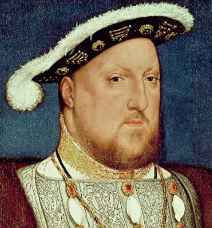
The Reformation.

- Why did reform movements want to bring changes to Catholicism in medieval Britain?

- Why did Henry XIII ‘divorce’ from the Pope and Catholicism?

- What were some of the religious changes Henry made in Britain?

- What were some of the religious changes Edward VI made?

- What could happen to someone who disagreed with the changes made under Edward VI?

Dates for your timeline:

- 16th Century 1534 CE 1547 CE 1553 CE

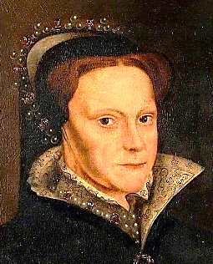
Mary and Elizabeth.

- How did Mary I change the religious landscape in Britain?

- What could happen to people who refused to convert to Catholicism?

- What happened as far as religion is concerned in Britain when Mary I died and Elizabeth I came to the throne?

- What had happened to the religious landscape in Britain by the end of Elizabeth I’s reign?

- What was introduced by James I in 1611 CE and why was this important?

Dates for your timeline:

- 1553 CE 1558 CE 1603 CE 1611 CE

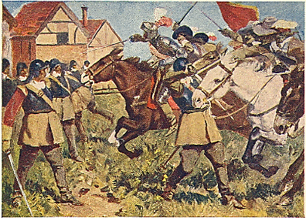
English Civil War.

- What was the ‘only danger’ to the Protestant order in Britain at this time?

- What did Charles I introduce to Scotland in 1637 and why was this significant?

- What was Charles I response to the Scottish anger he faces?

- Note down some key Puritan beliefs.

- What key event did Charles I’s actions lead to?

Dates for your timeline:

- 1625 CE 1637 CE 1642 CE

Oliver Cromwell.

- What happened in 1649 CE that led to the first and only ‘religious’ government in Britain?

- Explain the purpose of Cromwell’s ‘Assembly of Saints’.

- What did the Assembly of Saints believe needed to be reformed?

- What happened when elections were call in 1660 CE?

- What changes did Charles II bring in?

- Why do you think people were concerned about James II becoming King? What did this lead to?

- What did the 1689 Bill of Rights say about the monarchy?

- What did the Act of Toleration say about religion and why was this significant?

Dates for your timeline:

- 1649 CE 1653 CE 1660 CE 1685 CE 1688 CE 1689 CE

Eighteenth, Nineteenth and Twentieth Centuries – 18th Century
- Which religious organisation did John Wesley create? What was significant about this?

- What does evangelical mean?

- What did the Clapham Sect campaign for? Name a famous member.

- What did religious groups believe was important for poor children to improve their lives? What did this lead to?

- What did Raikes set up and why did he do this?

Dates for your timeline:

- 1698 CE 1739 CE 1780s 1787 CE

Eighteenth, Nineteenth and Twentieth Centuries – 19th Century
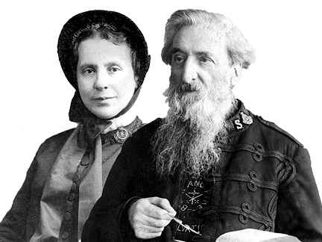
- What did the government start to do in 1833, inspired by the Sunday School Movement?

- What started to happen in the early 19th century that led to many new churches to be built?

- What Act of Parliament was passed in 1829 and how did this make a difference to one Christian group?

- What did a survey suggest about Church attendance and therefore Christianity between 1851 and 1881?

- What new religious movement was founded in 1865? Who founded it and what were their aims?

- What did the Church of England become particularly involved with during the 19th century? What is the evidence of this?

Dates for your timeline:

- 1811 CE 1829 CE 1833 CE 1851 CE 1865 CE

Eighteenth, Nineteenth and Twentieth Centuries – 20th Century
- With regard to religion, what was becoming less popular, what was becoming more popular? Suggest reasons for this.

- Which religious movement was formed in the early 20th century?

- What are the ‘Gifts of the Holy Spirit’?

- What kind of Christian groups were becoming popular in the 1970s and 80s?

- What is the Alpha Course?

- How many British schools are classed as faith schools?

Dates for your timeline:

- Early 20th Century 1960s 1970s and 80s 1977.

Eighteenth, Nineteenth and Twentieth Centuries – 20th Century
- With regard to religion, what was becoming less popular, what was becoming more popular? Suggest reasons for this.

- Which religious movement was formed in the early 20th century?

- What are the ‘Gifts of the Holy Spirit’?

- What kind of Christian groups were becoming popular in the 1970s and 80s?

- What is the Alpha Course?

- How many British schools are classed as faith schools?

Dates for your timeline:

- Early 20th Century 1960s 1970s and 80s 1977.

