SAMPLE FOOTER TEXT

5







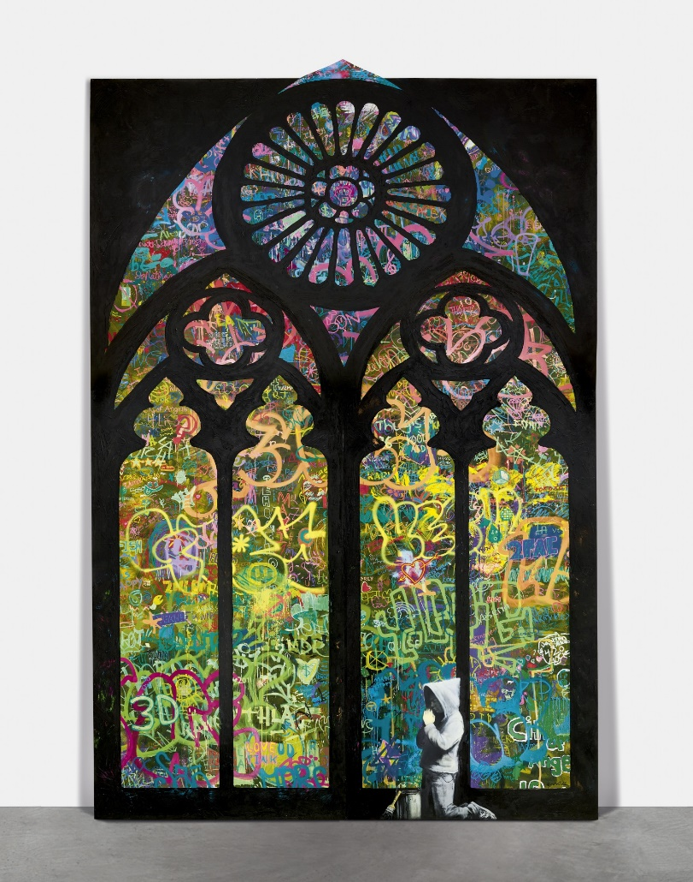



Science

**Examples**

* A picture containing diagram

  Description automatically generatedGeorges Lemaitre
* Charles Babbage
* Abu Ali Ibn Sina
* The Banu Musa brothers' "ingenious devices"
* Al-Zahrawi's surgical instruments

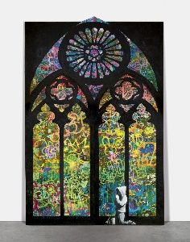



* A picture containing diagram

  Description automatically generatedText

  Description automatically generatedText

  Description automatically generated

**The above examples are suggestions, you can use them or find your own alternative examples to investigate.**

***Don’t forget*, in all cases you are looking for the religious aspects, explaining links to religion, which religions, how religion has influenced these aspects of life and, possibly, how religion is affected and influenced by the examples in the areas.**