Wise Words

Revision -

Wise Words – Holy Books.

- Give 3 examples of Holy Books from 3 different religions.

- Give 2 examples of Jesus’ parables.

- Give 1 example of a quotation from one of Jesus’ parables.

Match up – Holy Books and Religions Key Terms and Definitions
Using knowledge wisely

Teacher in Sikhism

Sikh place of worship

Treating people unjustly

Community kitchen

A story with a meaning

Guru

Wisdom

Langar

Parable

Gurdwara

Discrimination
Bible

Dhammapada

Guru Granth Sahib

Torah

Bhagavad Gita

Qur’an
Sikhism

Christianity

Buddhism

Islam

Judaism

Hinduism

Complete…
Complete the following quotations and the explanation of the quotations;
‘Faith without ____________is ___________’.
This means that believers should put their ______________ into ___________.
The above quotation can be found in the ___________.

‘The wise __________ for the ________________ of the world, without
_______________ for themselves’.
This means that believers should _________ others but not ____________ anything in return.
The above quotation can be found in the ___________________ ________.

Who is this?
Where was he from?
Complete the questions in the boxes about the people in the pictures…
What did he campaign for?
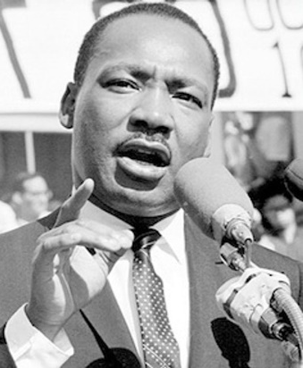
Why did he campaign?
What were his religious influences?

How did he campaign?
Where was he from?
What were his religious influences?
Who is this?
What did he campaign for?
Why did he campaign?

