Sikhism: The Harmandir Sahib

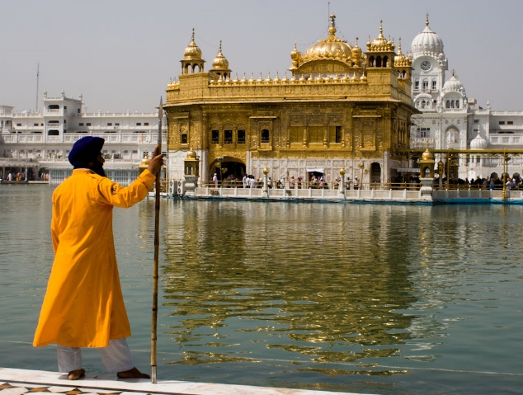
There is no religious requirement to go on pilgrimage in Sikhism, however many Sikhs visit a famous historic gurdwara in Amritsar (Punjab, India). This is the Harmandir Sahib (also known as the Golden Temple).
Guru Arjan, the fifth Guru, designed the original gurdwara (in 1604). This was destroyed during the eighteenth century. In the early 19th century, the Harmandir Sahib was rebuilt and the upper part of the building was covered with gold. This is why it is referred to as the Golden Temple.
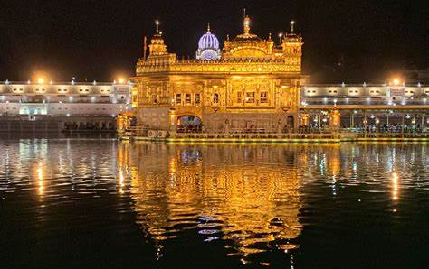
The Harmandir Sahib is significant because it housed the Sikhs’ holy book, the Adi Granth, when it was completed in 1604. Later on, Guru Gobind Singh added to the Adi Granth the compositions by his father, Guru Tegh Bahadur. The original copy of the Guru Granth Sahib rests on a throne beneath a velvet canopy decorated with silver and gold thread. The holy book is read out continuously, with each complete reading of the entire Adi Granth taking 48 hours. Sikhs see their holy book as a living Guru.
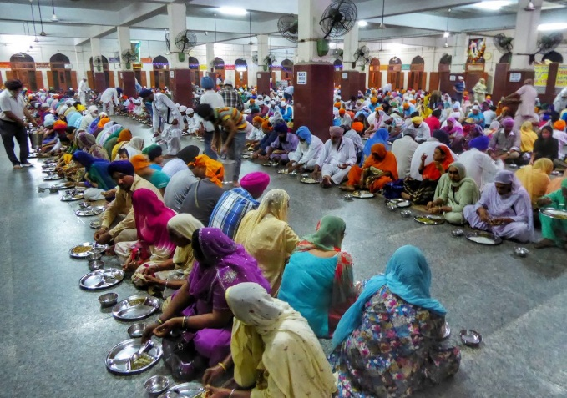
The design of the Harmandir Sahib is important. There are four doors which mark four entrances to the temple. This symbolises the Sikh belief in equality and their view that all people are welcome into their holy place. The building is surrounded by a large rectangular lake. It was this pool of amrit (holy water) which gave the city of Amritsar its name. The Gurdwara also has the world’s largest community kitchen (langar), serving over 100,000 daily and up to 600,000 on weekend days. The meal served is a free, vegetarian and available to anyone. People sit on the floor, together as a sign of equality. To help in the langar is seen as an honour as it is putting the Sikh belief of serving others into action.
Questions – Explain your answers…

1.The Harmandir Sahib has the worlds biggest what?
2. Approximately, how many visitors are there to the Temple on a weekend day?
3. Why are there four entrances to the Temple?
4. What do Sikhs give if they cannot afford to donate money?
5. Who can eat in the Langar?

