

Ten Gurus - Background.

After Guru Nanak there were 9 more human Gurus. Each made a contribution to the Sikh religion. Nanak gave his follower Lehna the name ‘Angad’ which means part of me. He became Nanak’s successor. Sometimes the other Gurus called themselves Nanak to show they were guided by the same spirit.

**Sikhism: Wise Words - Ten Gurus**

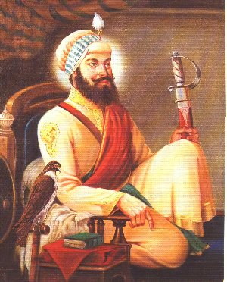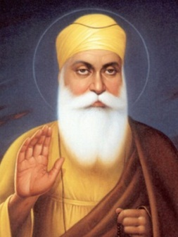

Guru Har Gobind He wore two swords, one representing spiritual power, the other representing political power. He built a fort in Amritsar and he helped the poor.

Guru Nanak The founder of the Sikh faith. He called his followers Sikhs as this meant ‘learner or ‘disciple’. He believed all people were equal.

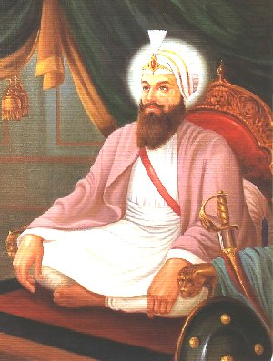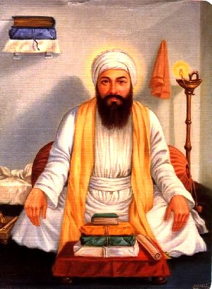

Guru Har Rai He was a gentle man who tried to live in peace. He set up three centres for the teaching of the Sikh faith.

Guru Angad His greatest contribution was to collect Guru Nanak’s songs and make them easier to understand by writing them in the Gurmurkhi script.

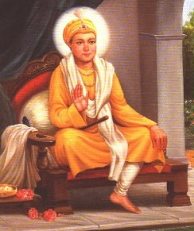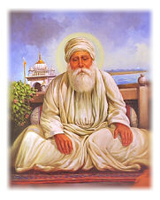

Guru Har Krishan He was 5 years old when he became Guru. He was young but was very good at explaining the scriptures. He cared for the sick and died of small pox.

Guru Amar Das He said everyone should eat together to show their equality. He introduced the Langar – the communal kitchen where anyone can have a meal.

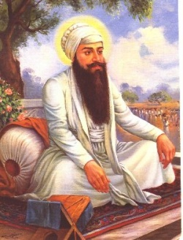

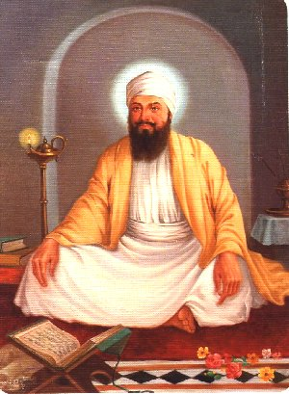

Guru Tegh Bahadur The first Sikh martyr. Sikhs were being persecuted and being forced to give up their faith. Guru Tegh Bahadur refused and he was beheaded.

Guru Ram Das He spread Sikhism by sending people far and wide to teach about the faith. He also set up the city of Amritsar, now the centre of the Sikh faith.

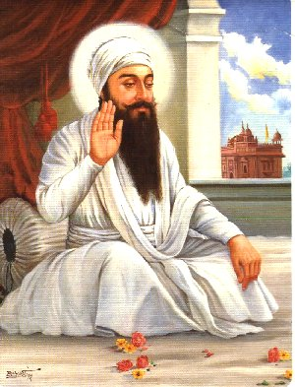

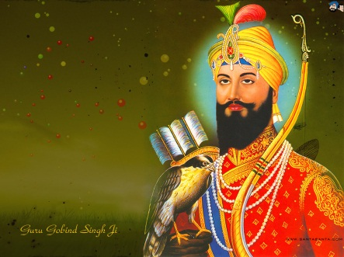

Guru Gobind Singh The Last Human Guru. He gave Sikhs their identity, the 5Ks, and set up the Khalsa, the Sikh brotherhood. He said the Holy Book was now their Guru.

Guru Arjan Dev He had the Golden Temple built in Amritsar. He also collected all the hymns written by the other Gurus and this became the Adi Granth – the Sikh Holy book.



Ten Gurus – Things to do.

1. Either draw pictures or use the pictures to not down the main achievements of each of the Gurus.
2. All the Gurus had ‘wise words’. Choose three Gurus and write down a word for each that describes a good quality they taught. Give reasons for your choices.
3. Think back to the starter task – Match a Guru up to each of the beliefs you identified. Choose the Guru that is most closely identified with that belief and give your reasons.

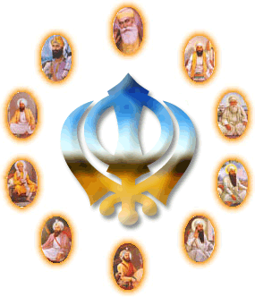Each of the Gurus were inspirational leaders. They all upheld and practiced the teachings of Guru Nanak. Sikhs believe;

* That everyone is equal
* In the importance of family life
* In working hard to improve life
* In worshipping one God
* In helping people
* In friendship – to treat each other as ‘brother’ and ‘sister’.

Extension Questions;



Prioritise these beliefs. Which do you think is the most important? Which is the least important?

Explain your choices.

Do you think some of these beliefs are of benefit to others? Explain your answer.

Review.

Write an equation to sum up the lesson. The beginning and end should be as follows;

Guru Nanak x ? + ? + ? + ? = Sikhism

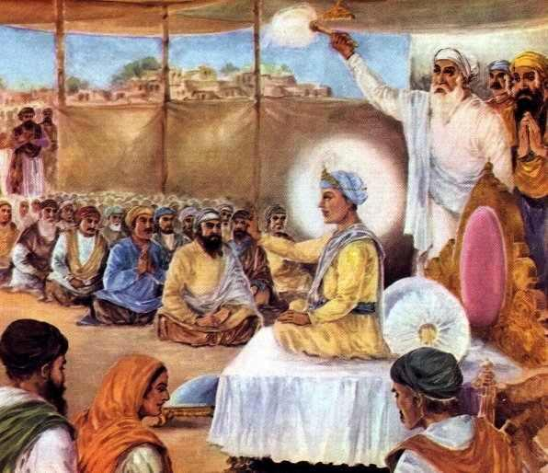







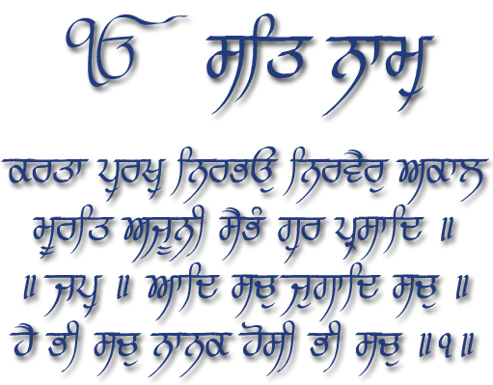







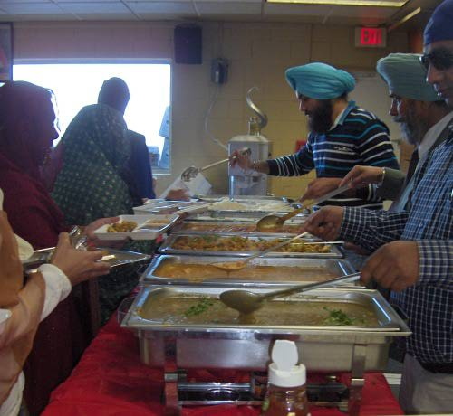

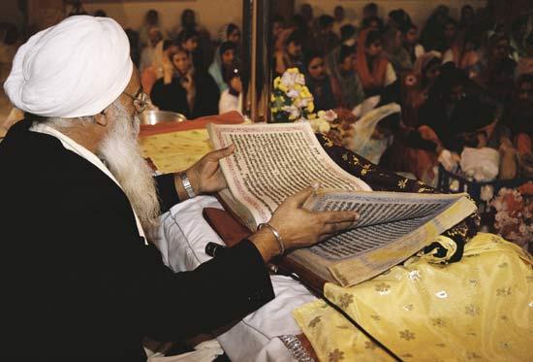



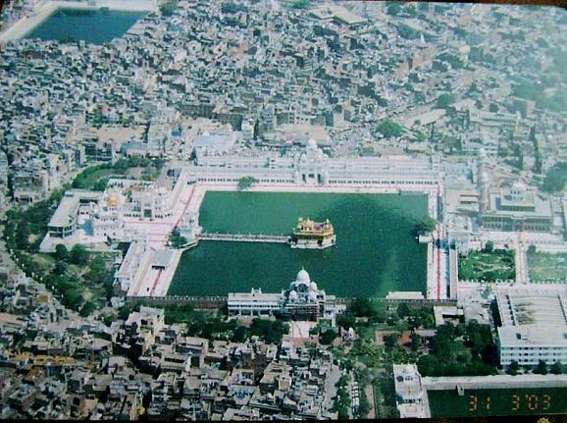

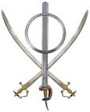



This Symbolises _________________________. Guru __________________ said everyone is ____________________ and he showed this by _______________________________________________________________________.



This Symbolises the belief that __________ is __________. Guru

___________________ _______________ told the Sikhs to wear a kara (bangle) to symbolise this belief.



This Symbolises the belief that Sikhs should _______________ __________ ________________. Guru _________ ____________________ showed this belief by ______________________________________________ _______________________________________________________________________.



This Symbolises _________________________. Guru __________________ said everyone is ____________________ and he showed this by _______________________________________________________________________.



This Symbolises the belief that __________ is __________. Guru

___________________ _______________ told the Sikhs to wear a kara (bangle) to symbolise this belief.



This Symbolises the belief that Sikhs should _______________ __________ ________________. Guru _________ ____________________ showed this belief by ______________________________________________ _______________________________________________________________________.