

The Case of the Disappearing Man.

Guru Nanak - Background.

Guru Nanak was born in 1439 in Northern India. He became the founder of the Sikh faith. He was the son of high caste Hindu parents and as such was expected not to mix with people of lower castes or with Muslims. However his best friends were Mardana, a Muslim and Bala, a low-caste Hindu. At the time India was in a state of unrest – many of the Hindu rulers had been replaced by Muslims. In Nanak’s hometown, the Muslim leader was very much respected. Nanak’s background would have a strong influence on the rest of his life.

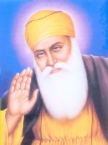

Nanak’s Vision.

*Nanak and his friend Mardana are by the river bank in Sultanpur. It is early morning.*

Mardana, I am going for a swim, please look after my clothes.

Yes, but don’t be too long.

*Nanak dives into the water and disappears.*

Nanak, where are you*? (He runs up and down the river bank)*

*When a couple of hours had gone by Mardana was beginning to panic. He picked up*

*Nanak’s clothes and hurried back to his sister’s house.*

*(anxiously)* What is it Mardana? Where is my brother?

I don’t know mistress Nanaki, he just disappeared into the water. I called and called but he

didn’t come.

*Nanaki calls her husband, Ram and they run to the river. They find nothing. The call the*

*governor of Sultanpur and he sends men to drag the river. Three days later Mardana,*

*Nanaki, Nanak’s father Kalu, his mother, Tripta his wife and many of his friends were*

*standing by the river as it was searched.*

*(coming up to them)* there’s nothing there.

I can’t believe my son would play a trick on us all like this.

*(sharply)* of course he wouldn’t father.

He’s been found. Nanak is alive!

Where is he? Just wait till I …

Kalu, our son is alive. Come, dear. *(she takes Kalu by the arm and leads him away*

He’s in the market place, dressed in strange clothes.

*Nanak was sitting in the market place on a stone seat. Kalu rushes forward but Mardana and*

*Nanaki get there first. Nanak stares at them but does not appear to see them.*

*(gently)* Nanak, are you alright?

*(softly)* There is no Hindu, there is no Muslim.

*(impatiently)* What nonsense is he saying?

*(quietly)* I think he has had a vision of some kind.

He’s wearing Holy men’s clothes. Both Hindu and Muslim.

I have had a vision of God. I shall leave here soon and begin my work as a Guru. I

have so much to teach about God to Hindus and Muslims. They are both equal

before God.

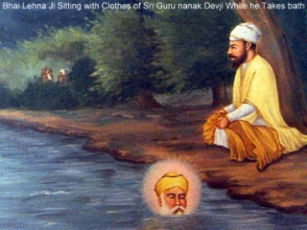

Nanak

Mardana

Mardana

Nanaki

Mardana

Ram

Kalu

Tripta

Ram

Kalu

Tripta

Ram

Nanaki

Nanak

Kalu

Nanaki

Mardana

Nanak

Questions.

1. Why do Buddhists feel the need to take ‘refuge’?

2. Who are Bhikkus and Bhikkunis and where do they live?

3. Why do you think some Buddhists want to make a public demonstration of their commitment and others don’t? Try to give different reasons for your answer.

Questions.

1. Why do Buddhists feel the need to take ‘refuge’?

2. Who are Bhikkus and Bhikkunis and where do they live?

3. Why do you think some Buddhists want to make a public demonstration of their commitment and others don’t? Try to give different reasons for your answer.

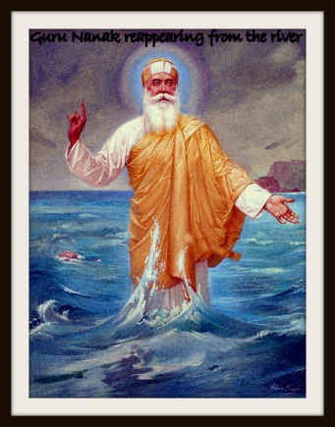

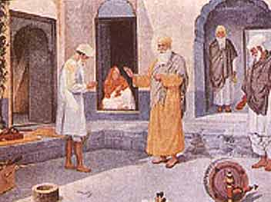



The Case of the Disappearing Man – Guru Nanak.

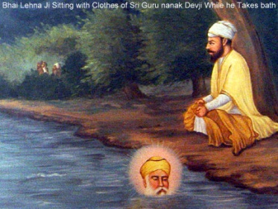[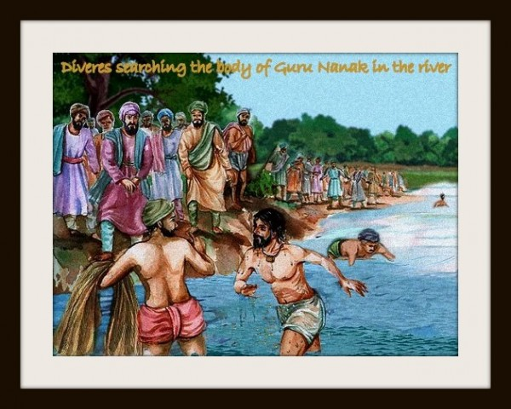](http://sikhgurusandgurdwaras.info/wordpress/?attachment_id=1366)

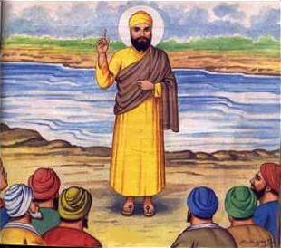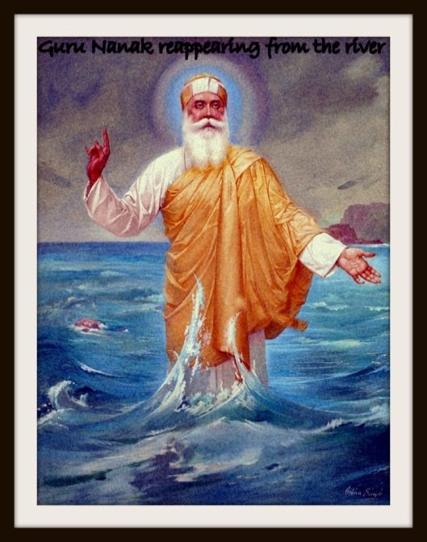

My symbol to represent the meaning of Guru Nanak’s teaching.



The Case of the Disappearing Man – Guru Nanak.

[](http://sikhgurusandgurdwaras.info/wordpress/?attachment_id=1366)

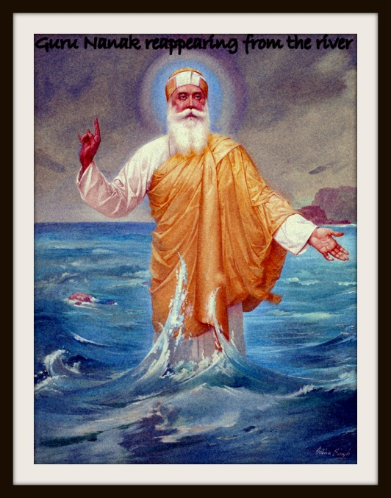

My symbol to represent the meaning of Guru Nanak’s teaching.

Guru Nanak – Beliefs and Symbols.

When Nanak became a Guru he gave people who wished to hear his teachings three golden rules;

* That all people are equal in the sight of God
* That Sikhs should accept one God
* That people should work hard and share their earnings with the poor.

In Guru Nanak’s time India was in a state of war. Many people were not ready to listen to Guru Nanak’s teachings some people were very hostile to the man who was saying that all people were equal. This put Nanak and his followers in danger. They believed the teachings of their new faith were very important and were prepared to defend themselves and their faith with force if absolutely necessary.

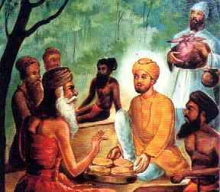

The Khanda .

The Khanda is the symbol of Sikhism. It represents their beliefs about God and that they will defend their faith.

* The circle symbolises that God is one and he is eternal – never ending.
* The double edged sword symbolises the almighty power of God.
* The curved swords (kirpans) symbolise the duty to defend their faith and to teach.

[](http://www.google.co.uk/imgres?imgurl=http://upload.wikimedia.org/wikipedia/commons/1/1d/Khanda_Dark_Red_Chiselled.jpg&imgrefurl=http://en.wikipedia.org/wiki/File:Khanda_Dark_Red_Chiselled.jpg&usg=__FHGgsB81jvRgB8ZzmCBTDSfSLDE=&h=1650&w=1450&sz=213&hl=en&start=2&zoom=1&tbnid=e14-Z_FtQgb3UM:&tbnh=150&tbnw=132&ei=S0XwUNHiKpKRhQfa1oHIAQ&prev=/search?q=khanda&num=10&hl=en&safe=vss&tbo=d&biw=1280&bih=929&sout=1&site=imghp&tbm=isch&itbs=1)





Things to do.

1. Note down Guru Nanak’s three golden rules for his followers.
2. Explain how these rules might have been different to what people were used to and believed before Guru Nanak came along.
3. Draw the Khanda. Label each part of it and explain what each part symbolises.
4. Explain why you think it was important for Sikhs to defend their faith in Guru Nanak’s time.

Independent Learning.

Design persuasive posters asking people to go to a public speaking by Guru Nanak. Include the following;

* Sikh beliefs;
* Sikh symbols and pictures;
* How following Sikhism will benefit converts and other people.

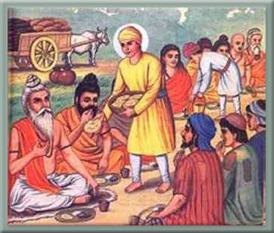





Independent Learning.

Design persuasive posters asking people to go to a public speaking by Guru Nanak. Include the following;

* Sikh beliefs;
* Sikh symbols and pictures;
* How following Sikhism will benefit converts and other people.



Independent Learning.

Design persuasive posters asking people to go to a public speaking by Guru Nanak. Include the following;

* Sikh beliefs;
* Sikh symbols and pictures;
* How following Sikhism will benefit converts and other people.

Independent Learning.

Design persuasive posters asking people to go to a public speaking by Guru Nanak. Include the following;

* Sikh beliefs;
* Sikh symbols and pictures;
* How following Sikhism will benefit converts and other people.

Independent Learning.

Design persuasive posters asking people to go to a public speaking by Guru Nanak. Include the following;

* Sikh beliefs;
* Sikh symbols and pictures;
* How following Sikhism will benefit converts and other people.

Independent Learning.

Design persuasive posters asking people to go to a public speaking by Guru Nanak. Include the following;

* Sikh beliefs;
* Sikh symbols and pictures;
* How following Sikhism will benefit converts and other people.