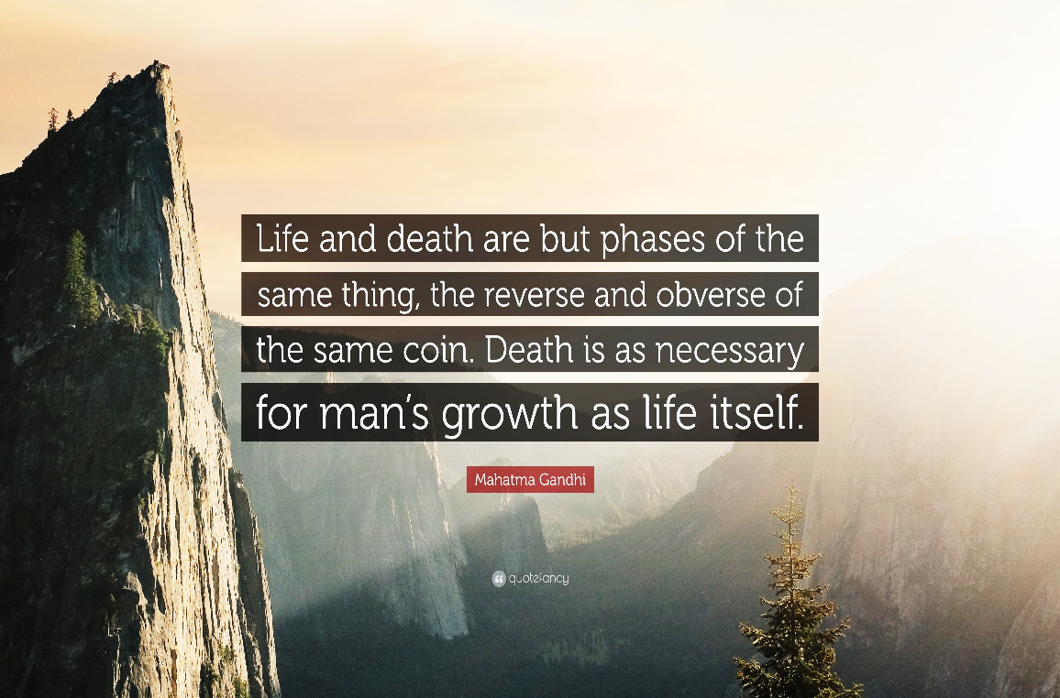

**3**

**1**

**Hinduism – Was Gandhi wise?**

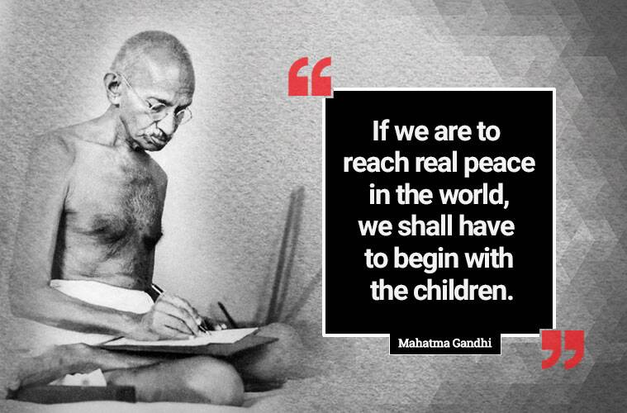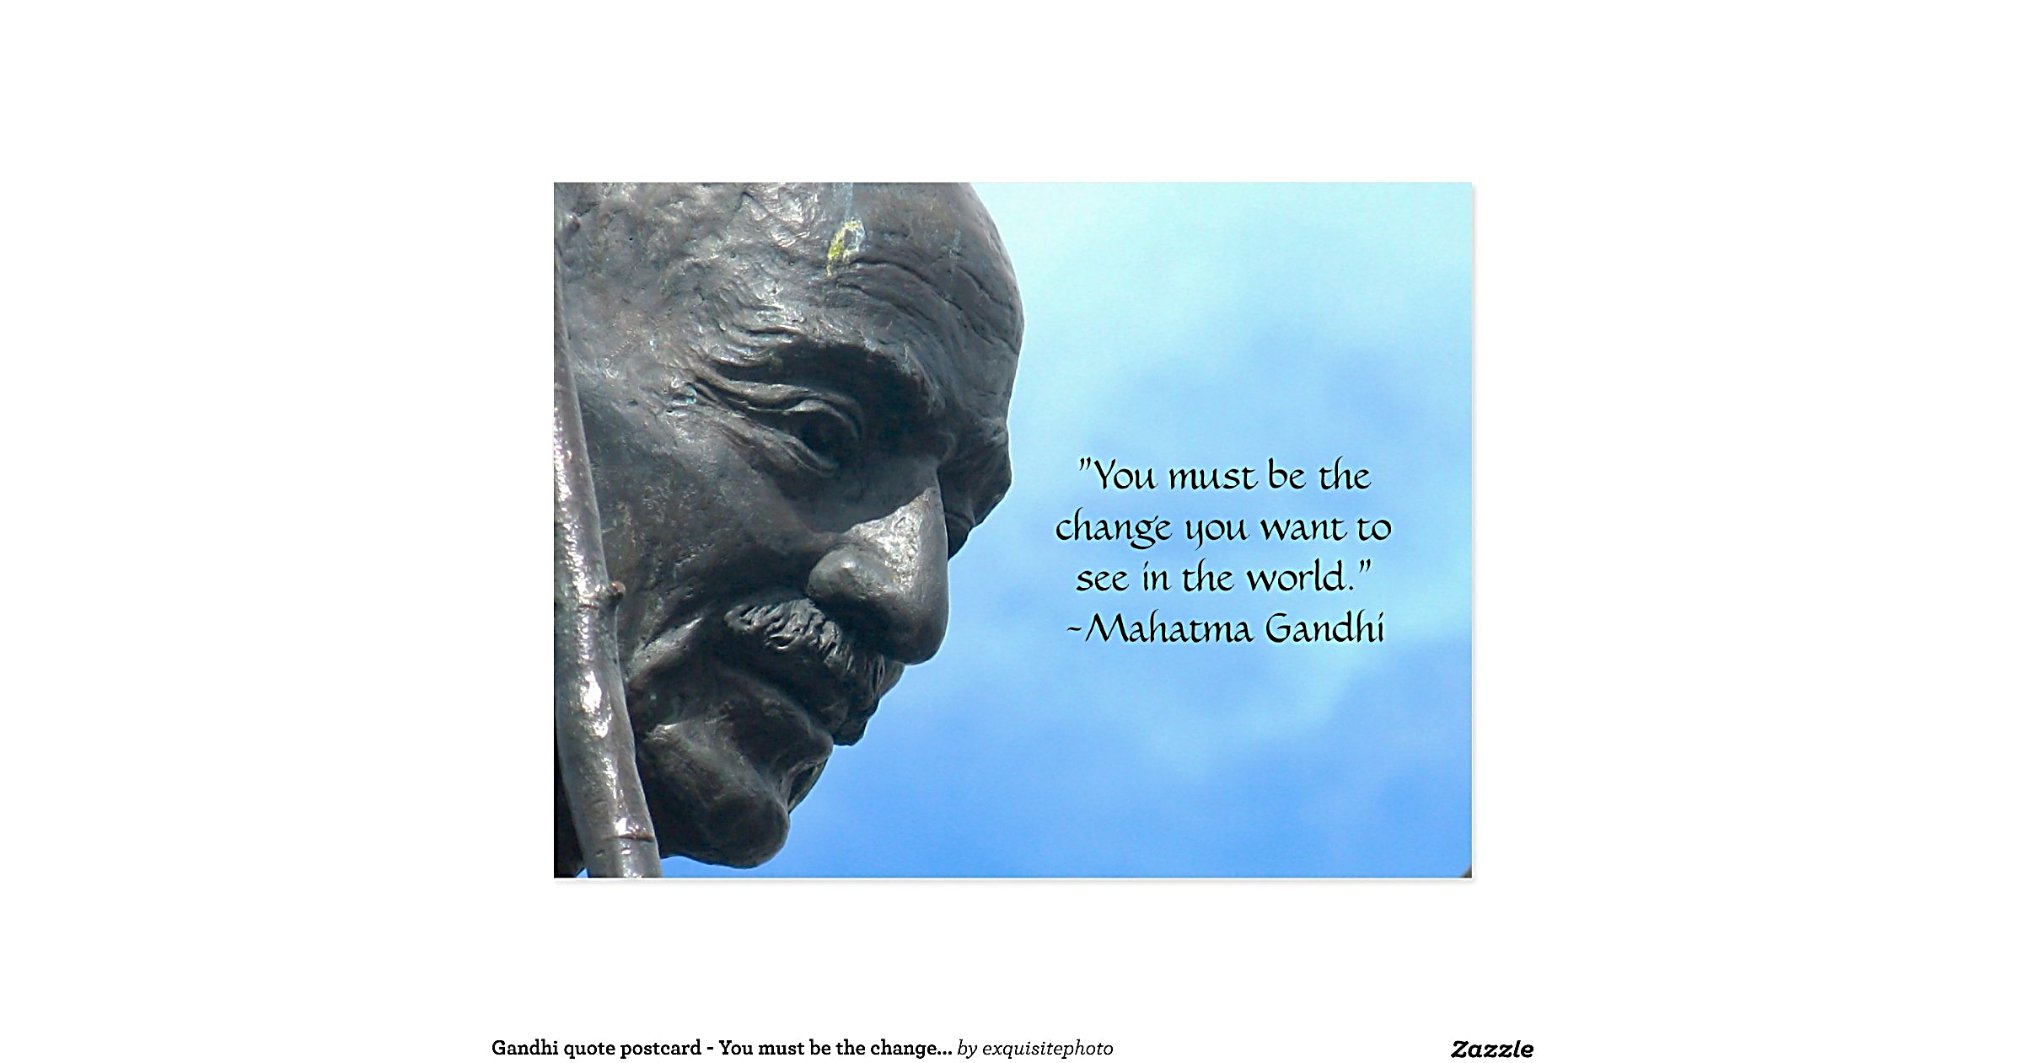

**2**

**4**

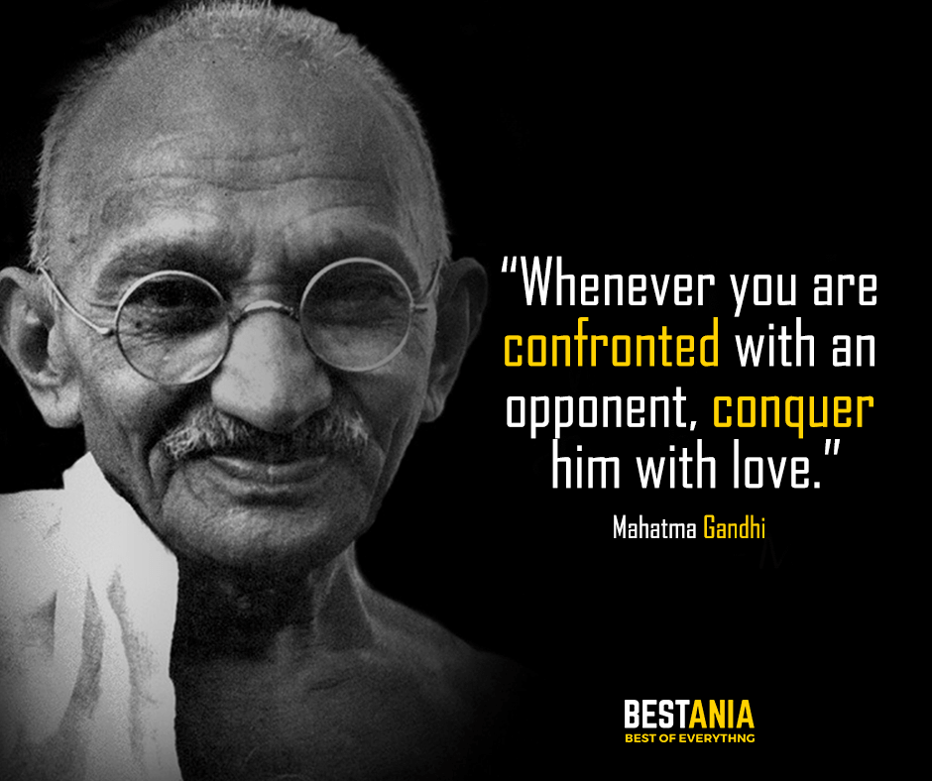

*Explain what you think each of these quotations by Gandhi mean.*

1.

2.

3.

4.

**Hinduism – Was Gandhi wise?**



**3**

**1**



**2**

**4**



*Explain what you think each of these quotations by Gandhi mean.*

1.

2.

3.

4.



[Mahatma Gandhi and India's Struggle for Independence - Bing video](https://www.bing.com/videos/search?q=Gandhi+for+Kids&&view=detail&mid=6BEA861AE999674AC2506BEA861AE999674AC250&&FORM=VRDGAR&ru=%2Fvideos%2Fsearch%3Fq%3DGandhi%2Bfor%2BKids%26FORM%3DRESTAB)