Gandhi – A Great Soul.
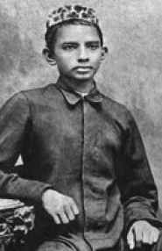
- What is Gandhi known for?

- What did Gandhi and his supporters never use during their campaigns?

- What was the focus of Gandhi’s leadership?

- What does ‘Mahatma’ mean?

- As a Hindu, born in India, what were some of Gandhi’s main beliefs?

- Where did Gandhi go to university to become a lawyer?

- Where did Gandhi go to work as a lawyer in 1893?

- What did Gandhi learn more about during his time in South Africa?

- What did Gandhi free himself from at this time?

- What did Gandhi first experience in South Africa, e.g. in the courtroom and on the trains?

- How were his experiences in South Africa a ‘turning point’ for Gandhi?

- What is ‘satiagraha’?

- Where did Gandhi and his family return to in 1915?

- What to over 400 Indian people in Amritsar in 1919?

- By 1920 Gandhi had become the most important campaigner for what?

- How did Gandhi campaign? Give at least two examples.

- What was the famous protest Gandhi led in 1930 called and what was the protest campaigning against?

- How did the new, 1945 Labour government change things for India?

- What were some of the consequences of this change?

- How did Gandhi campaign about violence after 1947?

- What happened to Gandhi in 1948?

