The Bhagavad Gita – ‘Song of God’.

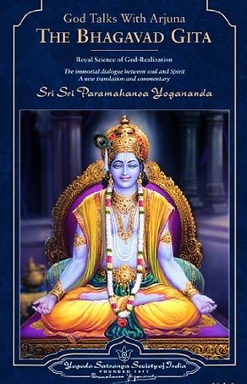
The Bhagavad Gita is a central Hindu scripture and includes guidance for worshippers. It explains that Hindu worship should focus on God:

Whenever and wherever the restless and unsteady mind wanders, one should bring it back and continually focus it on God. Bhagavad Gita 6.26

Another passage shows that Hindus (who are referred to as yogis in the quote) should worship God as the Supreme Being. This passage also says that God is within all things:

The yogi who is established in union with me, and worships me as the Supreme Soul residing in all beings, dwells only in me, though engaged in all kinds of activities. Bhagavad Gita 6.31.

This idea that God can be found everywhere allows Hindus to worship in a variety of ways. For example, they can worship through yoga practice, through nature, through acts of kindness and through being mindful that God is everywhere and everything.

The Bhagavad Gita is part of the sixth book of the Mahabharata, the world's longest poem (it has over 100,000 verses!). Composed between 500 BCE and 100 CE, the Mahabharata is an account of the wars of the house of Bharata. It is one of the most popular Hindu texts and has an important place within the Hindu tradition.

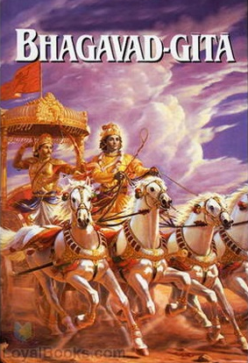
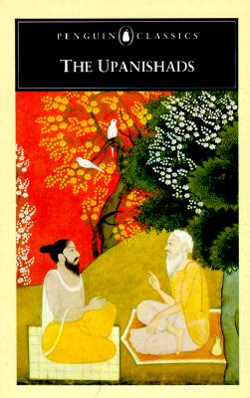
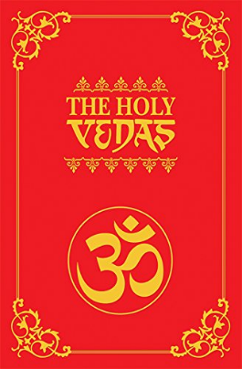
The Bhagavad Gita takes the form of a dialogue between prince Arjuna and Krishna, his charioteer. Arjuna is a warrior, about to join his brothers in a war between two branches of a royal family which would involve killing many of his friends and relatives. He wants to withdraw from the battle but Krishna teaches him that he, Arjuna, must do his duty in accordance with his class and he argues that death does not destroy the soul. Krishna points out that knowledge, work and devotion are all paths to salvation and that the central value in life is that of loyalty to God.
Note down…

4 facts about Hinduism.
3 Hindu scriptures.
2 facts about the Vedas.
1 fact about the Upanishads.

Hinduism.

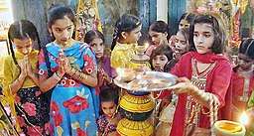
The Hinduism is the oldest of the six major world religions. It has no single founder but developed gradually over a period of time.

Hinduism has over 1 billion followers worldwide, with about 95% of Hindus living in India. At the time of the 2011 census, there were over 800,000 Hindus living in the UK.
Three Holy Books...

The Vedas
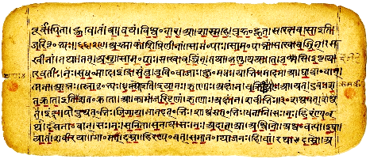
These are the most ancient religious texts which define truth for Hindus. They were introduced to India their present form between 1200-200 BCE. Hindus believe that the texts were received by scholars directly from God and passed on to the next generations by word of mouth. Vedic texts are sometimes called shruti, which means hearing, for hundreds, maybe even thousands of years, the texts were passed on orally. The Vedas include hymns of praise to God, worship rituals and prayers to guide the priests in their duties, meditations, mystical and philosophical teachings of Hinduism.

The Upanishads

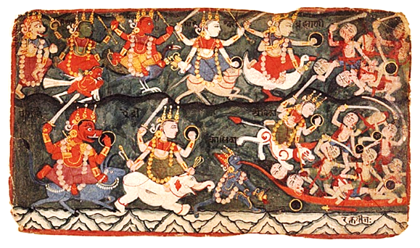
The Upanishads were so called because they were taught to those who sat down beside their teachers. (upa=near, ni=down, shad=sit).

The major Upanishads were largely composed between 800-200 BCE and are partly prose, partly verse. Later Upanishads continued to be composed right down to the 16th century. Originally they were in oral form.
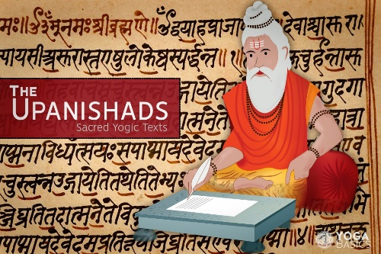
Central to the Upanishads is the concept of brahman; the sacred power which informs reality.

Whilst the priests (brahmins) had previously been the ones who, through rituals, restricted access to the divine, now the knowledge of the universe was open to those of the high and middle castes willing to learn from a teacher.

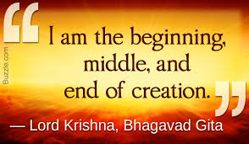
Hinduism – The Bhagavad Gita.

This quotation is about… _______________.

It means that … _________________________________

_______________________________________________

_______________________________________________

This quotation is about… _______________.

It means that … _________________________

__________________________________________

_______________________________________________

This quotation is about… __________________.

It means that … ____________________________

__________________________________________

_______________________________________________

This quotation is about… _______________________.

It means that … ________________________________

_______________________________________________

_______________________________________________

Hinduism – The Bhagavad Gita.

This quotation is about… _______________.

It means that … _________________________________

_______________________________________________

_______________________________________________

This quotation is about… _______________.

It means that … _________________________

__________________________________________

_______________________________________________

This quotation is about… __________________.

It means that … ____________________________

__________________________________________

_______________________________________________

This quotation is about… _______________________.

It means that … ________________________________

_______________________________________________

_______________________________________________

