Martin Luther King, Jr.: The ‘Mountaintop’ Speech April 3rd 1968.

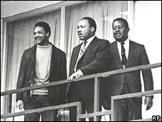
Something is happening in Memphis. Something is happening in our world. And you know, if I were standing at the beginning of time, with the possibility of taking a kind of general and panoramic view of the whole of human history up to now, and the Almighty said to me, “Martin Luther King, which age would you like to live in?”
Strangely enough, I would turn to the Almighty, and say, “If you allow me to live just a few years in the second half of the 20th century, I will be happy.”

Now that’s a strange statement to make, because the world is all messed up. The nation is sick. Trouble is in the land. Confusion all around. That’s a strange statement. But I know, somehow, that only when it is dark enough can you see the stars. And I see God working in this period of the twentieth century in a way that men, in some strange way, are responding.
Something is happening in our world. The masses of people are rising up. And wherever they are assembled today, whether they are in Johannesburg, South Africa; Nairobi, Kenya; Accra, Ghana; New York City; Atlanta, Georgia; Jackson, Mississippi; or Memphis, Tennessee – the cry is always the same: “We want to be free.”

Another reason that I’m happy to live in this period is that we have been forced to a point where we are going to have to grapple with the problems that men have been trying to grapple with through history. Survival demands that we grapple with them. Men, for years now, have been talking about war and peace. But now, no longer can they just talk about it. It is no longer a choice between violence and nonviolence in this world; it’s nonviolence or nonexistence.

Now, what does all of this mean in this great period of history? It means that we’ve got to stay together. We’ve got to stay together and maintain unity. You know, whenever Pharaoh wanted to prolong the period of slavery in Egypt, he kept the slaves fighting among themselves. But whenever the slaves get together, that’s the beginning of getting out of slavery. Now let us maintain unity.

You know, it’s possible that the priest and the Levite looked over that man on the ground [Parable of the Good Samaritan] and wondered if the robbers were still around, or it’s possible that they felt that the man on the ground was merely faking and he was acting like he had been robbed and hurt in order to seize them over there, lure them there for quick and easy seizure. So the first question that the priest asked, the first question that the Levite asked, was, “If I stop to help this man, what will happen to me?” But then the Good Samaritan came by and he reversed the question. “If I do not stop to help this man, what will happen to him?”

Then I got into Memphis and some began to say the threats, or talk about the threats that were out, what would happen to me, from some of our sick white brothers. Well, I don’t know what will happen now. We’ve got some difficult days ahead.
Like anybody, I would like to live a long life. But I’m not concerned about that now. I just want to do God’s will, and He’s allowed me to go up to the mountain. I’ve looked over and I’ve seen the Promised Land. I may not get there with you, but I want you to know tonight that we as a people will get to the Promised Land!
So I’m happy tonight. I’m not worried about anything. I’m not fearing any man. Mine eyes have seen the glory of the coming of the Lord!

Martin Luther King, Jr.: ‘I Have a Dream’ Speech. August 28th 1963.
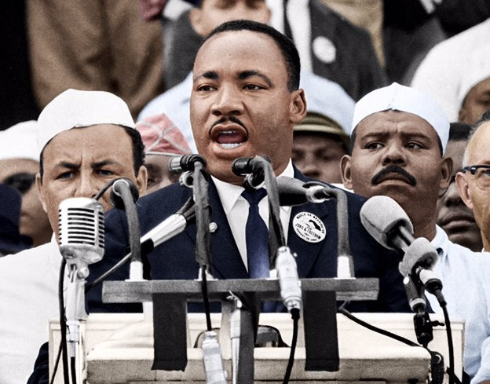
I am happy to join with you today in what will go down in history as the greatest demonstration for freedom in the history of our nation.

Five score years ago, a great American in whose symbolic shadow we stand today, signed the Emancipation Proclamation. This momentous decree came as a great beacon light of hope to millions of Negro slaves, who had been seared in the flames of withering injustice. It came as a joyous daybreak to end the long night of their captivity, but 100 years later, the Negro still is not free. 100 years later, the life of the Negro is still sadly crippled by the manacles of segregation and the chains of discrimination.

I am not unmindful that some of you have come here out of great trials and tribulations. Some of you have come fresh from narrow jail cells. Some of you have come from areas where your quest for freedom left you battered by the storms of persecution and staggered by the winds of police brutality. You have been the veterans of creative suffering. Continue to work with the faith that honour and suffering is redemptive. Go back to Mississippi, go back to Alabama, go back to the slums and ghettos of our northern cities, knowing that somehow this situation can and will be changed. Let us not wallow in the valley of despair. I say to you today, my friend, so even though we face the difficulties of today and tomorrow, I still have a dream. It is a dream deeply rooted in the American dream. I have a dream that one day this nation will rise up and live out the true meaning of its creed, “We hold these truths to be self-evident that all men are created equal.”

I have a dream that one day on the red hills of Georgia, the sons of former slaves and the sons of former slave owners will be able to sit down together at the table of brotherhood. I have a dream that one day, even the state of Mississippi, a state sweltering with the heat of injustice, sweltering with the heat of oppression, will be transformed into an oasis of freedom and justice. I have a dream that my four little children will one day live in a nation where they will not be judged by the colour of our skin, but by the content of that character. I have a dream today.

I have a dream that one day down in Alabama with its vicious racists, with its governor having his lips dripping with the words of interposition and nullification, one day right there in Alabama, little black boys and black girls will be able to join hands with little white boys and white girls as sisters and brothers. I have a dream today.

I have a dream that one day the rough places will be made plain and the crooked places will be made straight and the glory of the Lord shall be revealed and all flesh shall see it together. This is our hope. This is a faith that I go back to the South with. With this faith, we will be able to transform the jangling discords of our nation into a beautiful symphony of brotherhood. With this faith, we will be able to work together, to pray together, to struggle together, to go to jail together, to stand up for freedom together, knowing that we will be free one day.

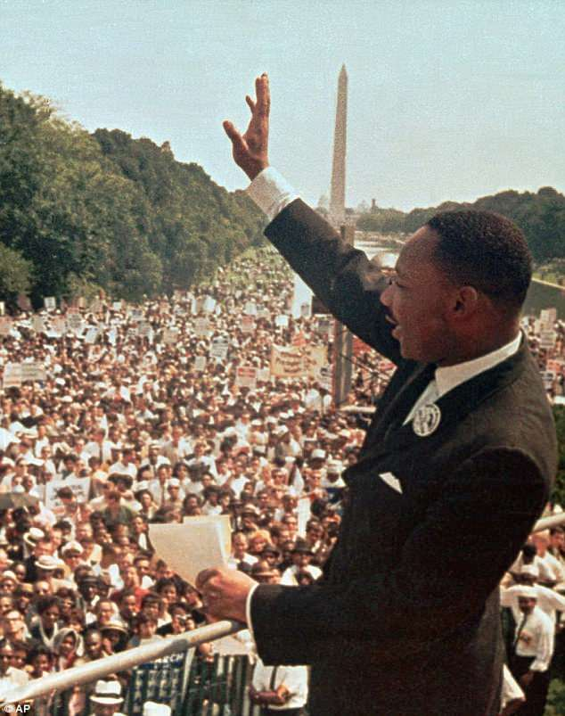
So let freedom ring from the mighty mountains of New York. Let freedom ring from the snow-capped Rockies of Colorado. But not only that, let freedom ring from Stone Mountain of Georgia. Let freedom ring from every hill and molehill of Mississippi. From every mountainside, let freedom ring, and when this happens, when we allow freedom ring, when we let it ring from every village and every hamlet, from every state and every city, we will be able to speed up that day when all of God’s children, black men and white men, Jews and gentiles, Protestants and Catholic, will be able to join hands and sing in the words of the old Negro spiritual, Free at last! Free at last! Thank God Almighty, we are free at last!
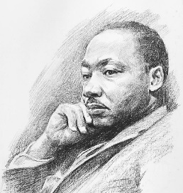
Martin Luther King Jr.: ‘I Have a Dream’ Speech. August 28th 1963.

- How does MLK make links between past and present (in 1963) attitudes to Black people in the USA?

- Note down some of the problems faced by Black people in the USA at this time?

- Note down three ‘dreams’ MLK had.

- What was MLK’s ultimate dream?

- Note down links between beliefs taught in the Bible and this speech.

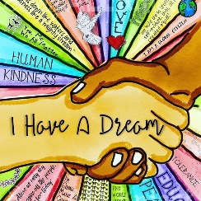
Martin Luther King Jr.: The ‘Mountaintop’ Speech April 3rd 1968.

- Give two reasons why it is surprising that MLK was ‘happy’ to be living in the second half of the 20th century.

- Why does he see ‘God working in the …20th century’?

- Why are unity and non-violence important when campaigning for change?

- What did the Parable of the Good Samaritan suggest to MLK in this context?

- What do the quotations, ‘I’ve seen the Promised Land’ and ‘but I may not get there with you’, suggest about how MLK saw the future?

- What happened to MLK the day after this speech? How does this link to his speech?

Reflections on MLK’s speeches.

Making links…

Identify and explain links between MLK’s speeches and the parables of Jesus you looked at last lesson. Consider the meaning of the parables, the moral ideas displayed in the parables and the speeches and the events at the time of MLK’s speeches and the attitudes of people in the parables.

Was MLK wise?

What can we learn from MLK’s speeches? Consider what he believed about we should treat each other and how we should behave. Were these good ideas? Explain what you think.

Making links…be artistic!

Create an artwork (of any kind) that shows how MLK was inspired by his Christian beliefs. Use words and pictures in your design.

Where did MLK live? | How did he campaign? | What did he campaign for?
Why was he referred to as ‘Rev. MLK Jr.? | What were MLK’s influences? | How were Black people treated in the USA in the 1950’s?
What major prize did MLK win? | Who were MLK’s influences? | What is the title of one of MLK’s speeches?
Martin Luther King – What do I already know?
Martin Luther King – What do I already know?

Where did MLK live? | How did he campaign? | What did he campaign for?
Why was he referred to as ‘Rev. MLK Jr.? | What were MLK’s influences? | How were Black people treated in the USA in the 1950’s?
What major prize did MLK win? | Who were MLK’s influences? | What is the title of one of MLK’s speeches?

