The Lamp - Matthew 5:14-16

“You are the light of the world. A town built on a hill cannot be hidden. Neither do people light a lamp and put it under a bowl. Instead they put it on its stand, and it gives light to everyone in the house. In the same way, let your light shine before others, that they may see your good deeds and glorify your Father in heaven.

Questions:

- What is meant by ‘your light’? What is your light?
- What good deeds have you done this week? Note down three things.

The Speck and The Log - Matthew 7:1-5

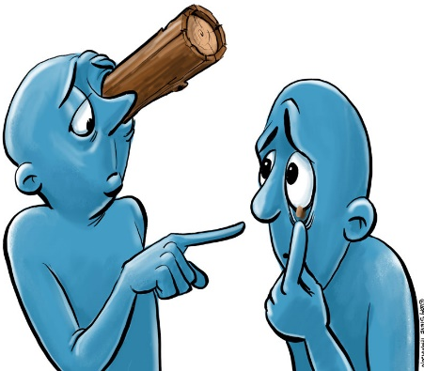
“Do not judge, or you too will be judged. For in the same way you judge others, you will be judged, and with the measure you use, it will be measured to you. “Why do you look at the speck of sawdust in your brother’s eye and pay no attention to the plank in your own eye? How can you say to your brother, ‘Let me take the speck out of your eye,’ when all the time there is a plank in your own eye? You hypocrite, first take the plank out of your own eye, and then you will see clearly to remove the speck from your brother’s eye.

Questions:

- What are the ‘speck of sawdust’ and the ‘plank’ metaphors for?
- What is a hypocrite?
- What is the meaning of this parable?

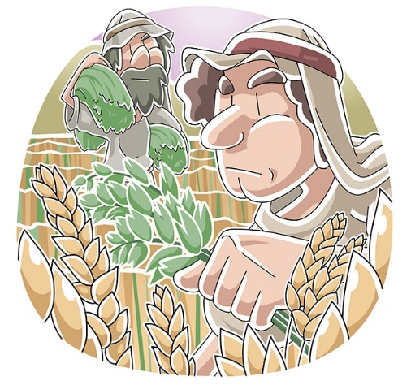
The Weeds Among the Wheat - Matthew 13:24-30

Jesus told them another parable: “The kingdom of heaven is like a man who sowed good seed in his field. But while everyone was sleeping, his enemy came and sowed weeds among the wheat, and went away. When the wheat sprouted and formed heads, then the weeds also appeared. “The owner’s servants came to him and said, ‘Sir, didn’t you sow good seed in your field? Where then did the weeds come from?’

“‘An enemy did this,’ he replied.

“The servants asked him, ‘Do you want us to go and pull them up?’

“‘No,’ he answered, ‘because while you are pulling the weeds, you may uproot the wheat with them. Let both grow together until the harvest. At that time I will tell the harvesters: First collect the weeds and tie them in bundles to be burned; then gather the wheat and bring it into my barn.’”

Questions:

- What are the ‘good seeds’ and the ‘weeds’ metaphors for?
- What is the meaning of this parable?

The Net - Matthew 13:47-50

“Once again, the kingdom of heaven is like a net that was let down into the lake and caught all kinds of fish. When it was full, the fishermen pulled it up on the shore. Then they sat down and collected the good fish in baskets but threw the bad away. This is how it will be at the end of the age. The angels will come and separate the wicked from the righteous and throw them into the blazing furnace, where there will be weeping and gnashing of teeth.

Questions:

- What are the ‘good fish’ and the ‘bad fish’ metaphors for?
- What is the meaning of this parable?
Hidden Treasure - Matthew 13:44

“The kingdom of heaven is like treasure hidden in a field. When a man found it, he hid it again, and then in his joy went and sold all he had and bought that field.

Pearl of Great Price - Matthew 13:45-46

“Again, the kingdom of heaven is like a merchant looking for fine pearls. When he found one of great value, he went away and sold everything he had and bought it.

Questions:

- What are the ‘treasure’ and the ‘pearl’ metaphors for?
- How are these two parables similar?

The Lost Coin - Luke 15:8-10

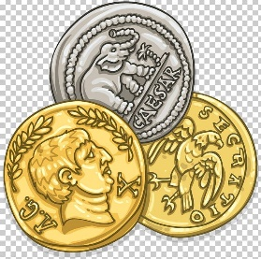
“Or suppose a woman has ten silver coins and loses one. Doesn’t she light a lamp, sweep the house and search carefully until she finds it? And when she finds it, she calls her friends and neighbours together and says, ‘Rejoice with me; I have found my lost coin.’ In the same way, I tell you, there is rejoicing in the presence of the angels of God over one sinner who repents.”

Questions:

- What is the meaning of this parable?
- Why is it important for Christians to believe God rejoices ‘over one sinner who repents’?

The Rich Fool - Luke 12:13-21

Someone in the crowd said to him, “Teacher, tell my brother to divide the inheritance with me.”
Jesus replied, “Man, who appointed me a judge or an arbiter between you?” Then he said to them, “Watch out! Be on your guard against all kinds of greed; life does not consist in an abundance of possessions.”
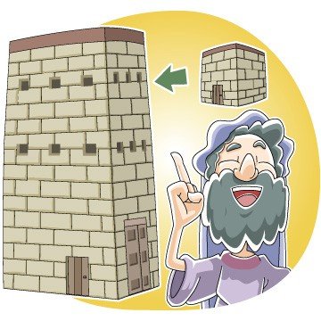
And he told them this parable: “The ground of a certain rich man yielded an abundant harvest. He thought to himself, ‘What shall I do? I have no place to store my crops.’
“Then he said, ‘This is what I’ll do. I will tear down my barns and build bigger ones, and there I will store my surplus grain. And I’ll say to myself, “You have plenty of grain laid up for many years. Take life easy; eat, drink and be merry.”’
“But God said to him, ‘You fool! This very night your life will be demanded from you. Then who will get what you have prepared for yourself?’
“This is how it will be with whoever stores up things for themselves but is not rich toward God.”

Questions:

- What message is Jesus teaching in this parable?
- What negative quality does the man show?
- Why is the man a ‘fool’?
- What should the man have done?

The Invited Guests - Luke 14:7-14

When he noticed how the guests picked the places of honour at the table, he told them this parable: “When someone invites you to a wedding feast, do not take the place of honour, for a person more distinguished than you may have been invited. If so, the host who invited both of you will come and say to you, ‘Give this person your seat.’ Then, humiliated, you will have to take the least important place. But when you are invited, take the lowest place, so that when your host comes, he will say to you, ‘Friend, move up to a better place.’ Then you will be honoured in the presence of all the other guests. For all those who exalt themselves will be humbled, and those who humble themselves will be exalted.”

Then Jesus said to his host, “When you give a luncheon or dinner, do not invite your friends, your brothers or sisters, your relatives, or your rich neighbours; if you do, they may invite you back and so you will be repaid. But when you give a banquet, invite the poor, the crippled, the lame, the blind, and you will be blessed. Although they cannot repay you, you will be repaid at the resurrection of the righteous.”

Questions:

- What does ‘exalt’ mean?
- What does it mean to be ‘humble?
- Why will ‘those who humble themselves be exalted’?
- What is the meaning of the second part of this parable?

