

**Wise Words**

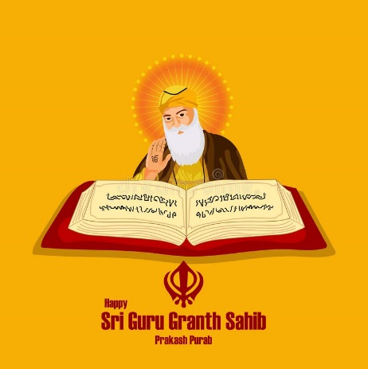



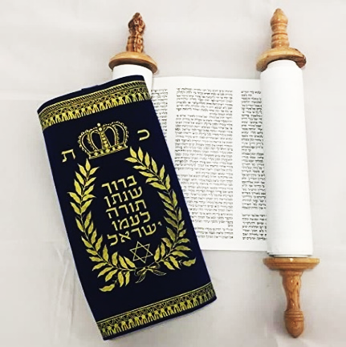

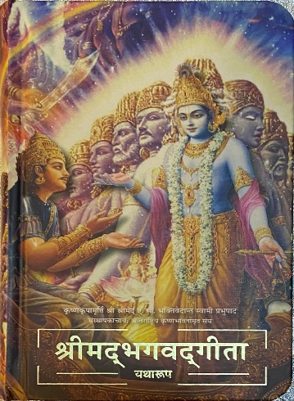

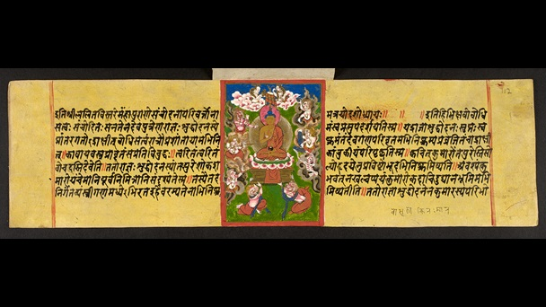

**Torah**

**Bible**

**Qur’an**

**Guru Granth Sahib**

**Dhammapada**

**Bhagavad Gita**

**Torah**

**Bible**

**Qur’an**

**Guru Granth Sahib**

**Dhammapada**

**Bhagavad Gita**

**Torah**

**Bible**

**Qur’an**

**Guru Granth Sahib**

**Dhammapada**

**Bhagavad Gita**