|  |  |  |  |  |  |  |  |  |  |  |  |  |  |  |
| --- | --- | --- | --- | --- | --- | --- | --- | --- | --- | --- | --- | --- | --- | --- |
| B | N | O | E | D | G | K | E | L | R | R | U | L | N | A |
| O | R | O | T | A | E | R | C | A | Y | M | L | E | D | A |
| M | C | L | O | N | B | A | P | T | I | S | M | D | Y | Y |
| Y | A | T | A | N | Q | S | I | T | R | U | M | I | R | T |
| F | L | E | T | U | C | H | E | R | D | A | E | G | A | I |
| H | A | N | I | P | C | A | U | S | E | V | A | U | L | N |
| H | E | N | W | S | O | O | N | I | G | H | E | C | M | I |
| D | A | S | N | C | G | N | A | B | G | I | B | T | I | R |
| S | T | N | E | M | D | N | A | M | M | O | C | N | E | T |

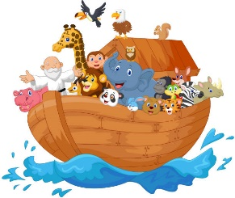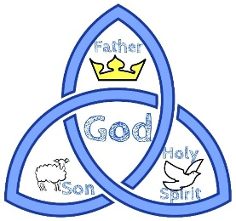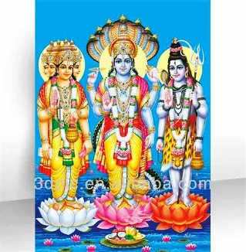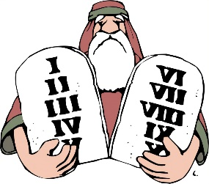

**Picture Clue Review Wordsearch**



