Paley: The Teleological or Argument from design was popularized by me - English Christian philosopher William Paley in the late 1700s, my argument for God’s existence is still around today, too. In fact, it’s one of the most popular, it is also known as Intelligent Design – intelligent – just like me!
Narrator 1: To make your case for the existence of God, you gave us what’s known as an argument by analogy, what does this mean?
Paley: This form of argument invites us to consider a particular state of affairs -- let’s just call it Situation A -- about which we’re already likely to have certain beliefs, and then likens it to Situation B, with which we are less familiar. The idea is that, in the interest of consistency, whatever conclusions we’ve drawn about A, we ought to draw about B as well.
Narrator 1: And in English…?!
Paley: We compare something we know about to something we know less about and assume the same thing about each thing!
Narrator 1: Okay – I think I get that.
Paley: I used my ‘Watchmaker Analogy’ to talk about God. (show Watchmaker card) Imagine what we’d think if we found a watch on the ground. Would we imagine that the watch simply appeared randomly, spontaneously, on its own? Or would we see the complexity of it, and notice that its parts seem to come together in a particular way in order to accomplish a goal? If so, wouldn’t we think that the watch must have been made by someone, on purpose, for a purpose?
Narrator 1: But what on Earth has that got to do with God? Are you saying God made everyone’s watches?!
Paley: No! Don’t be silly! This is where the analogy is important. If we compare the complexity of the watch and understand that the watch had a designer and maker, then compare this to the universe and see how complex that is, the universe must also have a designer and maker. As no human being is big enough and clever enough to design and make the universe, then it must be God! God was the designer, He is the intelligent creator with a particular reason in mind.
Narrator 1: Hang on a minute, you said your argument was also known as Teleological, what does this mean?
Paley: It means goal-oriented, or purposeful – God created the universe with a purpose.
Narrator 1: Hang on a minute, a watch is nothing like the Earth! Can you give me a different analogy?
Paley: Okay let’s look at the complexity of the human body. Heart and lungs working together, transforming food into energy – we’re just generally amazing all around. Look at how elements of the natural world operate sustaining a beautiful, natural harmony. This couldn't possibly just have happened, any more than the design of a pocket watch could just have happened. There must be a designer. Just like the purpose and design of a watch leads us to believe in a watchmaker, the purpose of the world compels us to believe in a worldmaker – God.
Narrator 1: When you put it like that your ‘Design Argument’ a is a fantastic argument. I think I believe in God now! (Show ‘Theist’ card)
Narrator 2: Well, I’m not buying it! (Show ‘Atheist’ card) – like human bodies – are completely different to watches. A watch obviously has a creator. After all, we can take it apart and see clearly how the gears fit together to move the hands and keep time. But there’s so much in the natural world that isn’t understandable in the same way. For instance, why would God have designed our eyes to have a blind spot?
Paley: It doesn’t matter whether we can understand how something was created. The point is simply that it was.
Narrator 1: I think Paley has a good point - I don’t understand the inner workings of my phone, but I still know it had a creator. Whether or not I can understand how it was created is beside the point.
Narrator 2: Mr Paley, you said God created everything with a purpose but some parts of nature seem to be without purpose. A blind spot obviously doesn’t have any function, and neither do nipples on a man!
Paley: Just because we don't know there's a purpose doesn't mean there isn't one.
Narrator 2: But this is a problem, too, because your whole argument for believing in God is that you should look at the world and see purpose. So if we see some things in the world that really seem to have complexity and a definite use, and others that don’t, that’s a flaw in his argument. Also, the absence of any obvious purpose in things can lead people to start searching for purposes and making them up. For instance, I could find a purpose for this finger (Show ‘nose/finger’ card) – I could use it as a nose-picker. It would make a good one – it’s just the right size to really get in there and dig around. But was my finger designed to pick noses? Probably not!
Narrator 1: Oh! When you put it like that… you could also misinterpret purpose - you could look at a bunny (Show ‘bunny’ card) and believe that God gave it a fuzzy white tail so hunters would have something to shoot at and I certainly hope that this is not the purpose of the bunny’s tail!
Narrator 2: Yes, well, the point is: If we're the ones inventing purposes, rather than recognizing ones that are naturally there, then we’re the real creators of purpose in the world, not God. Basically, if you believe that God made eyes for seeing, then you also have to believe that he designed fingers as nose-pickers, and rabbit tails as bullseyes, and blind spots as ways for us to get into car accidents. So the counterargument here is: We don't get to just pick and choose, and say God designed the stuff we want him to have designed, and not the other stuff.
Paley: Hang on a minute! Why are you all having a go at me!? Anyone could make up a false purpose for all sorts of things! I believe God made things that are purposeful, it is part of the mystery of God why he put a cute tail on a rabbit, maybe it was so we found it cute and therefore wouldn’t harm it! Mere humans cannot fully understand everything God does. The idea that things were made with a purpose means that they had to have been put there by an intelligent creator and that must be God.
Narrator 3: But another explanation for how bodies came to have the complexity and functionality we have today, is natural selection and random mutation. We can concede that the existence of a designer-god helped make sense of the origins the our world in a pre-scientific age, but now we have a perfectly good scientific explanation for how the complexity of the world came about. So, who needs a watchmaker when you have evolution by natural selection?
David Hume: Hello everyone, my name is David Hume, I am a Scottish Philosopher from the 18th century. I have an objection to Paley’s design argument. If we’re to take the analogy seriously, we’d need to conclude that this ‘intelligent designer’ that Paley talks about seems to make a lot of mistakes. And not just blind spots. Like, how about hurricanes? (Show Hurricane card) Or why would he make butterflies have to wait for hours, immobile, for their wings dry as soon as they come out of their chrysalis, making them easy prey for predators? The world is chock full of stuff that looks cruel, ridiculous, impractical, and contrary to life. A flawed world implies a flawed creator.
Narrator 3: But what about evolution (Show ‘evolution’ card)? There is evidence to suggest that creatures on Earth evolved into what we see now, rather than God designing and making them.
Frederick Tennant: Oh, I have an easy answer to that! I am Fred Tennant, a 20th century British philosopher (Show ‘God/DNA’ card). God still designed and created everything, he just designed things with the ability to develop. For the evolution of life to occur, it’s most likely that God set up the precise conditions that are required, rather than them coming about by accident. After all, if Earth were just a little closer to, or farther from, the sun… If the composition of our atmosphere was slightly different… Life would have never taken root.
Narrator 1: Oh, dear, now I am really confused! (Show ‘Agnostic’ card)

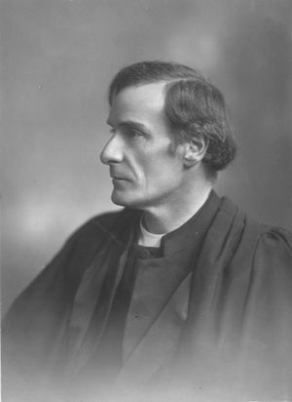

F.R. Tennent

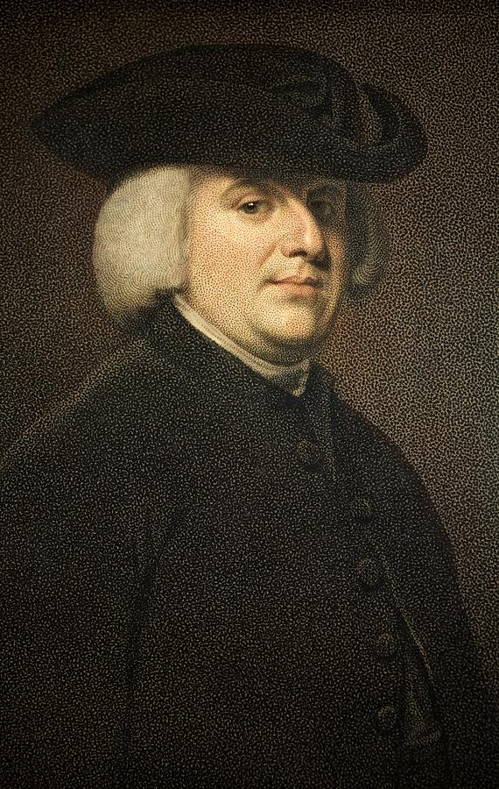

William Paley

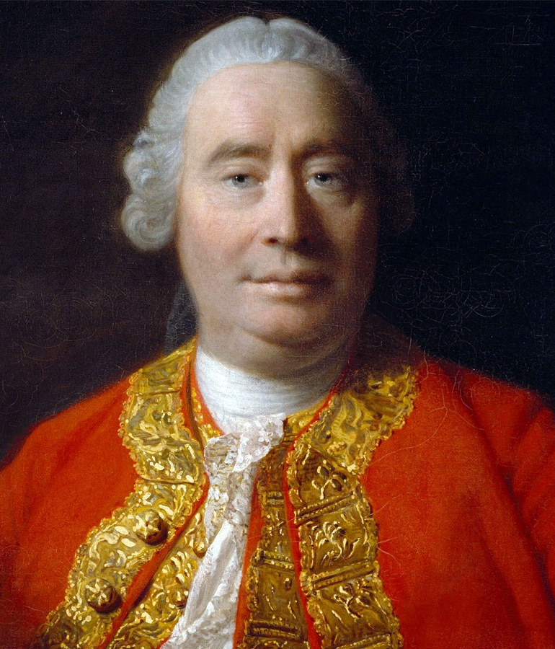

David Hume

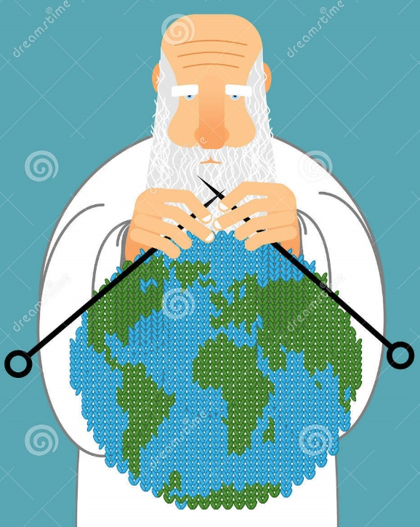
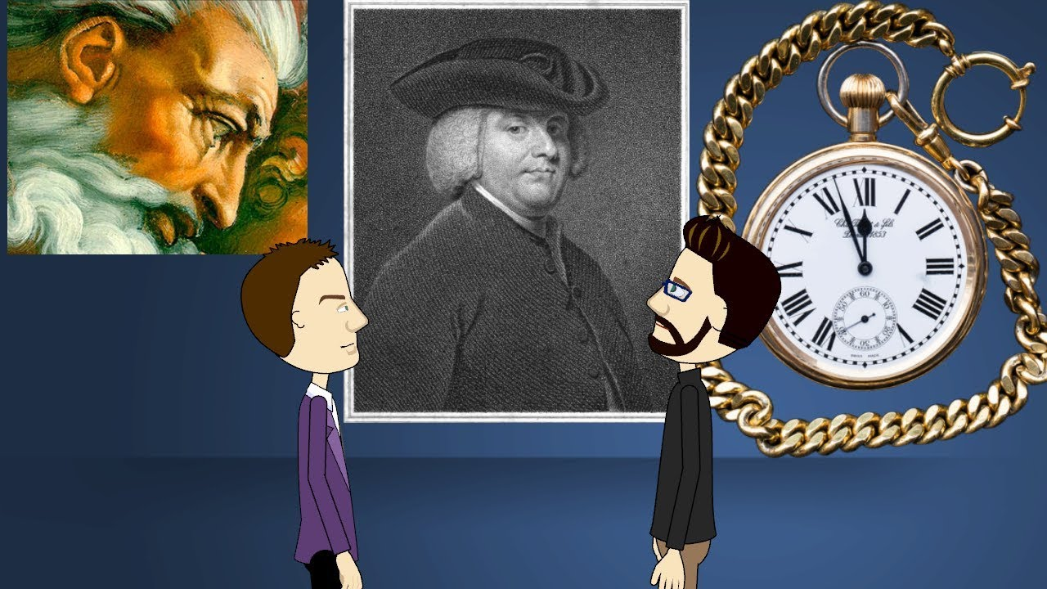

Theist
Agnostic
Atheist

o0
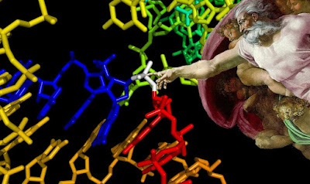

l

