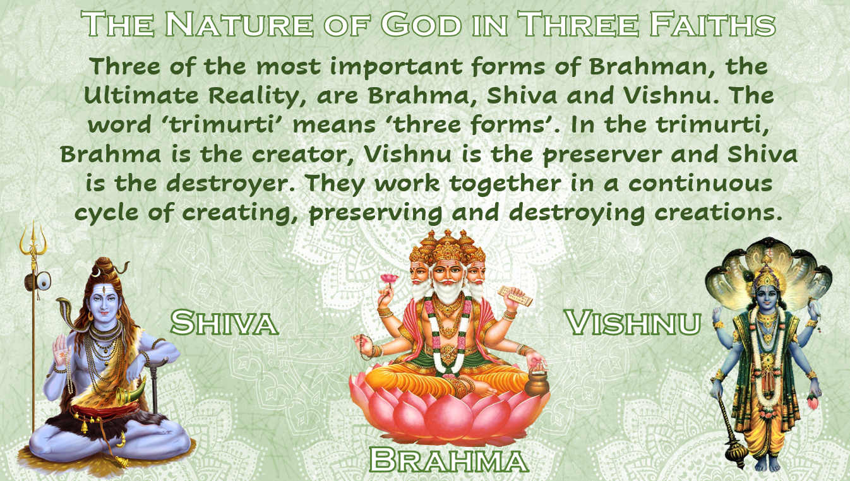

Brahman, the Ultimate Reality, is a key belief in Hinduism. Hindus worship gods and goddesses, including the trimurti (Brahma, Vishnu and Shiva) and the different forms of the gods and goddesses.
Hindu gods – the trimurti
In a Hindu temple, there are no images of Brahman. However, there are many images of gods and goddesses, which are aspects of the Divine One.

Remember the difference between Brahman (with an ‘n’), which refers to Ultimate Reality, and Brahma (with no ‘n’), which refers to the creator god.

The Trimurti – Brahma the creator, Vishnu the preserver and Shiva the destroyer are central to Hindus’ understanding of God.

Brahma the creator
Images, or murtis, of Brahma have four heads, seeing in all directions at once. Brahma’s four arms carry symbols of power – a goblet, a bow, a sceptre and the Vedas. In Hindu creation stories, Brahma brings the universe into being.

Vishnu the preserver
Murtis of Vishnu express splendour and power. His four arms carry symbols of power – a discus, a lotus flower, a conch shell and a mace. Vishnu, has appeared on Earth through avatars. Vishnu (and his avatars, including Krishna) are worshipped by many millions of Hindus today.

Shiva the destroyer
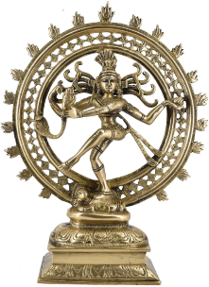
Murtis of Shiva vary. He is often pictured dancing and with four arms. He holds a drum and a flame, and he points to his dancing feet with one hand and holds in the other hand a pen, meaning ‘fear not’. His necklace of cobra snakes is another sign of power. Shiva is worshipped by many millions of Hindus today. Shiva murtis often show him dancing on a demon that represent ignorance, symbolising the destruction of ignorance.

Why are there so many gods?

“Worship of the unmanifest is exceedingly difficult for embodied beings. (Bhagavad Gita 12.5)”, The ‘unmanifest’ is Brahman, Ultimate Reality (God), who has no form. This scripture recognises that humans (‘embodied beings’) need a form, such as one of the gods or goddesses, to worship if they are to make progress along the path towards spiritual reality. This is why, although it appears that Hinduism is a polytheistic faith, the thousands of gods are simply representations of the Ultimate God, Brahman.
