**What is God like?**

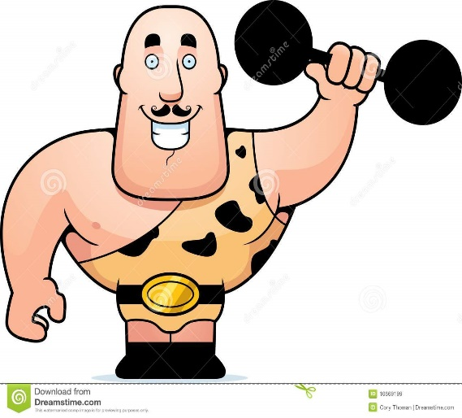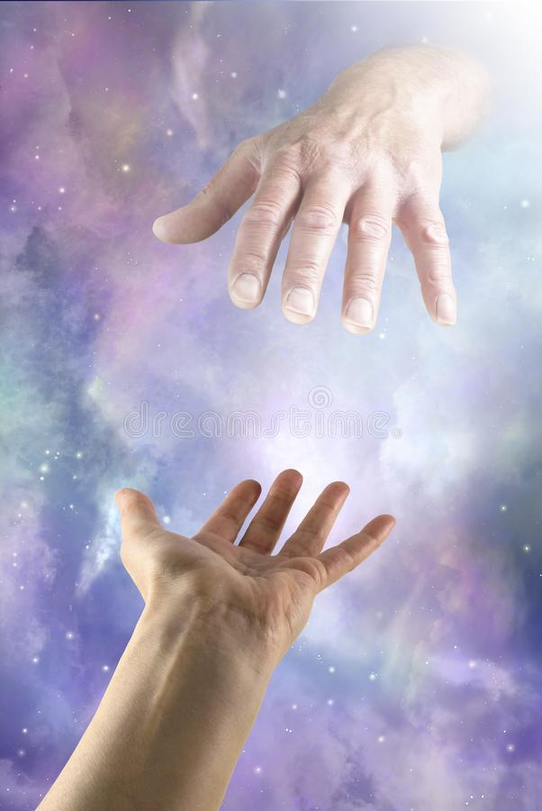

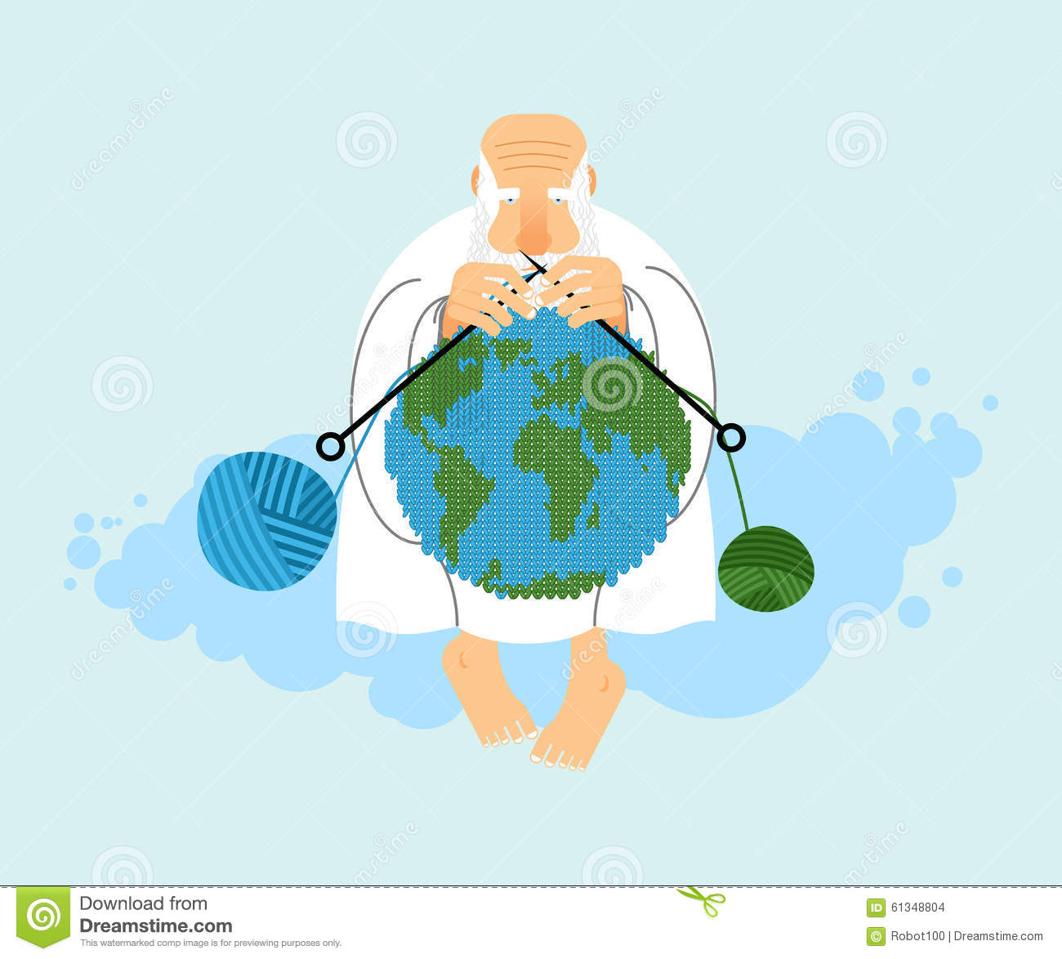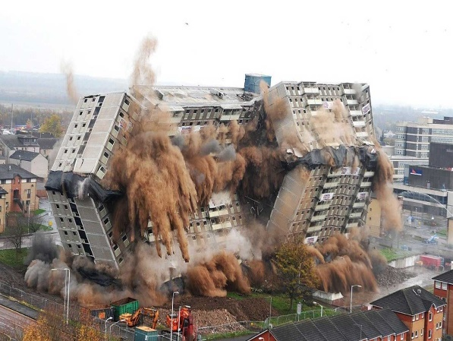

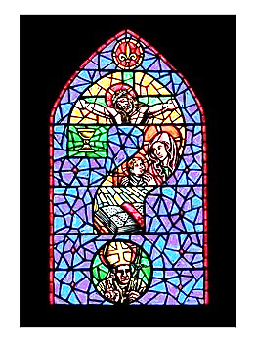

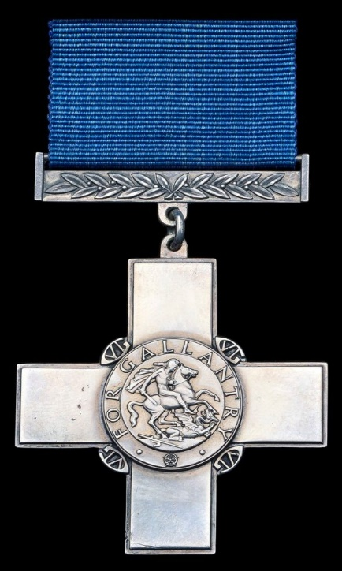

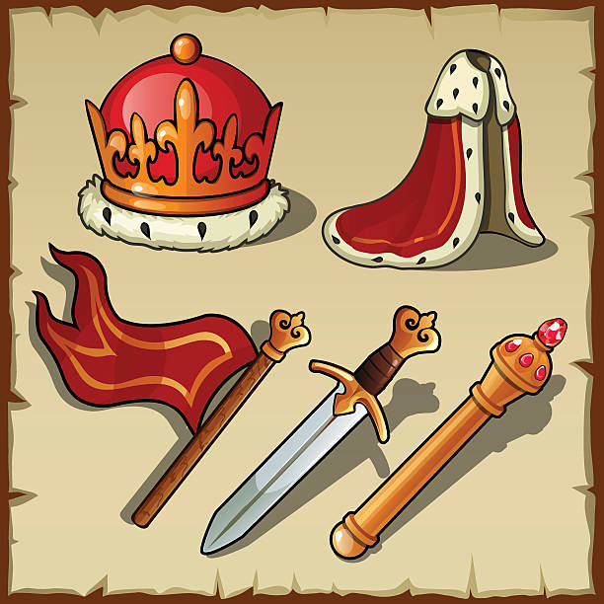

1. Write your name on the back of the pyramid.
2. Cut out the shape along the solid lines.
3. In the triangle draw pictures and/or symbols to represent each of the different persons of the Holy Trinity.
4. Colour in your pyramid.
5. Fold carefully along the dotted lines (scoring them first would be a good idea) and stick together as shown.

**God the Son**

**God the Father**

**God the Holy Spirit**

