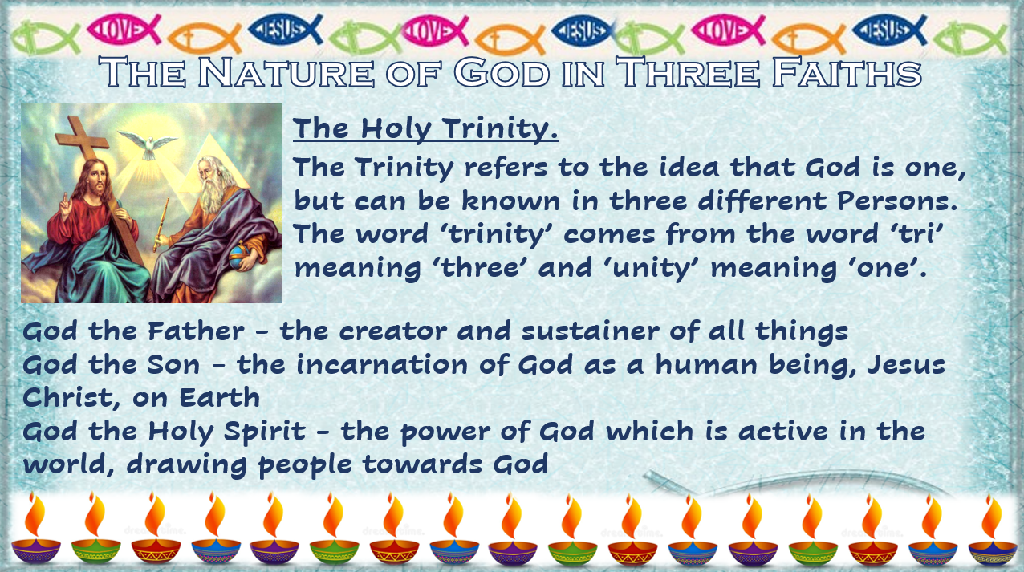

God the Father
Christians refer to God as the Father. God the Father is the creator of all things. He is the creator ex nihlio. This means that God created the universe and all things in it out of nothing. God is also viewed as a loving father. This means that he cares and loves humanity, as a father loves his children. This is shown in the Parable of the Prodigal Son. In the parable, despite the son having squandered his early inheritance, the father still welcomes him home with open arms and a celebration. In the same way, God welcomes back those who have sinned and now seek to be reconciled with him. God is also known as the father of Jesus Christ, as Jesus claimed to have a special relationship with God.

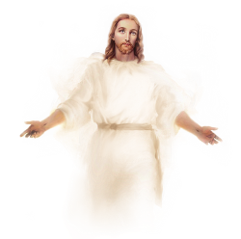
God the Son
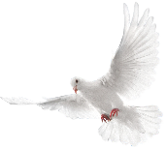
God the Son refers to Jesus Christ, the Son of God, this is Jesus as God in human form, who was sent to save humanity. He was sacrificed for the sins of humans, which allows them to be reunited with God after death. Christians believe that the Son was present at the creation of the universe, ‘In the beginning the Word was with God and the Word was God’, but wasn’t in his human form at this stage. God revealed himself as a human being in order to spread his teaching, to show how life should be lived.

God the Holy Spirit
The Holy Spirit is the power of God at work on the Earth. In the Bible he is often symbolised as wind, fire or in the form of a dove. It is through the power and workings of the Holy Spirit that God is known today and how Christians can know what God wants them to do, ‘…the Holy Spirit, …will teach you all things and will remind you of everything I [Jesus] have said to you’. John 14:25-26. It is through the Holy Spirit that Christians receive the gifts of the Holy Spirit, ‘...the fruit of the Spirit is love, joy, peace, patience, kindness, goodness, faithfulness, gentleness and self-control’. It is also believed that it was through the Holy Spirit that Mary became pregnant with Jesus.

