“Throwing Salt Over Your Shoulder”

European/Christian, ancient Roman

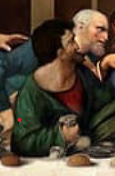
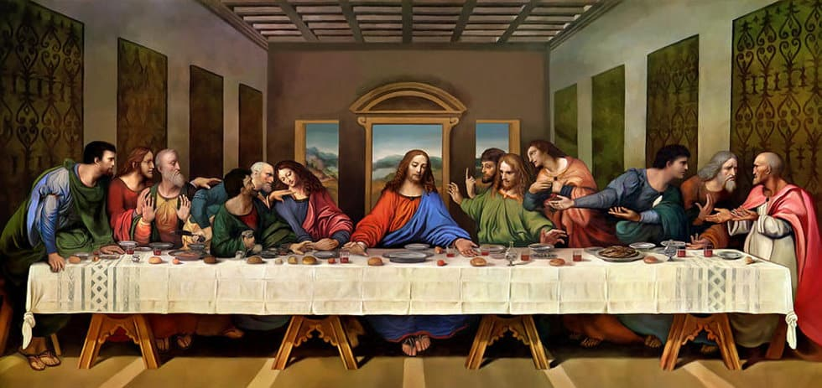
Perhaps the next most common superstition, at least in the West, involves tossing salt over one’s shoulder. Like ‘knocking on wood,’ this superstition also involves the idea of ‘warding off evil’ - in this case, the devil himself. In Leonardo da Vinci’s The Last Supper, Jesus’ betrayer, Judas Iscariot, is portrayed as having accidentally spilled salt. Since Judas was associated with doing something bad, the argument goes that, so was salt, and throwing it over your shoulder would blind the devil waiting there.

“Knocking on Wood”

Indo-European, Celtic, or possibly British

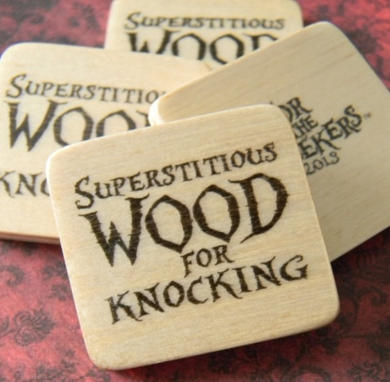
The actual origins, and even meanings, of the phrase are as varied as the cultures which use it, with some suggesting roots in the Indo-European or Celtic belief that spirits good and bad resided in trees who could be either called upon for protection or chased away by knocking on their home, and others (particularly Christians) linking the practice to the magical power of the wooden Crucifix. Many churches claimed to have pieces of Jesus’ cross, so knocking on wood is said to bring good luck. Most likely among the different theories, historians have attributed the superstition to a 19th-century British children’s game called “Tiggy Touchwood” in which young players claimed immunity from being tagged by touching the nearest piece of wood. Adults picked up on the habit and the phrase - “touch wood”.
“Walking under a ladder”
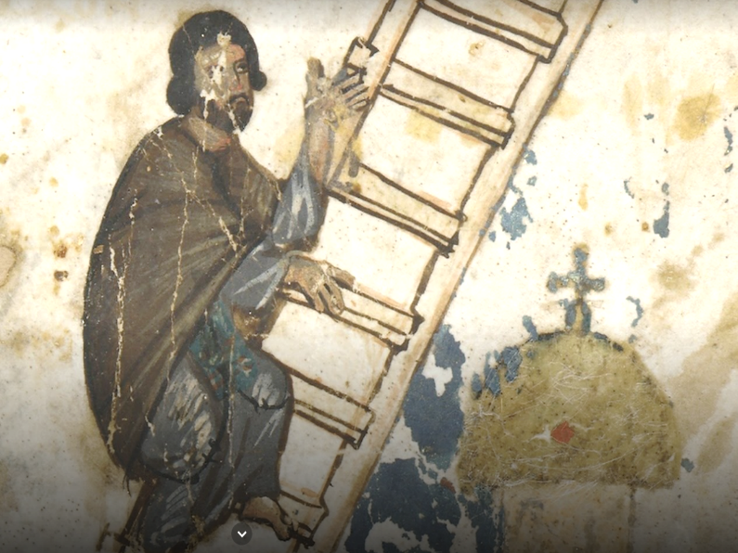
The superstition of not wanting to walk under a ladder also has roots in Christian symbolism: the “Holy Trinity” of the Father, the Son, and the Holy Spirit led to an association of the number three with something sacred. The triangle, with its three sides, came to be regarded as sacred as well, and a ladder of course forms a triangle, so, naturally, to walk under that ladder would be to destroy the sanctity of the Trinity and thus incur punishment.

“Friday the 13th”

European/Christian

Like the number 7 for the Romans, magical significance has been attached to the number 13--but this time, it’s unlucky rather than lucky. The number 12 has frequently been seen as positive (12 months of the year and 12 signs of the zodiac, for example, or 12 days of Christmas and 12 tribes of Israel), naturally making its nearest neighbouring number to the north negative.
Like other superstitions surrounding the Last Supper, the 13th is also seen as unlucky because, once again, the Great Betrayer, Judas Iscariot, was the 13th member of the Last Supper that led to Christ’s crucifixion. In addition, on Friday the 13th of October 1307, King Philip IV of France arrested and put to death hundreds of the Templar Knights (a Catholic military order, founded in 1119, with headquarters on Temple Mount in Jerusalem).

“Black Cats”
European
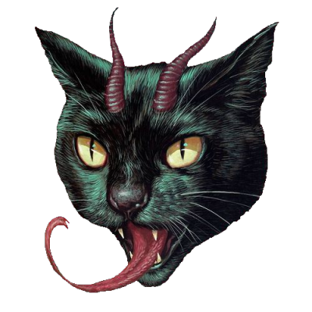
Though cats have often been associated with good luck rather than its opposite and were even worshipped as gods in Ancient Egypt, things took a turn for the worse for our dark-coloured feline friends sometime around the Dark Ages when, in 1232 AD, a papal bull by Pope Gregory IX declared them an “incarnation of Satan”, according to People magazine.
Things only went downhill for black cats from there, with people of the Middle Ages burning them in bonfires on Holy Days like Shrove Tuesday, the first Sunday of Lent, and even Easter, and with the Puritans in America connecting them to the practice of witchcraft. Also, the colour black has long been associated with evil and death, which didn’t help matters for our furry friends who had the misfortune of being born the colour of night.

Saying “God Bless You” when a person sneezes.
In 6th century Europe, people congratulated anyone who sneezed; they believed the person was expelling evil spirits.
Early Romans believed that a strong sneeze could release your soul into the world and a “bless you” would keep it safely at home.
When the Black Plague hit Europe in 1665, the pope required everyone to be blessed when they sneezed. He believed that a sneeze was a sign the person would likely die soon.
The blessing was usually followed up by making the sign of the cross, for good measure.

