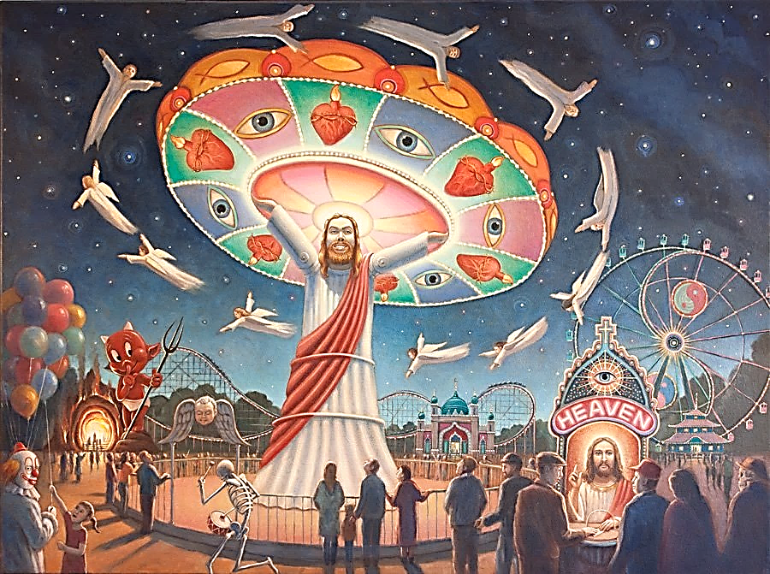

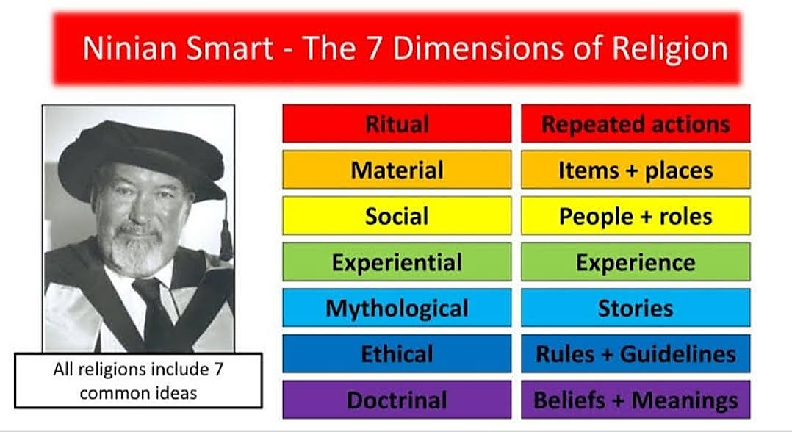



Beliefs &

Meaning

Rules &

Guidelines

Stories

Experiences

People &

Roles

Items &

places

Repeated

actions

Doctrinal

Ethical

Mythological

Experiential

Material

Social

Rituals

Seven Dimensions of Religion

0