[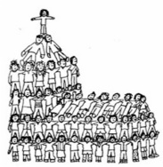](https://www.google.co.uk/url?sa=i&rct=j&q=&esrc=s&source=images&cd=&cad=rja&uact=8&ved=0ahUKEwi8qdiDs9PYAhUHKsAKHeV6DB8QjRwIBw&url=https://godspeaks-i-listen.com/2015/10/20/what-church-do-you-attend/&psig=AOvVaw0X1ohfNFgjx6wEVG4s1hSH&ust=1515879702108297)

**The Role of the Church in the Local Community**

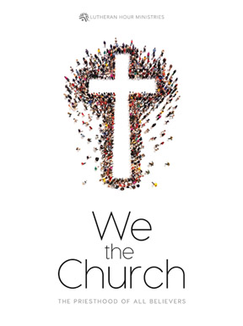

What do we mean when we talk about ‘the **C**hurch’?

The images above suggest that the **C**hurch is about the _______________

rather than the __________________. Originally the early Church did not

have a _______________ ___________________. The first Christians met

in ________________ _____________. The New Testament explains that

the Church is a _______________________________________________

___________________________________________________________.





group of believers under the leadership of Jesus.

What does the Church do?

The **c**hurch as a building provides a place where _________________ can ___________, ___________, ______________ _______________

and _______________.

Other activities that take place in a church may include;

1. _____________________________________________________
2. _____________________________________________________
3. _____________________________________________________

Throughout history the Church has been a major source of social services such as ______________ and ________________ _________ it has been involved in campaigns for _______________ and projects to help the local __________________ such as _________ _________

*28*

[](https://www.google.co.uk/url?sa=i&rct=j&q=&esrc=s&source=images&cd=&cad=rja&uact=8&ved=0ahUKEwjOwLqZ2tfYAhVEK8AKHULyDMMQjRwIBw&url=http://www.pearsfoundation.org.uk/article/pears-foundation/trussell-trust-wins-top-awards-at-charity-awards-2016&psig=AOvVaw3vxBItS5vwF7yOGz5xPLxX&ust=1516019604044353)

Food Banks – The Trussell Trust.

The Trussell Trust food banks provide ___________________ _________

to people who need ___________________________________________

___________________________________________________________.

Causes of poverty that may lead to people having to use food banks;

1. ________________________________________________________
2. ________________________________________________________
3. ________________________________________________________
4. ________________________________________________________

Food is donated to food banks by ________________ ________________

______________ __________________ and _______________________.

Care professionals such as ______________, ___________ ____________

and ___________ ______________ identify people in crisis and ________

a __________ _______________ and ____________ days of __________

is provided. _________________ Trust food banks provide food for over

_______________ people in the UK.

help and support when they are in crisis

[](https://www.google.co.uk/url?sa=i&rct=j&q=&esrc=s&source=images&cd=&cad=rja&uact=8&ved=0ahUKEwj4ke-hvdfYAhXoJMAKHa-RDzoQjRwIBw&url=http://www.srcl.com/latest-news/srcl-donates-trussell-trusts-food-bank-appeal/&psig=AOvVaw3vxBItS5vwF7yOGz5xPLxX&ust=1516019604044353)[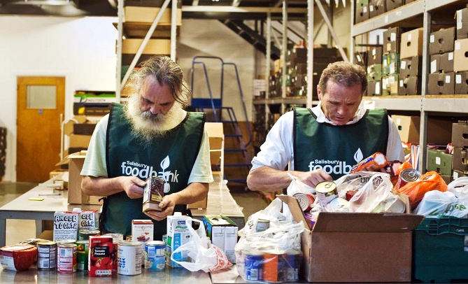](https://www.google.co.uk/url?sa=i&rct=j&q=&esrc=s&source=images&cd=&cad=rja&uact=8&ved=0ahUKEwjmsaP-u9fYAhVJAcAKHfHmAKcQjRwIBw&url=http://www.dancinggiraffe.com/trussell-trust-states-welfare-reform-responsible-increase-food-banks/&psig=AOvVaw3vxBItS5vwF7yOGz5xPLxX&ust=1516019604044353)[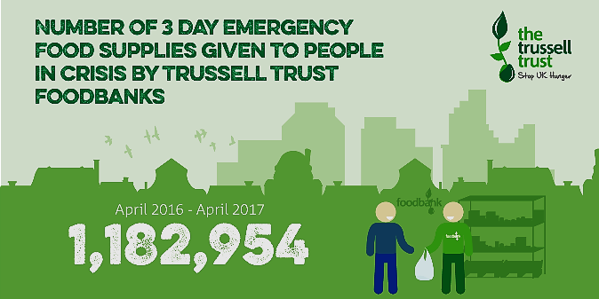](https://www.google.co.uk/url?sa=i&rct=j&q=&esrc=s&source=images&cd=&cad=rja&uact=8&ved=0ahUKEwjHwMKzu9fYAhXmLcAKHe-cAOkQjRwIBw&url=https://www.trusselltrust.org/news-and-blog/latest-stats/end-year-stats/&psig=AOvVaw3vxBItS5vwF7yOGz5xPLxX&ust=1516019604044353)

Why does the Church help others?

One reason is that through the parable of the ________ ___________

Jesus taught us to ___________ thy ___________________.

Also in the ___________ Jesus said, ‘For I was _______________ and

you gave me something to ________, I was ______________ and you

gave me something to _______________...’.

*29*

The Church in the Community – Street Pastors.

Christians believe in ____________, which is selfless, ________________,

_____________________ love. Because of this Christians should respond

actively to help people in need. These needs vary such as, a lack of

_________________ for ______________ people, insufficient _________

for the ____________________ and the problem of ___________ culture

and people not feeling __________ on the streets.

Churches have tried to meet these challenges with ______________ such

as ______________ _______________.

Street Pastors.

The network of Street Pastors began in _______________ in _______

with _____ volunteers. It was started by the _______________ Trust, a Christian _____________. Christian volunteers receive training in order to _____________ the _____________. They provide a ________________ presence in the local _____________________. Initially they were set up to challenge __________ ______________ and the use of ____________ and _________ in some areas of ___________. As groups began in other areas the focus widened to include responding to ___________________, _______-___________ behaviour and fear of ____________.

[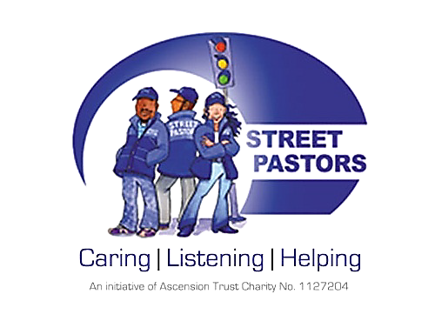](https://www.google.co.uk/url?sa=i&rct=j&q=&esrc=s&source=images&cd=&cad=rja&uact=8&ved=0ahUKEwi-vICZy9fYAhWiHsAKHQ8SClwQjRwIBw&url=http://www.truromethodist.org.uk/what-we-do/street-pastors/&psig=AOvVaw0kNtsIj7c6D7TydbTlvsks&ust=1516023851008828)

Street Pastors work with _______________ and the

__________________. Their aim is not to

_______________ but to work listen to

________________ problems, giving

_____________ regarding ________________

which may help to __________________ anti - social behaviour. There are now around _________ pastors in _____ locations worldwide.

*30*

School Pastors.

A sister organisation called _____________ pastors was set up in

________ with the aim of reducing _________-_______________

behaviour, illegal _________ _______and _________________.

School Pastors may _____________ young people and ____________

within an outside school to try to prevent ___________________

_______________.

Why would a Christian become a Street Pastor?

The mission of the Church is to ____________ a __________________

contribution to the community and to be good _____________________.

This is summed up in the Bible quotation, ‘_______________ by itself, if it

is not ____________________ by _______________ is ______________.

This has also led to Christians being in organisations such as charities, the

_______________________ Prayer ______________, the Boy’s and Girl’s

__________________ and the ___________.

I.L. – What is the YMCA?

Research the YMCA, find out why they were set up, by whom, what their aims are and how they try to achieve these aims.

____________________________________________________________

____________________________________________________________

____________________________________________________________

____________________________________________________________

____________________________________________________________

____________________________________________________________

____________________________________________________________

____________________________________________________________

*31*

*31*

I.L. The YMCA – ‘…just go there, to the YMCA I'm sure they can help you today…’

____________________________________________________________

____________________________________________________________

____________________________________________________________

____________________________________________________________

____________________________________________________________

____________________________________________________________

____________________________________________________________

____________________________________________________________

____________________________________________________________

____________________________________________________________

____________________________________________________________

____________________________________________________________

____________________________________________________________

____________________________________________________________

____________________________________________________________

____________________________________________________________

____________________________________________________________

____________________________________________________________

____________________________________________________________

____________________________________________________________

____________________________________________________________

____________________________________________________________

____________________________________________________________

____________________________________________________________

*32*