

**Christian Practices - Worship**

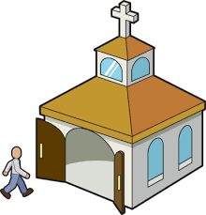[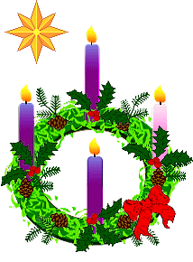](https://www.google.co.uk/url?sa=i&rct=j&q=&esrc=s&source=images&cd=&cad=rja&uact=8&ved=0ahUKEwjL7qGu4rLYAhXiL8AKHbpRBzAQjRwIBw&url=https://www.pinterest.com/pin/176133035400244321/&psig=AOvVaw2VLj4jg8RTnCEcB2XSYD07&ust=1514758784139370)How do Christians worship? Complete the spider diagram. [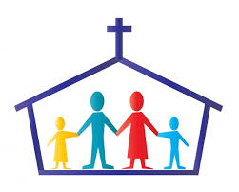](https://www.google.co.uk/url?sa=i&rct=j&q=&esrc=s&source=images&cd=&cad=rja&uact=8&ved=0ahUKEwjIl82w4LLYAhWFLcAKHVFgBVAQjRwIBw&url=http://www.unitedfaithmortgage.com/2016/09/14/life-after-bankruptcy/&psig=AOvVaw0J5WknO67Y3rH7GDpvP1y2&ust=1514758231360134)

[](https://www.google.co.uk/url?sa=i&rct=j&q=&esrc=s&source=images&cd=&cad=rja&uact=8&ved=0ahUKEwjIl82w4LLYAhWFLcAKHVFgBVAQjRwIBw&url=http://www.unitedfaithmortgage.com/2016/09/14/life-after-bankruptcy/&psig=AOvVaw0J5WknO67Y3rH7GDpvP1y2&ust=1514758231360134)

**Christian**

**Worship**

[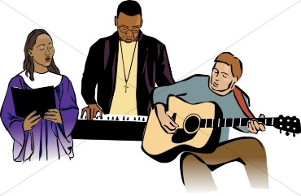](https://www.google.co.uk/url?sa=i&rct=j&q=&esrc=s&source=images&cd=&cad=rja&uact=8&ved=0ahUKEwjO3_bo4LLYAhXnJcAKHW-IDDkQjRwIBw&url=https://www.sharefaith.com/image/traditional-and-contemporary-worship.html&psig=AOvVaw0J5WknO67Y3rH7GDpvP1y2&ust=1514758231360134)[](https://www.google.co.uk/url?sa=i&rct=j&q=&esrc=s&source=images&cd=&cad=rja&uact=8&ved=0ahUKEwi__rOu4bLYAhUnLcAKHU4LDB4QjRwIBw&url=http://weclipart.com/kid%2Bpraying%2Bclipart&psig=AOvVaw1iURatQ13U13dirgi07ret&ust=1514758470378533)

[](https://www.google.co.uk/url?sa=i&rct=j&q=&esrc=s&source=images&cd=&cad=rja&uact=8&ved=0ahUKEwjIl82w4LLYAhWFLcAKHVFgBVAQjRwIBw&url=http://www.unitedfaithmortgage.com/2016/09/14/life-after-bankruptcy/&psig=AOvVaw0J5WknO67Y3rH7GDpvP1y2&ust=1514758231360134)

Christians worship to ________________ and ________________ God, to ask for _________________ and to ask for ____________ when they or others are _______________________.

Worship can take place at ________ ___________ but the main day for public worship is ________________ as this is the day of _________________ ___________________________.

*1*



**Christian Practices - Worship**

Worship is how Christians show their _______________, _______________________ and _________________ to God. Worship is connected with the word ________________,

therefore it is showing recognition of God’s __________________ and __________________.

Christian worship can take place in a _______________, a person’s home or, in fact _____________________. Worship may involve __________________ _____________________, __________________ _______________, __________________ and ______________________ ____________________________.

Christians worship is important because it helps ______________ _____________ ___________________ with God and gives them __________________ and ______________ to live a Christian life.

Key Terms.

Note down definitions for the key terms found on page 36 of

the text book. And also … Eucharist – also known as Holy Communion, the ritual of sharing bread and wine in

remembrance of Jesus.

[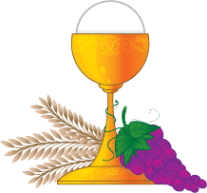](https://www.google.co.uk/url?sa=i&rct=j&q=&esrc=s&source=images&cd=&cad=rja&uact=8&ved=0ahUKEwjy6-KIwarYAhVpDcAKHcsABBAQjRwIBw&url=http://www.stameliareled.com/communion.html&psig=AOvVaw2sKWGpsVb1JhB4MwxfOcgA&ust=1514474945368493)

*2*

Liturgical worship is worship that follows a set _______________. For example a _____________ leads formal _______________, passages from the ______________ are read and in many churches __________________ or Holy Communion is celebrated. Whereas in non-liturgical worship or worship there is no set ­­­­­­­­­­­­­­______________ or ______________. This is the kind of worship that takes place in ________________________ churches such as _________________ and ___________________. There is also _____________________ worship which depends on people’s ____________________ prayers or sharing of _______________. This kind of worship happens in ___________________________ churches and may involve _________________________, __________________________ and _____________________ in ___________________________.

Private worship allows ______________________ to spend time with ____________. It may involve ___________________, ____________________, _______________ the _____________ or using aids to worship such as ___________ or a ____________.

[](https://www.google.co.uk/url?sa=i&rct=j&q=&esrc=s&source=images&cd=&cad=rja&uact=8&ved=0ahUKEwj1yJuB57HYAhVSGsAKHaeEDw4QjRwIBw&url=https://kr.123rf.com/photo_28111216_%EB%8B%A4%EC%B1%84%EB%A1%9C%EC%9A%B4-%EA%B8%B0%EB%8F%85%EA%B5%90-%EC%83%81%EC%A7%95.html&psig=AOvVaw3CLLXOFd-H8MZzNRsNq_eH&ust=1514725652769017)

*3*

|  |  |
| --- | --- |
|  | Liturgical Worship |
| 1 |  |
| 2 |  |
| [Image result for christian symbols](https://www.google.co.uk/url?sa=i&rct=j&q=&esrc=s&source=images&cd=&cad=rja&uact=8&ved=0ahUKEwjg45vM9bHYAhWCA8AKHYQsBXQQjRwIBw&url=https://www.dreamstime.com/stock-photo-christian-symbols-image22977890&psig=AOvVaw3CLLXOFd-H8MZzNRsNq_eH&ust=1514725652769017)3 |  |

|  |  |
| --- | --- |
|  | Non-Liturgical & Informal Worship |
| 1 |  |
| 2 |  |
| [Image result for christian symbols](https://www.google.co.uk/url?sa=i&rct=j&q=&esrc=s&source=images&cd=&cad=rja&uact=8&ved=0ahUKEwjg45vM9bHYAhWCA8AKHYQsBXQQjRwIBw&url=https://www.dreamstime.com/stock-photo-christian-symbols-image22977890&psig=AOvVaw3CLLXOFd-H8MZzNRsNq_eH&ust=1514725652769017)3 |  |

**Characteristics of Worship and why they are important.**

*4*