Explain two ways in which learning about the four sights influences Buddhists today.

1st way | Simple explanation of a relevant and accurate influence | 1 mark
 | Detailed explanation of a relevant and accurate influence | + 1 mark
2nd way | Simple explanation of a relevant and accurate influence | + 1 mark
 | Detailed explanation of a relevant and accurate influence | + 1 mark
Total |  | = 4 marks

Instruction: | Clue - Evidence/detail
Explain one way | Suffering
Develop your explanation with more detail/an example/a religious teaching. | Compassion
Explain a second way | Holy man
Develop your explanation with more detail/an example/a religious teaching. | Spiritual Path
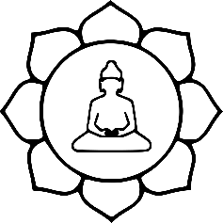

Explain two ways in which Buddha’s enlightenment influences Buddhists today (4).

1st way | Simple explanation of a relevant and accurate influence | 1 mark
 | Detailed explanation of a relevant and accurate influence | + 1 mark
2nd way | Simple explanation of a relevant and accurate influence | + 1 mark
 | Detailed explanation of a relevant and accurate influence | + 1 mark
Total |  | = 4 marks

Instruction: | Clue - Evidence/detail
Explain one way | Suffering/Eightfold Path
Develop your explanation with more detail/an example/a religious teaching. | Compassion/morality
Explain a second way | Meditation
Develop your explanation with more detail/an example/a religious teaching. | Enlightenment

Explain two ways in which learning about the life of the Buddha influences Buddhists.

1st way | Simple explanation of a relevant and accurate influence | 1 mark
 | Detailed explanation of a relevant and accurate influence | + 1 mark
2nd way | Simple explanation of a relevant and accurate influence | + 1 mark
 | Detailed explanation of a relevant and accurate influence | + 1 mark
Total |  | = 4 marks

Instruction: | Clue - Evidence/detail
Explain one way | Suffering/Eightfold Path
Develop your explanation with more detail/an example/a religious teaching. | Compassion/morality
Explain a second way | Meditation
Develop your explanation with more detail/an example/a religious teaching. | Enlightenment  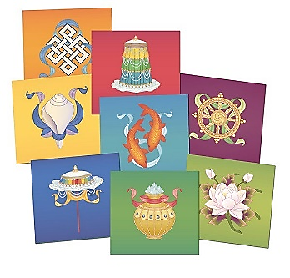

Explain two differences between an Arhat and a Boddhisattva. (4 marks)

1st way | Simple explanation of a relevant and accurate influence | 1 mark
 | Detailed explanation of a relevant and accurate influence | + 1 mark
2nd way | Simple explanation of a relevant and accurate influence | + 1 mark
 | Detailed explanation of a relevant and accurate influence | + 1 mark
Total |  | = 4 marks

Instruction: | Clue - Evidence/detail
Explanation | Arhat - meaning
Develop your explanation with more detail/an example/a religious teaching. | Theravada
Explanation | Bodhisattva - meaning
Develop your explanation with more detail/an example/a religious teaching. | Mahayana / Ending suffering / compassion

Explain two Buddhist beliefs about the fourth noble truth. (5 marks)

1st way | Simple explanation of a relevant and accurate influence | 1 mark
 | Detailed explanation of a relevant and accurate influence | + 1 mark
2nd way | Simple explanation of a relevant and accurate influence | + 1 mark
 | Detailed explanation of a relevant and accurate influence | + 1 mark
Additional point | Relevant and accurate reference to sacred writing | + 1 mark
Total |  | = 5 marks

Instruction: | Clue - Evidence/detail
Explain one belief | Middle Way/Eightfold Path
Develop your explanation with more detail/an example/a religious teaching. | Compassion/morality
Explain a second belief | Enlightenment
Develop your explanation with more detail/an example/a religious teaching. | Ending suffering
Teaching | The cure
Explain two Buddhist beliefs about dependent arising. (5 marks)

1st way | Simple explanation of a relevant and accurate influence | 1 mark
 | Detailed explanation of a relevant and accurate influence | + 1 mark
2nd way | Simple explanation of a relevant and accurate influence | + 1 mark
 | Detailed explanation of a relevant and accurate influence | + 1 mark
Additional point | Relevant and accurate reference to sacred writing | + 1 mark
Total |  | = 5 marks

Instruction: | Clue - Evidence/detail
Explain one belief | Definition
Develop your explanation with more detail/an example/a religious teaching. | 12 Nidanas
Explain a second belief | Samsara/karma
Develop your explanation with more detail/an example/a religious teaching. | Wheel of life
Teaching | Wheel/foot/Ox  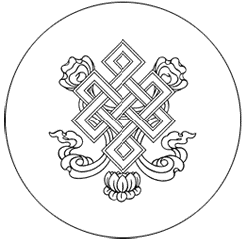
Explain two realisations the Buddha made during the three watches of the night when he became enlightened. (5 marks)

1st way | Simple explanation of a relevant and accurate influence | 1 mark
 | Detailed explanation of a relevant and accurate influence | + 1 mark
2nd way | Simple explanation of a relevant and accurate influence | + 1 mark
 | Detailed explanation of a relevant and accurate influence | + 1 mark
Additional point | Relevant and accurate reference to sacred writing | + 1 mark
Total |  | = 5 marks

Instruction: | Clue - Evidence/detail
Explain one example | Previous lives
Develop your explanation with more detail/an example/a religious teaching. | Jataka tales, e.g…
Explain a second example | Suffering
Develop your explanation with more detail/an example/a religious teaching. | Fourth Noble Truth
Teaching/example | 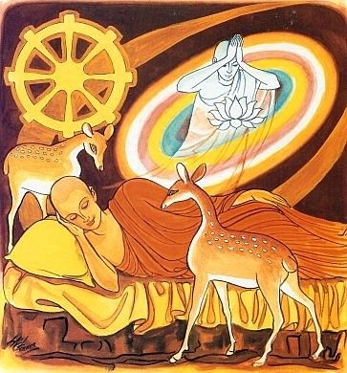  Eightfold Path
Explain two Mahayana teachings. (5 marks)

1st way | Simple explanation of a relevant and accurate influence | 1 mark
 | Detailed explanation of a relevant and accurate influence | + 1 mark
2nd way | Simple explanation of a relevant and accurate influence | + 1 mark
 | Detailed explanation of a relevant and accurate influence | + 1 mark
Additional point | Relevant and accurate reference to sacred writing | + 1 mark
Total |  | = 5 marks

Instruction: | Clue - Evidence/detail
Explain one teaching | Sunyata - definition
Develop your explanation with more detail/an example/a religious teaching. | Anatta
Explain a second teaching | Buddha-nature - definition
Develop your explanation with more detail/an example/a religious teaching. | Already enlightened…?
Teaching example | 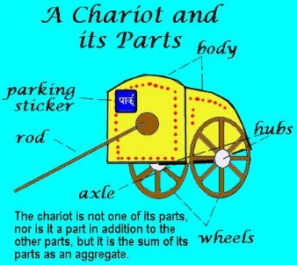  The Chariot
Explain two Mahayana teachings. (5 marks)

1st way | Simple explanation of a relevant and accurate influence | 1 mark
 | Detailed explanation of a relevant and accurate influence | + 1 mark
2nd way | Simple explanation of a relevant and accurate influence | + 1 mark
 | Detailed explanation of a relevant and accurate influence | + 1 mark
Additional point | Relevant and accurate reference to sacred writing | + 1 mark
Total |  | = 5 marks
‘The best way to understand the Buddha’s teachings about the Three Marks of Existence is by meditating.’

Evaluate this statement.
In your answer you should:
• refer to Buddhist teaching
• give reasoned arguments to support this statement
• give reasoned arguments to support a different point of view
• reach a justified conclusion.

Students may include some of the following evidence and arguments, but all relevant evidence and arguments must be credited.
Arguments in support • gives devoted time to consider this/allows search within self for the truth of this teaching, full understanding can only come through total focus on the teachings to uncover the truths
• this is how the Buddha found understanding for himself – and monks also practise it • meditation creates a disciplined mind which is necessary to understand such complex ideas/– meditation is this/etc.
Arguments in support of other views • the individual may only be able to do samatha meditation, which does not allow exploration of religious truths, or may not have enough time to do the necessary meditation • Buddhists could read scripture/could speak to monks even children can have the Marks explained without meditating • a study of the physical world/human experience can lead to an understanding of the three truths
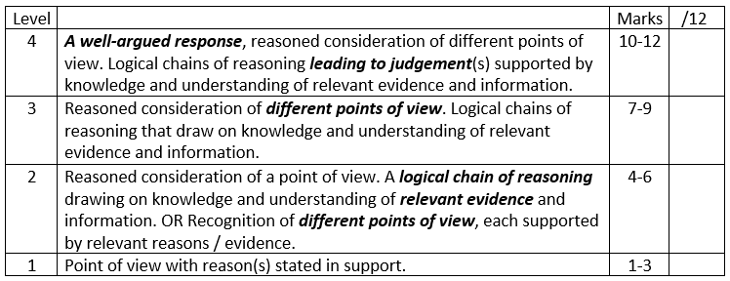

‘Achieving Enlightenment is not that difficult’. Evaluate this statement. (12)
Paragraphs | Clues - Evidence
In support of the statement | Four Noble Truths; Eightfold path (the cure); Buddha
Opposing the statement | Buddha’s spiritual quest; different lifestyles etc.
Conclusion | 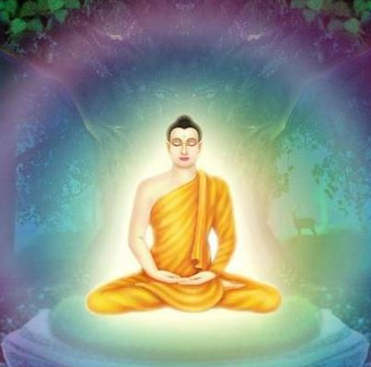  Rare
Achieving Enlightenment is not that difficult’. Evaluate this statement. (12)
In your answer you should:

• refer to Buddhist teaching
• give reasoned arguments to support this statement
• give reasoned arguments to support a different point of view
• reach a justified conclusion.

Some people might agree with this statement because Buddha was a human being, just like the rest of us and if he could achieve enlightenment, so can we. Also during his enlightenment Buddha discovered the Four Noble Truths, the second of which tells us why we suffer (tanha) and the fourth tells us how to end suffering by achieving enlightenment and being released from the cycle of samsara. The fourth noble truth is also known as the Eightfold Path, if we follow this we can achieve enlightenment as this is the ‘cure’ to end suffering by becoming enlightened. For example part of the Eightfold Path is meditation, this is how Buddha attained enlightenment, suggesting enlightenment can’t be that difficult if all we have to do is meditate and follow the rest of the Eightfold Path.

However, it took Buddha many years to achieve enlightenment. When he witnessed the four sights Siddhartha (Buddha) needed to find out why we suffer, he gave up his rich lifestyle and spent six years as an ascetic. Neither of these two life styles led him to the ‘truth’, suggesting that achieving enlightenment if very difficult. Whilst meditating, Siddhartha was distracted by Mara, he managed to overcome the distractions, but for most people, overcoming distractions whilst meditating is very difficult, therefore achieving enlightenment is very difficult.

Overall I disagree with the statement as achieving enlightenment is very rare and requires a lot of focus on spiritual practice.
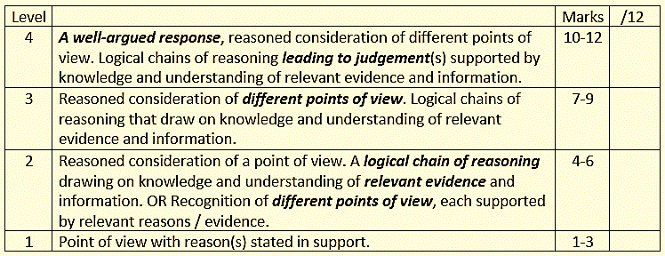

SPaG - High performance
• Learners spell and punctuate with consistent accuracy • Learners use rules of grammar with effective control of meaning overall • Learners use a wide range of specialist terms as appropriate. 3/3
On the answer, tick where you think there is something correct and relevant. Give the answer a level and a mark out of 12. On this paper SPaG is out of 3. Award the answer an appropriate SPaG mark.

