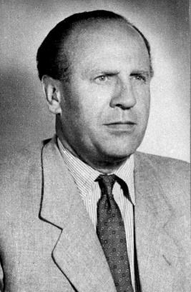
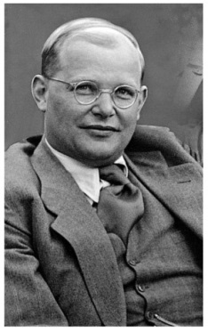
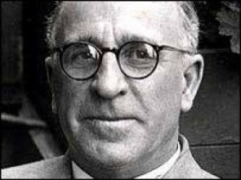
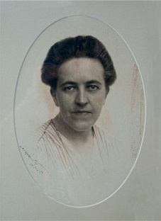
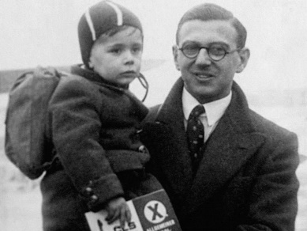
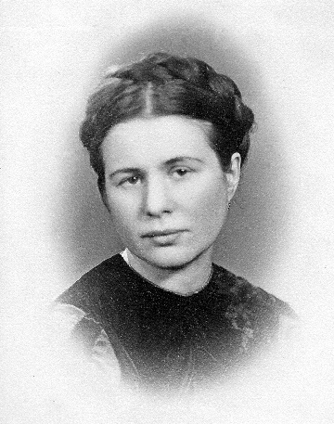

People Who Rescued Jews

Person’s name:________ __________________________________
Nationality:
Job(s) during World War 2 (e.g. social worker, soldier):

Any religious beliefs (if known):

Brief description of what they did:

Motives for saving people (if known):

Year of death:
Honours/awards (e.g. medals, knighthood):

