|  |  |  |  |  |
| --- | --- | --- | --- | --- |
|  |  |  |  |  |
| Image result for moses clip art |  |  |  |  |
|  |  |  | Image result for synagogue |  |
|  |  |  |  |  |
|  |  |  |  |  |

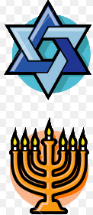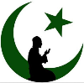

**Islam & Judaism – Picture Quiz!**

**Islam & Judaism – Picture Quiz!**

|  |  |  |  |  |
| --- | --- | --- | --- | --- |
|  |  |  |  |  |
| Image result for moses clip art |  |  |  |  |
|  |  |  | Image result for synagogue |  |
|  |  |  |  |  |
|  |  |  |  |  |