[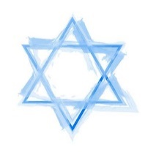](https://www.google.co.uk/url?sa=i&rct=j&q=&esrc=s&source=images&cd=&cad=rja&uact=8&ved=2ahUKEwjm9bH7nv7bAhXH0RQKHTKiANQQjRx6BAgBEAU&url=https://www.123rf.com/clipart-vector/magen_david.html&psig=AOvVaw0bOGboHMHsW7mdWCyN0XVd&ust=1530546147183169)[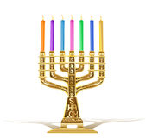](https://www.google.co.uk/url?sa=i&rct=j&q=&esrc=s&source=images&cd=&cad=rja&uact=8&ved=2ahUKEwjW9_q4nv7bAhXLaxQKHYINDWEQjRx6BAgBEAU&url=https://www.dreamstime.com/illustration/golden-menorah.html&psig=AOvVaw0P895x_JCzib3jowRKRF0U&ust=1530545999637630)

**Jewish Beliefs**

**Rabbi Moses ben Maimon**

[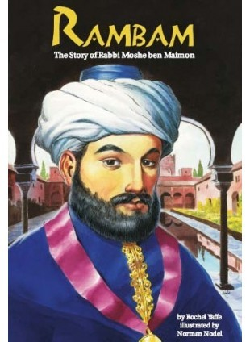](https://www.google.co.uk/url?sa=i&rct=j&q=&esrc=s&source=images&cd=&cad=rja&uact=8&ved=2ahUKEwjB_MSPjP7bAhVLaRQKHTaeAOEQjRx6BAgBEAU&url=http://www.jewishbooksforchildren.com/rambam.html&psig=AOvVaw0pKj4ZuVgudPRJXBF9UTvU&ust=1530541048924034)

Reflect…

Bearing in mind what we have learnt about Judaism so far, note down four aspects of the faith that you think are the most important. Rank them in order of importance (1-5).

Rabbi Moses ben Maimon, also known as Maimonides and The Rambam was a 12th century Jewish philosopher and the first to write a systematic code of all Jewish law.

Two of Rambam’s most famous works are his Thirteen Principles of Faith and his Eight Degrees of Charity.

[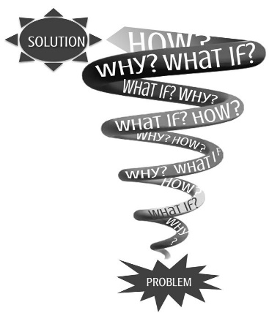](https://www.google.co.uk/url?sa=i&rct=j&q=&esrc=s&source=images&cd=&ved=2ahUKEwi90PHIk_7bAhXC6RQKHRPICcUQjRx6BAgBEAU&url=https://www.pinterest.com/pin/337488565797032989/&psig=AOvVaw1FbJX5Whx85aEZ62bzM7nv&ust=1530543110831398)[](https://www.google.co.uk/url?sa=i&rct=j&q=&esrc=s&source=images&cd=&cad=rja&uact=8&ved=2ahUKEwisvMeblf7bAhVC7xQKHRHyAJsQjRx6BAgBEAU&url=https://www.intouch.org/read/magazine/faith-works/ministry-of-asking-questions-an-introduction&psig=AOvVaw1FbJX5Whx85aEZ62bzM7nv&ust=1530543110831398)

Things to do – Spiralizer!

Rambam’s Principles of Faith have been debated for hundreds of years. What do you think of them? Chose four of the Principles and complete a spiral text sheet considering the following:

* Your idea/belief about each chosen Principle
* What a Christian would think
* What a Muslim would think
* A question about each Principle.

Thirteen Principles of the Jewish Faith

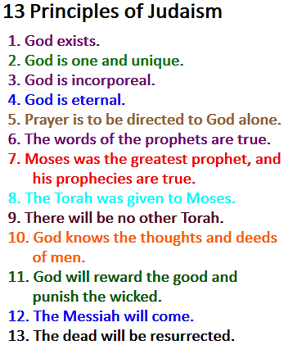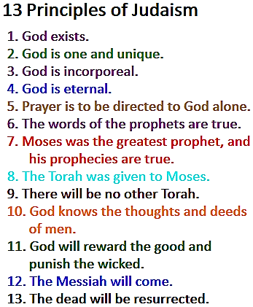

Eight Degrees of Charity.

1. Why do we give to Charity? Note down four reasons.
2. Which Charities do you give to? Why these particular charities?
3. Are there any charities you would not donate to? Why/why not?
4. Sort Rambam’s Eight Degrees of Charity from the most charitable to the least. Stick them in your exercise book.

[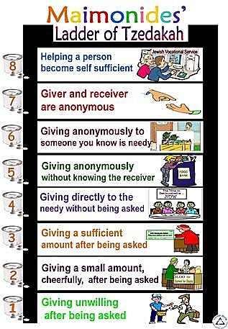](https://www.google.co.uk/url?sa=i&rct=j&q=&esrc=s&source=images&cd=&cad=rja&uact=8&ved=2ahUKEwj9793En_7bAhWDuxQKHehrAVYQjRx6BAgBEAU&url=https://www.pinterest.com/brigo1/maimonides/&psig=AOvVaw3Nd2vJr1QNFUw5xV4fOwhd&ust=1530546327412755)

[](https://www.google.co.uk/url?sa=i&rct=j&q=&esrc=s&source=images&cd=&cad=rja&uact=8&ved=2ahUKEwj9793En_7bAhWDuxQKHehrAVYQjRx6BAgBEAU&url=https://www.pinterest.com/brigo1/maimonides/&psig=AOvVaw3Nd2vJr1QNFUw5xV4fOwhd&ust=1530546327412755)

[](https://www.google.co.uk/url?sa=i&rct=j&q=&esrc=s&source=images&cd=&cad=rja&uact=8&ved=2ahUKEwj9793En_7bAhWDuxQKHehrAVYQjRx6BAgBEAU&url=https://www.pinterest.com/brigo1/maimonides/&psig=AOvVaw3Nd2vJr1QNFUw5xV4fOwhd&ust=1530546327412755)