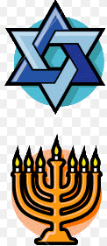

**Judaism – The Basics**

|  |  |  |
| --- | --- | --- |
| Example | Picture | Answer(s) + 1 fact. |
| Founder | Image result for Abraham |  |
| Other key people | Image result for moses clip art |  |
| Main symbols |  |  |
| Holy Books |  |  |
| Place of Worship | Image result for synagogue |  |
| Weekly day of rest |  |  |
| Main festivals |  |  |
| Homeland |  |  |
| Main groups within Judaism |  |  |
| Coming of age ceremonies |  |  |