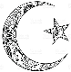

*Fill in the blanks…*

1. There are _______ Pillars of Islam.
2. The first Pillar is the _________________. This is the belief that there is ______ ______ and _________________ is His __________________.
3. During the month of Ramadan Muslims take part in another Pillar of Islam which is ________________ or _________ (Arabic).
4. Muhammad was born in _____________.
5. The Angel ________________ revealed the ____________ to Muhammad in a ________ on Mount _________.

*Label the pictures…*

**Islam - Ramadan**

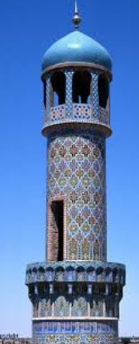

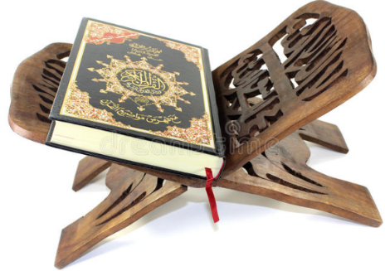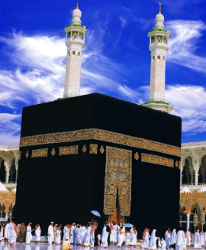





*Fill in the blanks…*

1. There are _______ Pillars of Islam.
2. The first Pillar is the _________________. This is the belief that there is ______ ______ and _________________ is His __________________.
3. During the month of Ramadan Muslims take part in another Pillar of Islam which is ________________ or _________ (Arabic).
4. Muhammad was born in _____________.
5. The Angel ________________ revealed the ____________ to Muhammad in a ________ on Mount _________.

*Label the pictures…*

**Islam - Ramadan**



