Islam - Ramadan
What is Ramadan?

Ramadan is the ninth month of the Islamic calendar. It is during this month that Muslims fast (Sawm) during the hours of daylight. In Islam, a month begins with a new moon and lasts for 28-29 days, as there are twelve months in the Islamic calendar this adds up to 354 days. This means that Ramadan starts approximately 11 days earlier each standard international year. In the UK, when Ramadan falls in the middle of summer fasting can be for up to 19 hours a day! A day during Ramadan starts before dawn because all eating and drinking must be finished before the day begins. Each year, calendars are published so Muslims know what day Ramadan starts and finishes, and what time each day, during the month, the fast should begin and end.

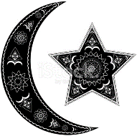

Why do Muslims fast?

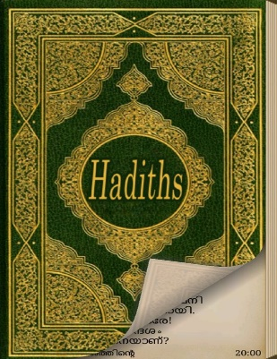
There are numerous reasons why Muslims fast during the month of Ramadan. The tradition goes back to the time of Muhammad – he taught his followers that they should fast as a sign of their submission to Allah. It is also believed that Muhammad received his revelations from Allah in the month of Ramadan over 23 years. The Hadith shows that Muhammad fasted, therefore, as he is thought to be the perfect example to be followed, Muslims should also fast. Fasting (sawm) is, of course, one of the Five Pillars of Islam, therefore one of the most important aspects of Islam for the whole Ummah.

What is the point of fasting?

Fasting teaches us all many things – it can help us
develop our self-discipline, if a fast can be stuck to,
it shows we can discipline ourselves to achieve
other things. Much of the purpose of Ramadan is
to think about other people. There are many
people in the world who do not know when or
if they will get another meal, a Muslim who is
fasting and feels hunger will develop compassion
for those who are in poverty and undergoing
hardship. Fasting also encourages people to be more
generous and selfless towards others in difficulty and
learn to appreciate and value what they have because it
reminds them that there are many people in the world
who have a lot less than they do. There is also much more of a focus on prayer and community during Ramadan so fasting can also help a Muslim spiritually.
Develop
Compassion

Self-
discipline

Learn
to endure
hardship

Sawm
Appreciation
for what
we
have

Selflessness

Spiritual
development

Things to do… the basics;

- How do Muslims know when Ramadan starts and when each day’s fasting should start?
- How long does Ramadan last?
- Why does the time of Ramadan change each year? What affect does this have on how long Muslims fast each day?
- Give four reasons why Muslims fast.

More things to do…

- On the template, give examples and explain some of the benefits of fasting.
Who fasts?

The easy answer to this question is, most Muslims. There are exceptions though. You should not fast if you are very young, very old, sick or pregnant. Basically, if it is going to be detrimental to your health you should not fast.

What if a fasting day is missed?

Let’s face it – fasting (don’t forget, no eating or drinking during the daylight hours) isn’t easy. A Muslim will always try their best to stick to the fast, but there may be occasions when they feel it is just impossible – students taking very important exams for example. If a fast day is missed there are ways a Muslim can make up for it…

Fidyah - What is Fidyah?
When someone cannot fast in Ramadan and can’t make up the lost days afterwards (for example, due to ill health or pregnancy), then they should pay for someone else to be fed. This is known as Fidyah.

How much do I need to pay?

The present rate is £5 for each day that is missed (this should provide one person with two meals or two people with one meal.) If someone misses all the fasts of Ramadan, they would need to pay £150.

Kaffarah - What is Kaffarah?

Kaffarah is the compensation that you should pay if you deliberately miss or break a fast in the month of Ramadan without a valid reason.
What is the required payment?

To atone for the missed/intentionally broken fast, a person must fast continuously for 60 days. If they are unable to do that, then they have to feed 60 poor people at a rate of £5 per person (the cost of an average meal in the UK). This amounts to £300 Kaffarah for each missed/intentionally broken fast.
What happens during Ramadan?

Ramadan may not seem like a lot of fun, but as well as the spiritual and moral benefits, there are many enjoyable things about it.

Each day when it is time for the fast to end, families will get together and break their fast, often with dates and water (as this is what Muhammad did) and then they then have iftar – this is a family meal. As there is much more focus on prayer and going to the masjid (mosque) communities often get together in the masjid, break the fast and enjoy time together. There is also something to look forward to at the end of the month – Eid-ul-fitr.
This is one of the most important celebrations in the Islamic calendar.
Families and communities visit each other, have feasts together and
often share gifts, particularly new clothes and money. It is also at the
end of Ramadan when Muslims (that can, not those in poverty) give
their zakat – 2.5% of their earnings. This goes to help people less
fortunate than themselves – the people that they have been thinking
about throughout their fast.

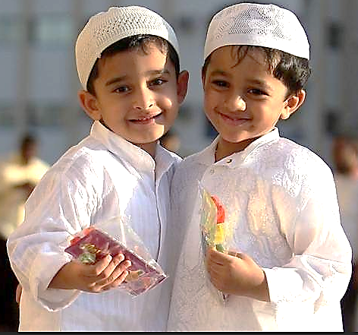

Learn to endure hardship

Appreciation for what we have

Develop compassion

Sawm

Self-discipline

Selflessness

Spiritual development

Who fasts?

Rahul is 5 years old,
and at primary school
he wants to be a good
Muslim.

Nadiya is 33 and has a
husband and 3
children. She is a chef.

Muhammad is 25
and a footballer.

Aaliya is 25 and 6
months pregnant

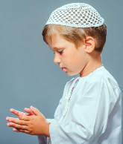
Reasons explained…
Fast?

