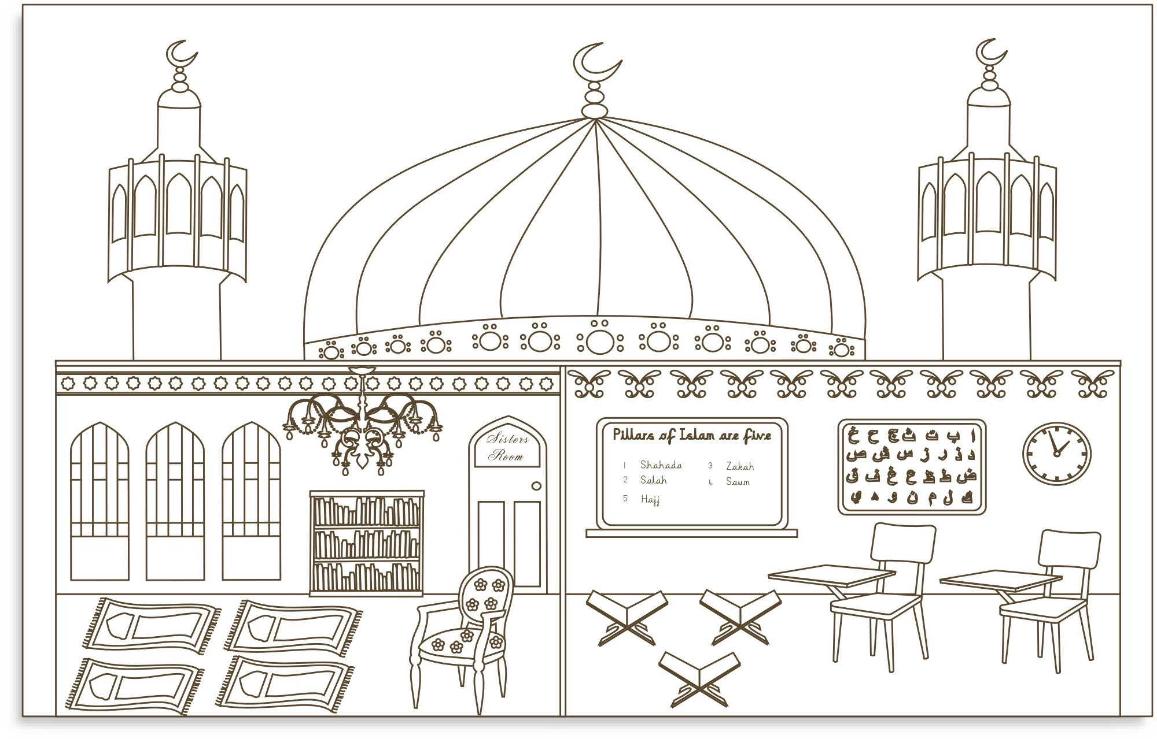1

**3**

**1**

**1**

**2**

**9**

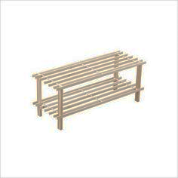

Image result for outline  clogs

**15**

Image result for outline of pairs of shoes

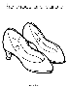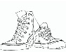Image result for outline of pairs of shoes

**14**

**12**

**7**

**6**

**5**

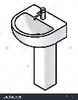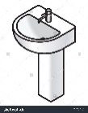

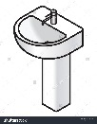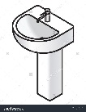

13

**11**

**8**



10

4

|  |  |  |  |  |
| --- | --- | --- | --- | --- |
| **1** | **2** | **3** | **5**  4 |  |
| **6** | **7** | **8** | **9** | 10 |
| **11** | **12** | 13 | **14** | **15** |

* The chandelier is symbolic of _______________________________________________________
* The clock is important because _____________________________________________________

____________________________________________________________________________________

* There are shoe racks because _______________________________________________________
* There is a madrassa (school room) because __________________________________________

____________________________________________________________________________________

* There is a separate women’s room because __________________________________________

____________________________________________________________________________________

* There is a wash room because ______________________________________________________

____________________________________________________________________________________

* There is a mihrab because __________________________________________________________

____________________________________________________________________________________

* There is a library because ___________________________________________________________

________________________________________________________________________________________________________________________________________________________________________

