Five Pillars of Islam

**Islam**

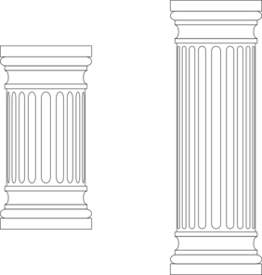

**Belief**

**Charity**

**PrAyer**

**Pilgrimage**

**Fasting**