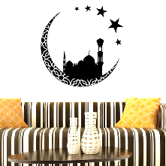

Key Terms:

**Islam/Muslim** – come from the word for ***submission***. It means that Islam is about submitting to Allah.

**Qur’an** – Muslim Holy book, it means ‘***recitation***’.

**Prophet** – someone with a message from God.

**Islamic Beliefs**

The Symbol of Islam.

The crescent moon and five pointed star is the symbol of Islam. The first

Muslims lived in desert areas, they used the stars and the light from the

moon to guide them. Muslims believe their religion shows them how to live, like the moon and stars guided them in the desert. The five points of the star symbolise the Five Pillars of Islam.

The most important belief Muslims hold is that there is only one God. In Arabic (the language of the Qur’an) the word for God is Allah. Muslims believe that Allah sent prophets (messengers) to earth to teach people how to live. According to Islam Muhammad was the last of these prophets. Muhammad received messages from Allah through the Angel Jibril (Gabriel). These messages were collected together and became the Islamic holy book – the Qur’an.

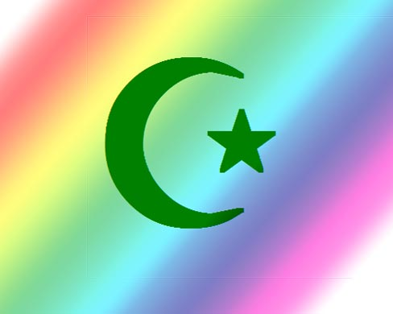

Things to do…

1. What is the most important belief in Islam?
2. Explain why Muhammad is believed to be a prophet of Allah.
3. What is the Qur’an and how was it revealed to Muhammad?
4. In an outline of the Islamic symbol, explain the meaning of the symbol.

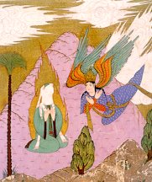

The Qur’an.

The Holy book of Islam is believed to be the word of Allah. It was

recited to Muhammad and he and several of his friends learned it by

heart and it was written down around twenty years after his death. A true version of the Qur’an is always written in Arabic so meaning cannot be lost in translation. Before reading the Qur’an Muslims will wash, when not being used it is carefully wrapped and placed on a high shelf, showing the importance of the book. Some people learn all off the Qur’an by heart, they are given the title Hafiz.

The Qur’an is made up of 114 surahs (chapters), all but one begins with the words, ‘In the name of Allah, the compassionate, the merciful’. Some surahs give teachings, some describe events. The Qur’an accepts important people from Judaism and Christianity, such as Abraham (Ibrahim), Moses and Jesus – as prophets, but it says that people kept forgetting what Allah taught, so Allah showed Muhammad by giving him the Qur’an. In other words, Muslims believe that Islam completes what Judaism and Christianity began.

The Hadith is another important Holy book of Islam. It is a collection of sayings of Muhammad and examples of his actions. It helps Muslims to understand how they should live.

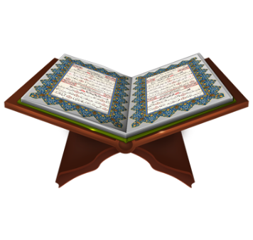

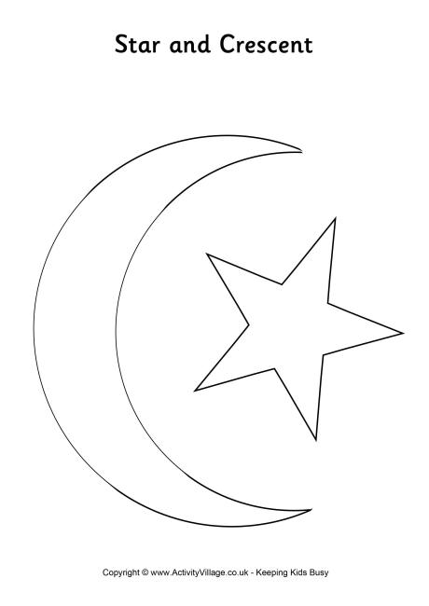



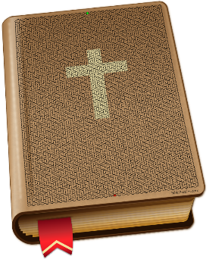

The symbol

of Islam

The Qur’an –

Holy book of Islam

* **Muhammad was the profit of God.**
* **Allah recited the Hadith to Muhammad through the Angel Jibril.**
* Allah recited the Hadith to Muhammad through the Angel Jibril.
* Muhammad was the profit of God.
* The most important belief Muslims have is that they should pray five times a day.



The symbol

of Islam

The Qur’an –

Holy book of Islam

* **Muhammad was the profit of God.**
* **Allah recited the Hadith to Muhammad through the Angel Jibril.**
* Allah recited the Hadith to Muhammad through the Angel Jibril.
* Muhammad was the profit of God.
* The most important belief Muslims have is that they should pray five times a day.



The symbol

of Islam

The Qur’an –

Holy book of Islam

* **Muhammad was the profit of God.**
* **Allah recited the Hadith to Muhammad through the Angel Jibril.**
* Allah recited the Hadith to Muhammad through the Angel Jibril.
* Muhammad was the profit of God.
* The most important belief Muslims have is that they should pray five times a day.