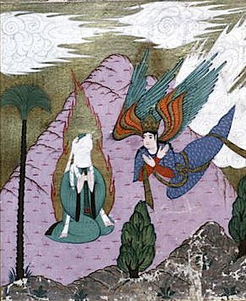
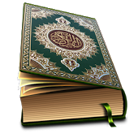
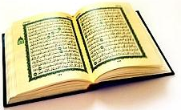
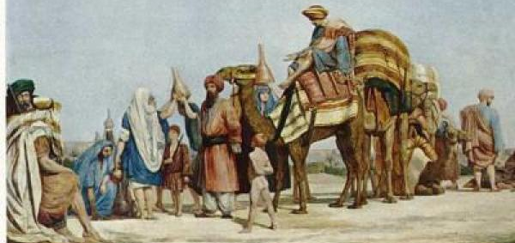
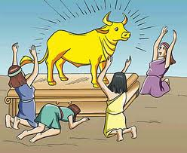

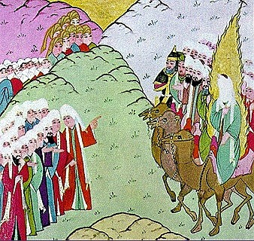
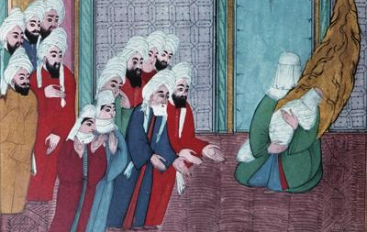
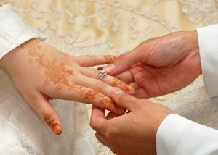
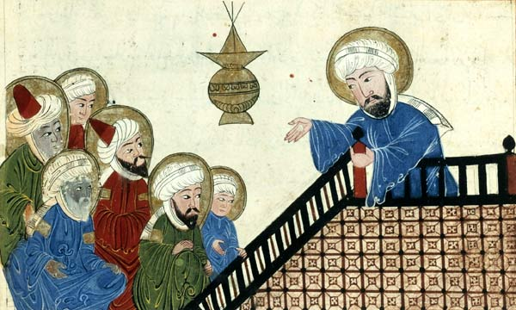
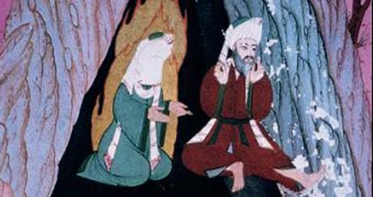

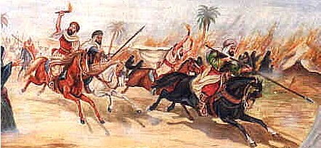
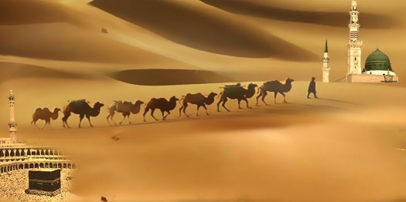
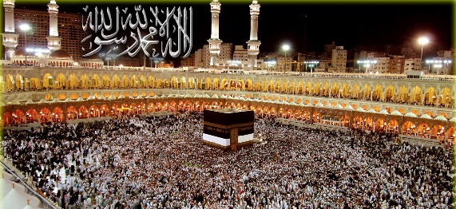
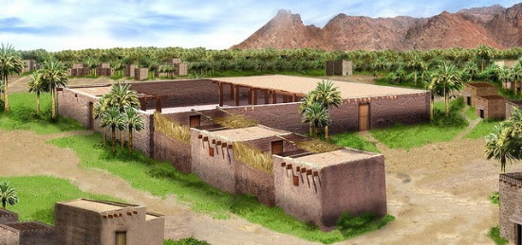

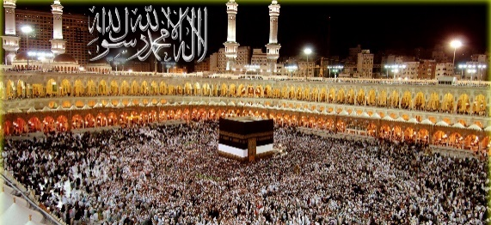

 |  | The Life of Muhammad
Muhammad was born in Makkah in about 570CE. Both his parents died when he was very young and he was very poor. | He went to live with his uncle who was a trader. Muhammad also became a trader and made his name as a very honest and trustworthy man. | He began to work for a woman named Khadija. They fell in love and married, Muhammad was 15 years younger than his new wife. | Muhammad didn’t like what was going on in Makkah. Women and the poor were being treated badly. There was a lot of drunkenness and gambling. Some people were worshipping idols (false gods).
Muhammad was very thoughtful. He often spent nights in a cave praying and meditating. One night he was visited by an angel. | Angel Jibril told Muhammad to ‘recite’. Muhammad said he could not read, but the Angel repeated the instruction and told Muhammad that he was to be the messenger of Allah. | He received a number of messages which eventually became the Qur’an. He began to preach the word of Allah, that Allah was the one true God and people should not worship false gods. | Muhammad said Allah was the greater and would one day, judge them. Some people believed him, but others were angry and said he was lying, or mad.
In 622CE there was an assassination attempt on Muhammad. He and his followers (called Muslims) left Makkah and went to Medinah. | In Medinah Muhammad set up the first Muslim community. | Many battles took place between Makkah and Medinah. In 630 CE Makkah was defeated and Muhammad returned to his home town. | Makkah is now the most holy place in Islam. It is the focus of the Hajj – the pilgrimage site all Muslims, who are able, should visit at least once in their lifetimes.

