Task One; Note down the name of each creature and its current status:

Chose from the options on the sheet you will be given.

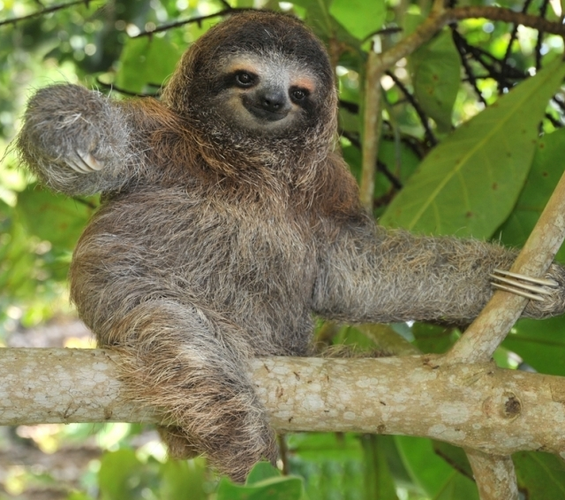
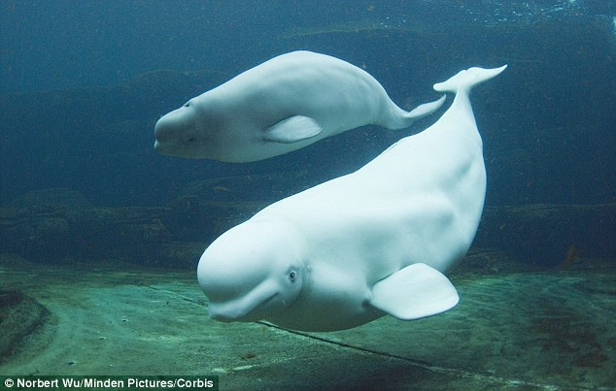
The creature is a;

________________

Its status is;

__________________
The creature is a;

________________

Its status is;

__________________

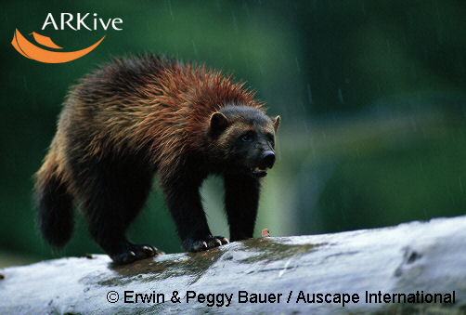
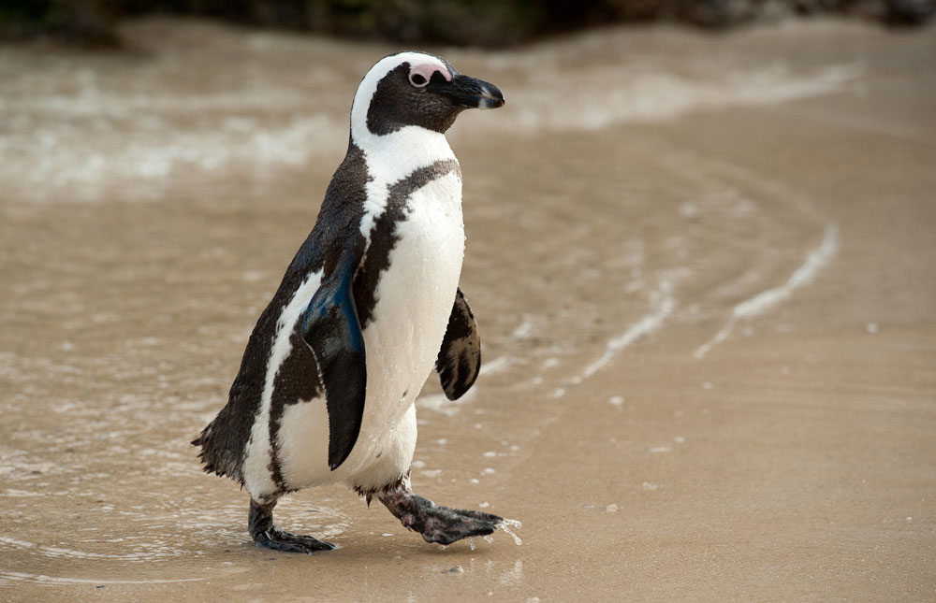
The creature is a;

________________

Its status is;

__________________
The creature is an;

________________

Its status is;

__________________

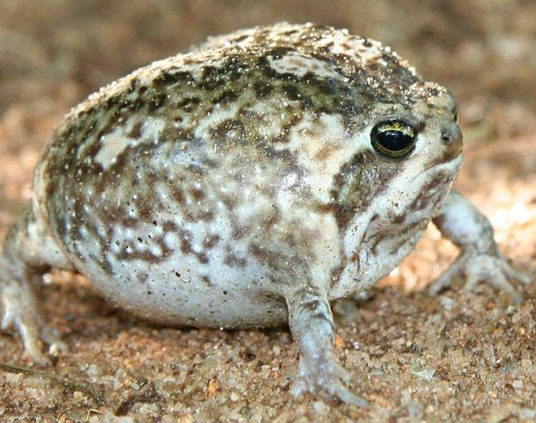
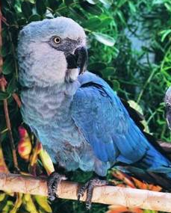
The creature is a;

________________

Its status is;

__________________
The creature is a;

________________

Its status is;

__________________

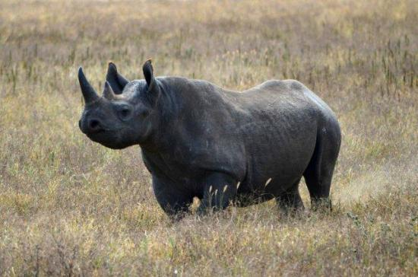

Task 2.

Hindus believe in reincarnation. This means that when you die your soul is free to enter another body. This could be an animal. Which animal would you like to be reincarnated as? Give reasons
for your answer.
The creature is a;

________________

Its status is;

__________________



Task 3.

- If you could only save one of these creatures which would it be? Give reasons for your answer.
- If you could save all but one of these creatures which would you allow to die
out? Give reasons for your answer.

Save the Snake!

I am a serpent.
I am an endangered species, and also disliked by many. I have been evil. I have been good.
Sikhs tell a story of Guru Nanak asleep in a field with his cattle. The sun’s rays fell on his face but he did not wake up. His face grew red. I slithered by his side and spread my hood to block the sun’s rays and provide shade for Guru Nanak’s face. A village elder saw this and told Guru Nanak’s father, ‘your son is a great being… both of us are blessed as he is born in our village’. I was a hero…
In Christianity, I took the form of a serpent and tempted Adam and Eve. I caused evil to enter the world and I made it fall from perfection. I was cursed…
But Muslims know that Satan is a rebellious angel who leads people astray – he is not a serpent. I have been misunderstood and wrongly accused … or have I?
I can bite you with poison or crush you to death; I am not friendly, but my skin and markings make me beautiful… and make me hunted for luxury shoes, belts and handbags.

Would you campaign to Save the Snake?

Consider the Evidence. Am I a creature to be protected or am I evidence that the natural world can be evil? Must nature be controlled, animals used? Is a whale more worthy of being saved than I?

Would religious believers want to save me? Do you want to save me?

I, the snake am on trial – and you must present both the prosecution and the defence.
What will your arguments be?

Things to do.

- Find evidence of what Christians, Sikhs, Hindus and Muslims believe about the snake.
- Note down your evidence and your ideas – should the snake be saved?
- Include religious views about the environment and explain how these views could be used either for the prosecution or the defence.
- Work out some arguments that you could present to help a court decide whether
the snake is innocent or guilty.



Homework.

Research more about how the snake is portrayed in Hinduism and Buddhism, and
find out more about different religious views about the environment.

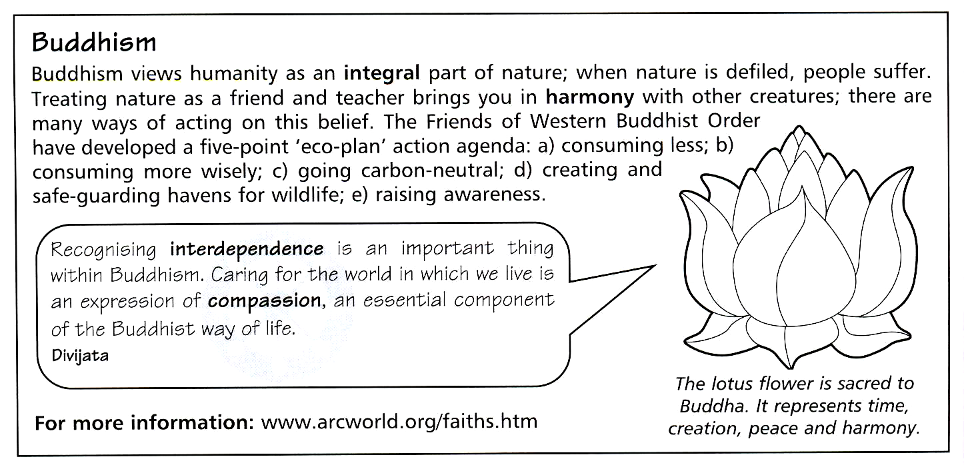

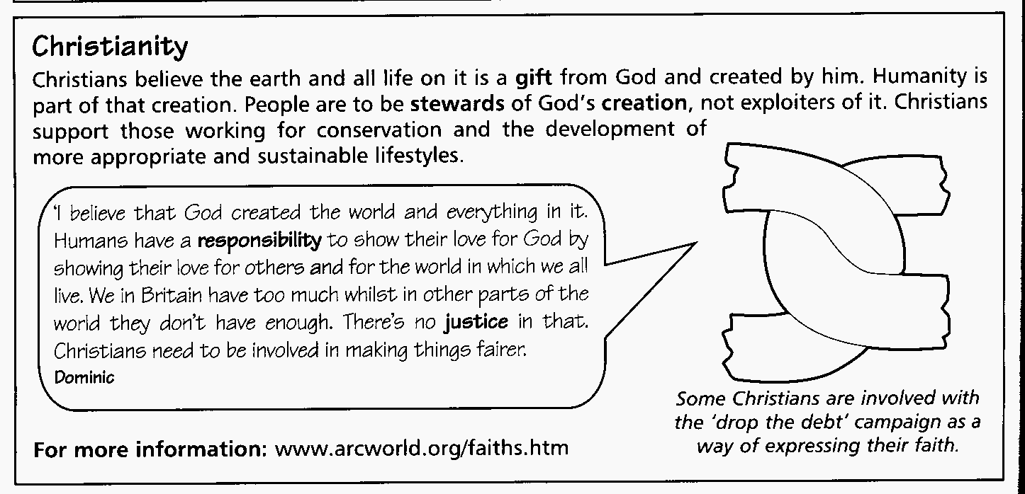

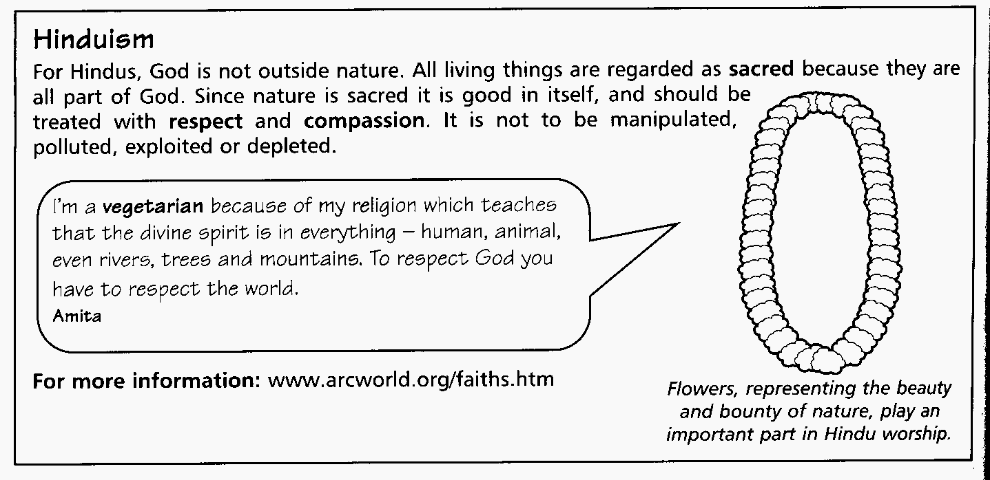

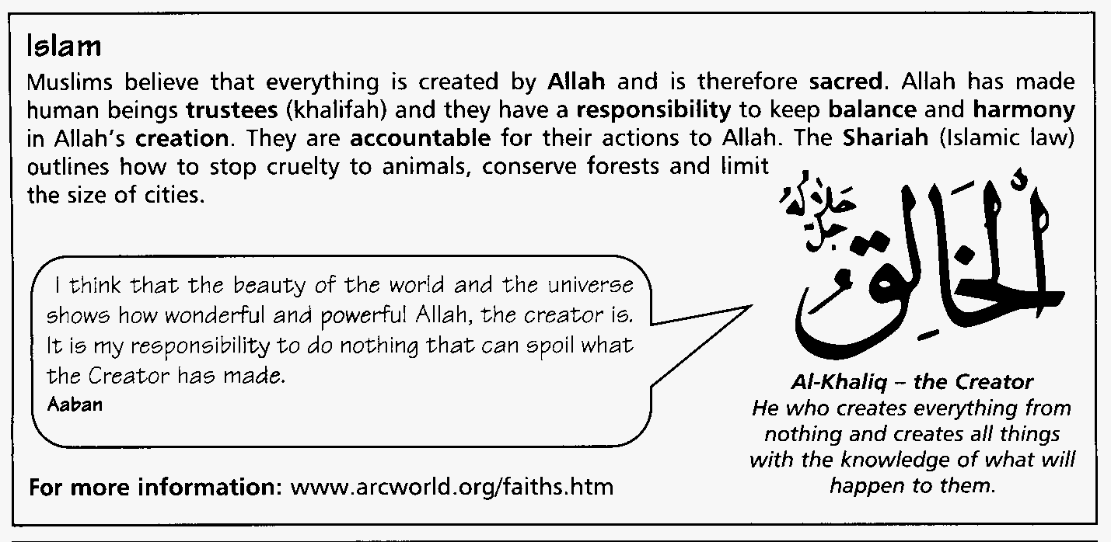
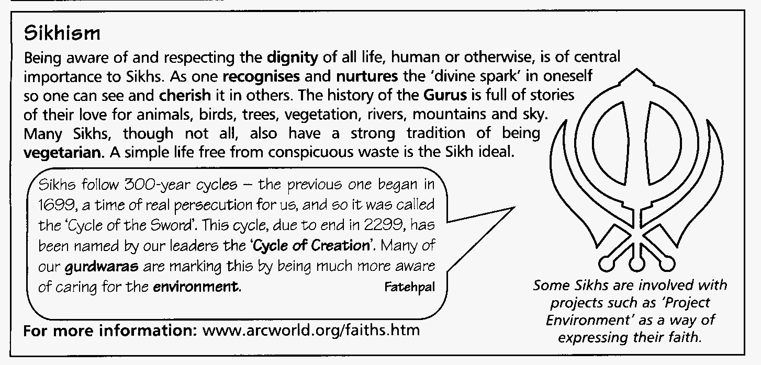

The Prosecution (points against the snake).  The religions I have studied say; | I think the best argument is number…  …because…
The Defence (points in favour of the snake).  The religions I have studied say; | I think the best argument is number…  …because…
The Verdict (my conclusion).  I think… | The Jury’s decision…  Guilty  Not Guilty


Squirrels - The history of the snake in at least two religions.

Squirrels - The history of the snake in at least two religions.

Squirrels - The history of the snake in at least two religions.

Squirrels - The history of the snake in at least two religions.

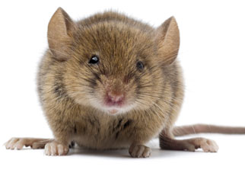

Mice - Religious views about the environment (and how this could affect the snake)
+ Gather the evidence and evaluate (come to a conclusion).

Mice - Religious views about the environment (and how this could affect the snake)
+ Gather the evidence and evaluate (come to a conclusion).

Mice - Religious views about the environment (and how this could affect the snake)
+ Gather the evidence and evaluate (come to a conclusion).

Mice - Religious views about the environment (and how this could affect the snake)
+ Gather the evidence and evaluate (come to a conclusion).

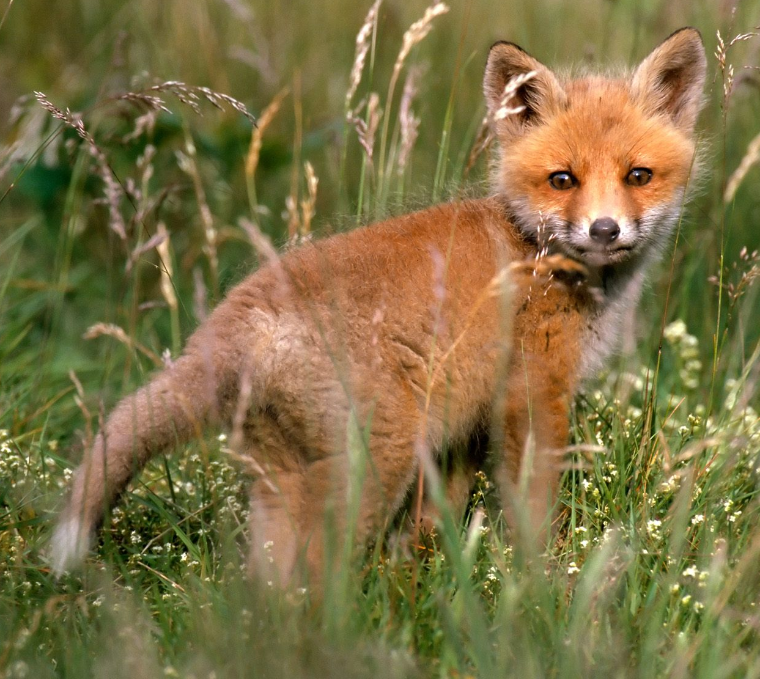

Foxes – arguments for and against the snake’s survival

Foxes – arguments for and against the snake’s survival

Foxes – arguments for and against the snake’s survival

Foxes – arguments for and against the snake’s survival



Rabbits – Investigate why the snake is in danger. E.G. environmental issues etc and how they affect the animal kingdom.

Rabbits – Investigate why the snake is in danger. E.G. environmental issues etc and how they affect the animal kingdom.

Rabbits – Investigate why the snake is in danger. E.G. environmental issues etc and how they affect the animal kingdom.

Rabbits – Investigate why the snake is in danger. E.G. environmental issues etc and how they affect the animal kingdom.


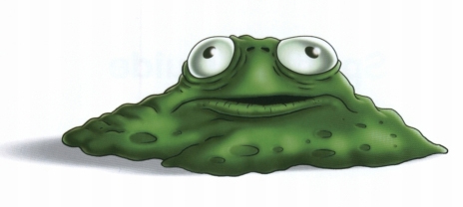

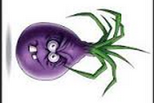

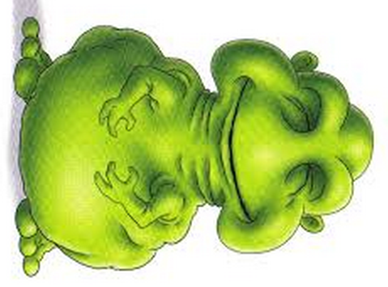

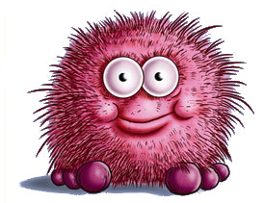

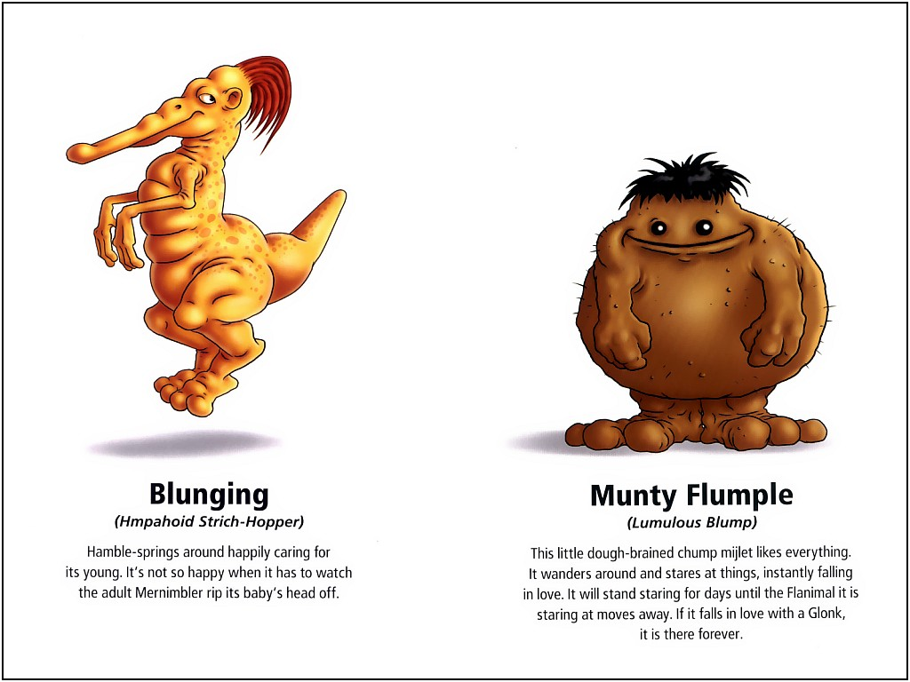

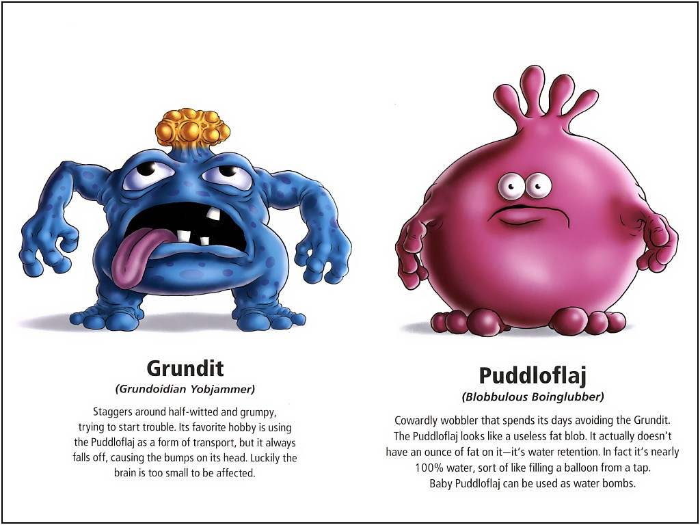

The Prosecution (points against the snake).  The religions I have studied say; | I think the best argument is number…  …because…
The Defence (points in favour of the snake).  The religions I have studied say; | I think the best argument is number…  …because…
The Verdict (my conclusion).  I think… | The Jury’s decision…  Guilty  Not Guilty

The Prosecution (points against the snake). The religions I have studied say;

I think the best argument is number……….. because…

The defence (points for the snake). The religions I have studied say;

I think the best argument is number……….. because…

