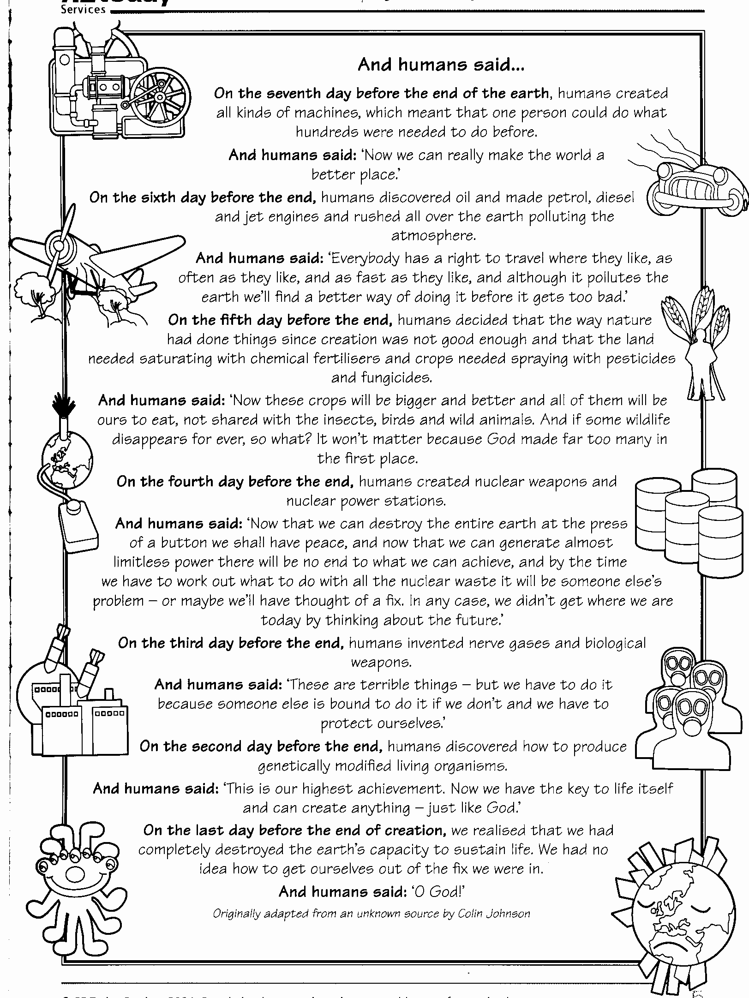

The Bible story In Genesis explains how God created the earth in six days. Many people might suggest now that humans beings are responsible for reversing God’s creation and destroying the earth.

Things to do.

Remind yourself of the first creation story in the Bible. Inside the number outlines draw or write examples of what was created on each day. In the number 8 draw or note down something you think God should have also created. This can be completely made up, something that people believe in but doesn’t actually exist or a concept or idea. Give reasons for your answer.

Extension: What do you think God shouldn’t have created? Explain why.

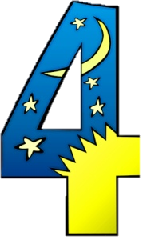

The poem ‘Reverse Creation’ suggests how that might happen. Read the poem and then complete the following tasks;

Things to do.

- Using the poem for information complete the ‘Human Progress Chart’.

- Compare the poem with the Bible story of creation. In what ways is the poem
similar to and different from the Biblical text? You can do this as a table if
you wish.

- Complete a cartoon strip of the Reverse Creation poem. Add things that
you think will also contribute to the destruction of the earth.

Perspectives on the natural world.

- You will be given a set of ‘quotes’ cards and a set of ‘headings’ cards. Lay the ‘quotes’ cards face down on your desk and the ‘headings’ cards face up on your desk.

- In your group take it in turns to pick up one of the ‘quotes’ cards and read it out loud.

- As a group discuss which of the headings the quote belongs to, and place the quote card with the ‘correct’ heading.

- In your books note down the quotations you agree with the most, and the one you disagree with, the headings they belong to and reasons why you agree/disagree.

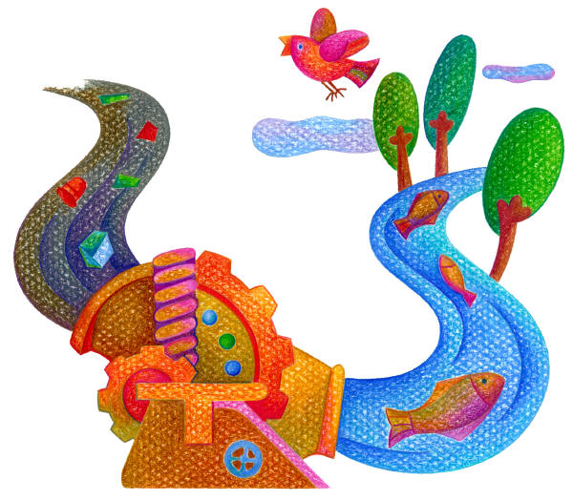

Extension task.

Write a poem offering an alternative to this reverse creation, showing what would be needed for people to live together peacefully in a sustainable environment.

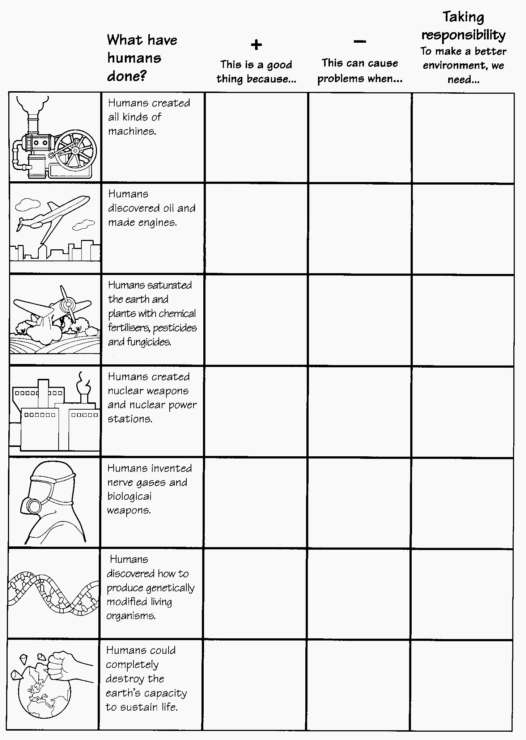

What makes life happy and worthwhile is what we can buy – homes, cars, clothes, holidays, food and drink.

I believe nature and the world’s resources are there to make the most of, so oil, steel, silicon and hardwood serve our needs.

Freedom of choice and plenty to choose makes for happiness.

When you have enough money, you can do exactly as you wish. That’s where I want to get t0 in life.

I see the world as a wonderful stock pile of resources – humans can use these to make goods that people will enjoy.

I just play my own game in life, and sing my own song – you can’t carry the world on your shoulders.
The ‘Green Movement’ will be of more use when it really gets to grip with issues in industry, rather than criticising from the sidelines.

Cycle and recycle – it’s up to every individual to do their bit to save the planet.

Please leave this planet as you would like to find it.

Every living thing is sacred. Life comes from the divine spark, and is always worth our respect.

We live in the ruins of a once beautiful planet, which we have damaged severely. It might not be too late to build it again.

Take a long view and you’ll see that we all have a social and political duty to preserve and renew the world’s environment.

If the whole world was vegetarian, we could solve our problems of poverty and environment much more easily.

Everything lives in the power of the gods and goddesses.

In my faith, the land is God’s gift to the people. We try to treat the gift with love and care, and make it fruitful.

We like to preserve life in all its forms. We often maintain cow protection shelters as a sign of care for all life.

It’s part of our commitment to ‘renew the earth’ for us to work with the environmental movement in the 21st century.

Nature is an asset to industry: we take and make what we can out of what we find.

God has given us one world to share and to care for. He loves it and so should we.

Rest is one of God’s gifts. People rest on Shabbat, and we should give the land a rest too, rather than exploit it.

When God planted the Garden of Eden, he showed us a pattern for caring for nature. We should live like that.

Men and women should be stewards of the world, holding it in trust from God. We can’t just do as we like with it.

We don’t just inherit the world from our parents, we hold it in trust for our children, and must leave it beautiful for them.

Jesus loved the birds, the trees, the lakes and the land. I can’t imagine him clubbing seals to death.

A Consumerist.

Lives life to get and
enjoy its good things.

An Industrialist.

Lives life to make and sell what is profitable.

An Environmentalist.

Lives life to care for the natural world.

A Hindu.

Lives life to fulfil the duty of the Dharma.

A Jew.

Lives life to honour the Almighty.

A Christian.

Lives life to follow Jesus.

