Starter Task

In your exercise book write answers to the following question. What was your best Christmas present? Why would you not deliberately destroy or damage it?

A visitor to South America said;

‘I have a personal relationship with Pachamama. I know her – she exists. She breaths in the forests, she rages in the earthquakes and the volcanoes, she flows through the rivers and crashes on the shore with the sea. I feel her arms around me and all she asks of me in return is to love her, care for her, nurture her.’

Task One

- Using examples from the quote explain who/what you think Pachamama is.

- How do you think we could all love, care and nurture Pachamama?

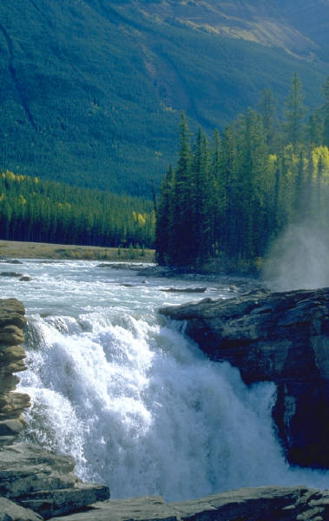
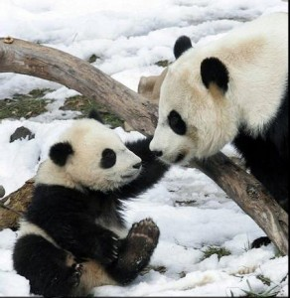
Previously, we have thought about what made the world a special place. I would suggest that the world is special because it is unique. As far as we have yet discovered, there is no other place like it. Some people believe in God because the earth is so intricately designed to support so many different life forms that only a being as powerful as God could create it. There are many beautiful things on this planet – landscapes, birds, animals etc. Do you ever stop to appreciate the planet or even just where you live? If you have lived in an industrial town and then go to live in the country you appreciate the green open spaces and sheep in the fields, if you live near the sea you can appreciate a blustery day making huge waves come over the sea wall.
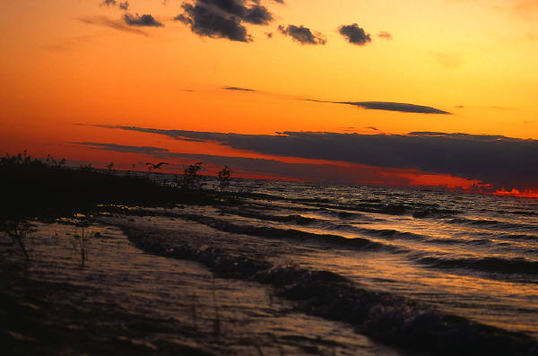
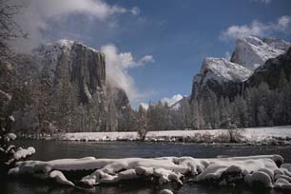

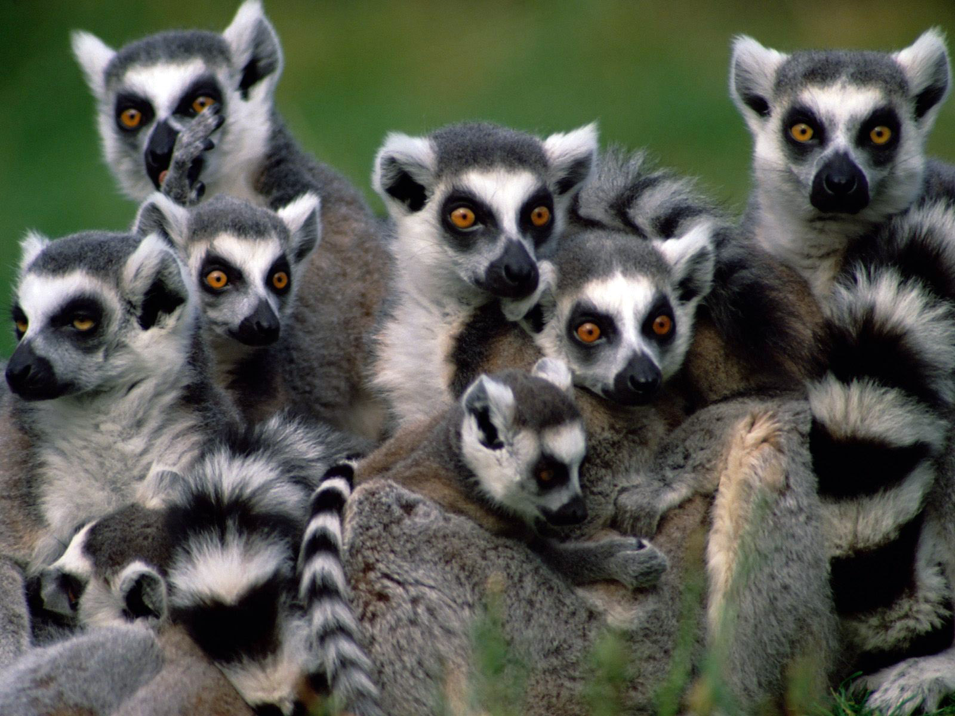

Task Two

Think about where you live or a place that you have visited. Write down answers to the following questions.

- Where is it?
- What is there that is special or beautiful about that place?
- There are many creatures in danger of extinction. What do you think Pachamama would think if we let these creatures die out? Explain your answer with examples.

GEO 2000

If we can appreciate the world we live in, then why do we treat it so badly? We look after our own personal items with care, so why don’t we treat the planet we share with the same care?
In the year 2000 the United Nations prepared a report called the Global Environment Report (GEO). It told us about the state the world is in and how they could get much, much worse in our own life times.

Task Three

Note down some of the things we do to damage the earth. You can do this by writing a list, drawing a spider diagram or with illustrations of your examples.
Ways we damage the planet.

Spaceship Planet Earth

If we imagine that the earth is a spaceship a summary of the GEO report might read something like this;

‘We all have an impact on our route and flight plan. This update is to tell you that from here, it looks like you’re making a pretty poor job of it! We would like to wish you a pleasant life-flight, but we have just checked out the computer predictions and I have to tell you that, if you behave as recklessly as your parents, the good ship Plant Earth will come crashing down in the not too distant future.
This need not happen of course, but all of you out there, especially those who are chewing up its surface and wasting its fuel, will have to choose a different flight plan – and do it pretty soon if this flight is going to have a happy ending. Thank you and choose your flight plan carefully.’

GEO’s message is that although there are signs that we are waking up to the need for a change in attitudes and the way we treat the planet, the truth is it is not happening quickly enough. Without the social, political and economic problems caused by humans the planet would be in much better shape.
It has been suggested that if people suddenly disappeared, the planet would recover and within a thousand years it would look like it did 100,000 years ago.

Task Four.

- Explain what social, political and economic problems human cause for the earth.

- Take the ‘Green Test’. Write down your score and what it means.

- Write down as many ways you can think of to clean up the planet and make the world a special place again.

