j0338178[1]

**Sacred Earth**

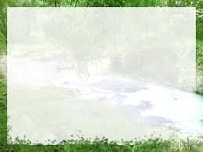

**If the earth were just a few feet in diameter and floating a few feet above a field somewhere, people would come from everywhere to marvel at it. People would walk round it marvelling at its big pools of water, its little pools and the water flowing between them. They would marvel at the bumps on it, the holes in it and the thin layer of gas surrounding it.**

**The people would marvel at the creatures walking on the surface of the ball and at the creatures in the water. The people would declare it special because it is the only one and they would protect it. The ball would be the greatest wonder known. People would love it and defend it with their lives because they would somehow know that their lives could be nothing without it.**

**If the world were a few feet in diameter.**

Things to do;

Read the poem above then complete the following:

From the poem note down some of the wonders of the earth.

How does this poem suggest the earth is a special place? Give reasons and evidence for your answer.

This we know, all things are connected. Like the blood which unites one family, all things are connected. Whatever befalls the earth, befalls the sons of earth.

Man did not weave the web of life, he is merely a strand in it.

What he does to the web, he does to himself.

This we know.

*Chief Seattle 1854*

Things to do;

Read the Quotation from Chief Seattle:

Why does it matter that we realise that everything in connected?



Note down at least 3 possible consequences of failing to do the following things:

*\* putting rubbish in the bins;*

*\* doing the washing up.*