bd06662_

**Making a Difference – Sister Frances Dominica**



Things to do;

Draw two starfish, one from the beginning of the story and one from the end. Show, using words and images, how the starfish felt when he was stranded and then when he was put back into the sea.

**A Story That Made a Difference**

One day two people were walking along a beach which was covered with starfish. The starfish had been washed up by the sea and could not get back to the water. One man picked up a starfish and walked to the edge of the sea to put it back.

‘Why bother?’ asked his friend. It won’t make any difference – they will all die when the sun gets hot’.

The man looked down at the starfish he was holding. ‘It will make a difference to this one,’ he said, and he threw the starfish back in the sea.





Sister Frances Dominica - timeline.

* Born in Scotland in 1942
* She grew up wanting to be a nurse
* A religious experience whilst visiting the Roman Catholic shrine at Walsingham changed her mind and she became a nun. Her family were stunned and didn’t speak to her for 15 years
* She took vows for life in 1972 and in 1977, at the young age of 34 she was elected to be the Mother Superior of her community
* The following year she met a family with a sick child and offered to give her respite care. It was that relationship which gave Sister Frances the idea of starting a children’s hospice
* In 1982, Helen House opened – it was the first children’s hospice in the world
* Douglas House, opened in 2004, extends care to teenagers and young adults. Like Helen House it is named after a patient who made a particular impression on Frances, although he did not survive to see it open.





*Making Comparisons;*

Sister Frances is a Christian nun. How does she follow the example of Jesus?

Read the stories of Jesus Healing Jarius’ daughter (Mark 5:21-24, 35-43) and of Jesus blessing the children (Luke 18:15-17).

5. Note down some examples

of how Helen and Douglas

House help young people.

6. Note down some of the

ways in which the children

at the hospices have fun.

*Using the Helen House*

*brochure;*

1. Note down the expressions

of the children you notice.

2. What surprises you about

their expressions?

3. What questions would you

like to ask some of the

children?

4. Note down some examples

of how Helen House raises

funds.







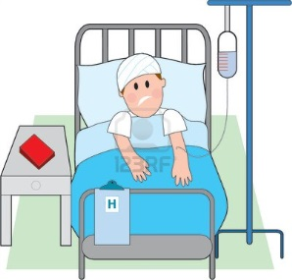

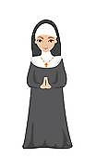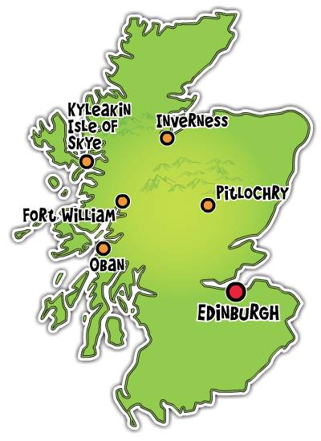

**Sister Frances Dominica - Timeline**

|  |  |
| --- | --- |
| http://scotlandstophostels.com/wordpress/wp-content/themes/scotlandstophostels/static/images/macb_map.jpg | Frances was born in \_\_\_\_\_\_\_\_\_\_\_\_\_\_\_\_\_\_\_\_ in \_\_\_\_\_\_\_\_\_\_\_\_\_\_\_. |
| http://www.clipartlord.com/wp-content/uploads/2013/10/nurse4.png | When she was young \_\_\_\_\_\_\_\_\_\_\_\_\_\_\_\_\_\_\_ wanted to be a \_\_\_\_\_\_\_\_\_\_\_\_\_\_\_\_\_\_\_\_. |
| http://www.charitychoice.co.uk/media/profile/t/the-walsingham-college-trust-association-5924/Walsingham.jpg | When visiting the \_\_\_\_\_\_\_\_\_\_\_\_\_\_\_\_ at Walsingham \_\_\_\_\_\_\_\_\_\_\_\_\_\_\_\_\_\_ had a religious \_\_\_\_\_\_\_\_\_\_\_\_\_\_\_\_\_\_\_\_\_\_\_\_. |
| http://thumbs.gograph.com/gg62898015.jpg | Frances decided to become a \_\_\_\_\_\_\_\_\_\_. Her family were shocked and didn’t \_\_\_\_\_\_\_\_\_\_\_\_\_\_\_\_ to her for 15 years. |
| http://us.123rf.com/400wm/400/400/mkoudis/mkoudis0707/mkoudis070700008/1200540-sick-man-in-hospital-bed-with-intravenous.jpg | Sister Frances met \_\_\_\_\_\_\_\_\_\_\_\_\_\_\_\_ and her \_\_\_\_\_\_\_\_\_\_\_\_\_\_ in hospital and offered to give her \_\_\_\_\_\_\_\_\_\_\_\_\_\_\_\_ care. |
| http://www.alecsangels.co.uk/wp-content/uploads/2011/07/helenhouse.png | Helen \_\_\_\_\_\_\_\_\_\_\_\_\_\_\_ opened in \_\_\_\_\_\_\_\_\_\_\_, the first children’s \_\_\_\_\_\_\_\_\_\_\_\_\_\_\_\_\_\_. \_\_\_\_\_\_\_\_\_\_\_\_\_\_\_\_\_\_\_\_\_ House opened in \_\_\_\_\_\_\_\_\_\_ for \_\_\_\_\_\_\_\_\_\_\_\_\_\_\_\_\_\_\_ and young adults. |

Jesus Raises a Dead Girl and Heals a Sick Woman - Mark 5:21-24, Mark 5:35-43

21When Jesus had again crossed over by boat to the other side of the lake, a large crowd gathered around him while he was by the lake. 22Then one of the synagogue leaders, named Jairus, came, and when he saw Jesus, he fell at his feet. 23He pleaded earnestly with him, “My little daughter is dying. Please come and put your hands on her so that she will be healed and live.” 24So Jesus went with him. 35While Jesus was still speaking, some people came from the house of Jairus, the synagogue leader. “Your daughter is dead,” they said. “Why bother the teacher anymore?”

36Overhearing what they said, Jesus told him, “Don’t be afraid; just believe.”

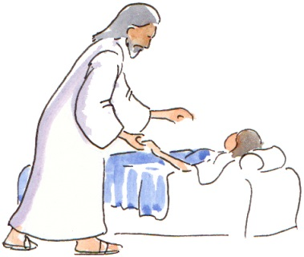37He did not let anyone follow him except Peter, James and John the brother of James. 38When they came to the home of the synagogue leader, Jesus saw a commotion, with people crying and wailing loudly. 39He went in and said to them, “Why all this commotion and wailing? The child is not dead but asleep.” 40But they laughed at him. After he put them all out, he took the child’s father and mother and the disciples who were with him, and went in where the child was. 41He took her by the hand and said to her, “Little girl, I say to you, get up!”. 42Immediately the girl stood up and began to walk around (she was twelve years old). At this they were completely astonished. 43He gave strict orders not to let anyone know about this, and told them to give her something to eat.

### The Little Children and Jesus; Luke 18:15-17

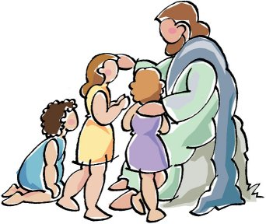15People were also bringing babies to Jesus for him to place his hands on them. When the disciples saw this, they rebuked them. 16But Jesus called the children to him and said, “Let the little children come to me, and do not hinder them, for the kingdom of God belongs to such as these. 17Truly I tell you, anyone who will not receive the kingdom of God like a little child will never enter it.”