Sun City

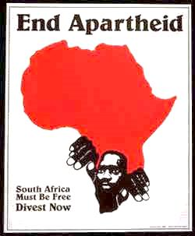Top of Form

South Africa Away to South Africa  
Got to say I ain't gonna play Sun City  
  
I ain't gonna play Sun City  
I ain't gonna play Sun City   
(Everybody Say)  
I ain't gonna play Sun City  
(No baby)  
I ain't gonna play Sun City

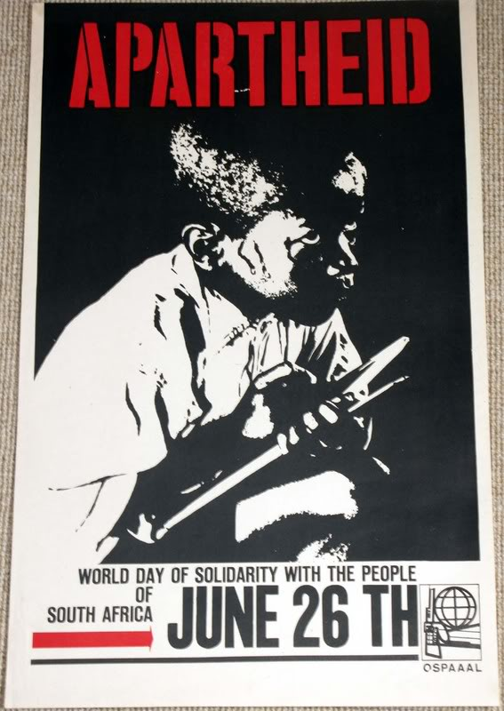Relocation to phoney homelands  
Separation of families I can't understand  
Twenty three million can't vote 'cause they're black  
We're stabbing our brothers and sisters in the back I'm gonna say

Out Government tell us "we're doing all we can"  
Constructive engagement is Ronald Reagan's plan  
Meanwhile people are dying and giving up hope  
This quiet diplomacy ain't nothing but a joke

It's time to accept responsibility  
Freedom is a priviledge nobody rides for free  
Look around the world baby it cannot be denied  
Why we're always on the wrong side

Boputhuswana is far away  
But we know it's in South Africa no matter what they say  
You can't buy me I don't care what you pay  
Don't ask me Sun City 'cause I ain't gonna play



Watch the video then answer the following questions;

1. What do some of the images and words suggest about what was going on in South Africa?
2. How were different groups of people treated differently?
3. What do the lyrics above tell you about what apartheid was?