bd06662_

**Desmond Tutu and Apartheid**

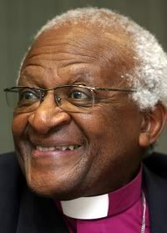Desmond Mpilo Tutu (born 7 October 1931) is a South African activist and retired Anglican bishop who rose to worldwide fame during the 1980s as an opponent of apartheid. He was the first black South African Archbishop of Cape Town, South Africa. Tutu has been active in the defense of human rights and uses his high profile to campaign for the oppressed. He has campaigned to fight AIDS, tuberculosis, poverty, racism, sexism, homophobia, and transphobia. Tutu received the Nobel Peace Prize in 1984.

What was Apartheid?

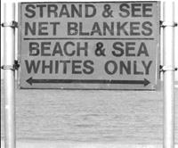

Apartheid - "the state of being apart" was a system of [racial segregation](http://en.wikipedia.org/wiki/Racial_segregation) enforced by law by the [National Party](http://en.wikipedia.org/wiki/National_Party_(South_Africa)) (NP) governments, who ruled South Africa 1948 to 1994. The rights of the black people, who were in the majority, were restricted and the whites, who were in the [minority, rule](http://en.wikipedia.org/wiki/Minority_rule)d.

Racial segregation in South Africa began it was under Dutch and British rule. However, apartheid as an official policy was introduced following the [general election of 1948](http://en.wikipedia.org/wiki/South_African_general_election,_1948). New laws classified people into four [racial groups](http://en.wikipedia.org/wiki/Historical_definitions_of_race) - "black", "white", "[coloured](http://en.wikipedia.org/wiki/Coloured)", and "Indian". Where people lived was segregated, sometimes people were forced to move. Non-whites were prevented from voting or becoming MPs. The government segregated [education](http://en.wikipedia.org/wiki/Education_in_South_Africa), medical care, beaches, and other public services, and provided black people with services that were not as good as those for white people.

Apartheid sparked unrest and violence. A series of uprisings and protests were met with the banning of political opposition parties and many anti-apartheid leaders were sent to prison. As unrest spread the government responded with more repression and violence.

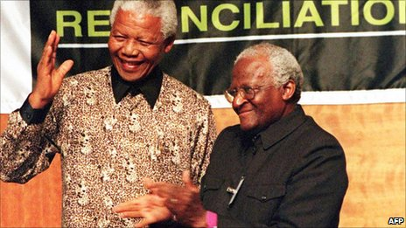Due to the unrest in the country and also criticisms from many other countries and high profile opposition from film and music stars, changing the apartheid Laws began to happen in the 1990s when President [Willem de Klerk](http://en.wikipedia.org/wiki/Frederik_Willem_de_Klerk) began [negotiations to end apartheid](http://en.wikipedia.org/wiki/Negotiations_to_end_apartheid_in_South_Africa). In 1994 multi-racial democratic elections took place, which were won by the [African National Congress](http://en.wikipedia.org/wiki/African_National_Congress) under [Nelson Mandela](http://en.wikipedia.org/wiki/Nelson_Mandela) who, after almost 27 years in prison became president.

Desmond Tutu opposed apartheid and used his position as a Christian minister to fight it. He spoke out against the supporters of apartheid, including the government whose laws made life very unfair for non-whites people. Desmond wanted everyone to be treated equally and live together in peace. He always used peaceful methods to protest, based on the teachings of Jesus.

Since the end of apartheid Desmond Tutu has worked to help blacks and whites forgive each other and live in harmony.

Things to do.

Read the information about Desmond Tutu and apartheid then note down questions in a grid like the one below.

|  |  |  |  |  |  |  |
| --- | --- | --- | --- | --- | --- | --- |
|  |  | What | When/where? | Who? | Why? | How? |
|  |  | Event | Situation | Person | Reason | Means |
| Is? | *Present* |  |  |  |  |  |
| Did? | *Past* |  |  |  |  |  |
| Can? | *Possibility* |  |  |  |  |  |
| Would? | *Probability* |  |  |  |  |  |
| Will? | *Prediction* |  |  |  |  |  |

Swap your grid with someone else, stick their question grid in your book and write answers their questions in your exercise book.

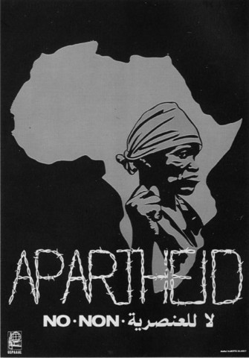

Review/Reflect – 3-2-1;

*Note down;*

3 New things/facts you learnt.

2 New things you learnt that surprised or shocked you.

1 New key word with a definition (put this on you key

word sheet.

**Desmond Tutu and Apartheid**

|  |  |  |  |  |  |  |
| --- | --- | --- | --- | --- | --- | --- |
|  |  | What | When/where? | Who? | Why? | How? |
|  |  | Event | Situation | Person | Reason | Means |
| Is? | *Present* |  |  |  |  |  |
| Did? | *Past* |  |  |  |  |  |
| Can? | *Possibility* |  |  |  |  |  |
| Would? | *Probability* |  |  |  |  |  |
| Will? | *Prediction* |  |  |  |  |  |