**Desmond Tutu’s Speech Against Apartheid**

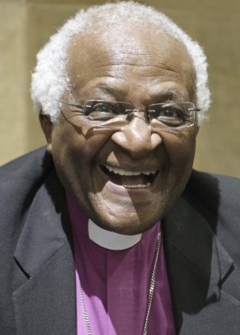You know, you and I are rightly appalled when we hear, or read, of this or that other awful occurrence. When something like the outrage in Madrid happens. When you get the things in Baghdad. When you hear of the molestation of a child. You are quite rightly outraged. I have not, as yet, ever heard anyone stand up and blatantly announce, ‘I am a child molester.’ ‘I am an abuser of women.’ Even the worst possible dictator will never say, ‘You see me. I am in this position and I violate human rights.’ None of them ever says that. Not even dictators such as those you have in Burma, or anywhere else in the world.

Why… why…Why is this so? Why are you appalled when something awful happens? When you see children starving? Why? Why are you appalled when you see long lines of refugees running from this or that, fleeing from oppression or some other disaster? Why?

Well, it is because you and I acknowledge that that is not the norm. That evil is not the norm. Injustice is not the norm. Poverty is not the norm. War is not the norm. It is one of the most almost incontrovertible pieces of evidence… that those are the aberrations.

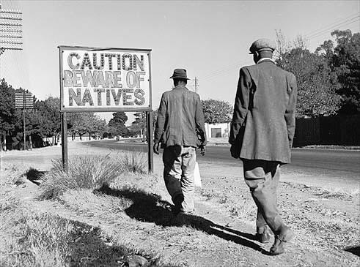The norm…the norm…the norm is goodness. The norm is compassion. The norm is gentleness. Because that is what you and I are made for. Isn’t that fantastic? That you and I are created for goodness. You know it. You know it. Who, of you, has never experienced when you have done something gratuitously good, when you have been nice to someone when you needn’t have been. You have a wonderful glow inside of you. You really feel good.

The opposite is, I mean when you have done something lousy. Your body tells you. You, you feel it in your stomach. Anger, resentment affects you…affects you. Your blood pressure goes up because our nature is in fact to be good. That is, that is, what we are created for. That we are fundamentally good.

Questions;

1. When you got to the end of the speech what were your first initial feelings?
2. Highlight key words and phrases that you particularly agree with.
3. What are the differences between the beginning and the end of the speech?
4. Do you think this is an effective speech? Give reasons for your answer.
5. In your exercise books note down one phrase you agree with the most and explain why you agree with it.