Rev Dr Martin Luther King Jr

Harder Version (adapted from Spartacus Educational)

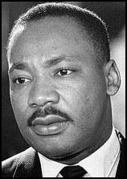 Martin Luther King was born in [Atlanta](http://en.wikipedia.org/wiki/Atlanta), [Georgia](http://en.wikipedia.org/wiki/Georgia_(U.S._state)) on 15th January, 1929. Both his father and grandfather were [Baptist](http://en.wikipedia.org/wiki/Baptist) preachers who had been actively involved in the [civil rights](http://spartacus-educational.com/USAcivilrights.htm) movement. He was raised as a Christian and many of his ideas were based on the teachings of Jesus.

*‘We have to protest…but we must not be violent…our actions must be guided by our Christian faith. Remember the words of Jesus: Love your enemies, bless them that curse you, pray for them that use you badly.’*  (MLK).

King graduated from [Morehouse College](http://www.morehouse.edu/" \t "_blank) in 1948. After considering careers in medicine and law, he entered the ministry. While studying at [Crozer Theological Seminary](http://www.oldchesterpa.com/schools_crozer_seminary.htm" \t "_blank) in [Pennsylvania](http://en.wikipedia.org/wiki/Pennsylvania), King heard a lecture on [Mahatma Gandhi](http://en.wikipedia.org/wiki/Mohandas_Karamchand_Gandhi) and the nonviolent civil disobedience campaign that he used successfully against British rule in India. He became convinced that the same methods could be employed by blacks to obtain civil rights in America. He was particularly struck by Gandhi's words: "Through our pain we will make them see their injustice". King was also influenced by [Henry David Thoreau](http://spartacus-educational.com/USAthoreau.htm) and his theories on how to use [nonviolent resistance](http://spartacus-educational.com/USAnonviolent.htm) to achieve social change.

After his marriage to [Coretta Scott](http://spartacus-educational.com/USAcoretta.htm), King became pastor of the [Dexter Avenue Baptist Church](http://www.dexterkingmemorial.org/) in [Montgomery](http://en.wikipedia.org/wiki/Montgomery,_Alabama), [Alabama](http://en.wikipedia.org/wiki/Alabama). In Montgomery, like most towns in the [Deep South](http://en.wikipedia.org/wiki/Deep_South), buses were segregated. On 1st December, 1955, [Rosa Parks](http://spartacus-educational.com/USAparksR.htm), a middle-aged tailor's assistant, who was tired after a hard day's work, refused to give up her seat to a white man.

He visited India in the late 1950’s and considered how to put Ghandi’s ideas into practice. In 1957 King joined with the Reverend [Ralph David Abernathy](http://spartacus-educational.com/USAabernathy.htm) and [Bayard Rustin](http://spartacus-educational.com/USArustin.htm) to form the [Southern Christian Leadership Conference](http://spartacus-educational.com/USAsclc.htm) (SCLC). The new organisation was committed to using nonviolence in the struggle for civil rights, and SCLC adopted the motto: "Not one hair of one head of one person should be harmed."

There had been a long tradition of nonviolent resistance to racism in the United States. [Frederick Douglass](http://spartacus-educational.com/USASdouglass.htm) had advocated these methods during the fight against slavery. Other black leaders such as [Philip Randolph](http://spartacus-educational.com/USArandolph.htm) and [Bayard Rustin](http://spartacus-educational.com/USArustin.htm) had successfully used nonviolence against racism in the 1940s. The importance of the SCLC was that now the black church, a powerful organisation in the South, was to become fully involved in the struggle for civil rights.

King travelled the country making speeches and inspiring people to become involved in the [civil rights movement](http://spartacus-educational.com/USAcivilrights.htm). As well as advocating non-violent student sit-ins, King also urged economic boycotts similar to the one that took place at [Montgomery](http://spartacus-educational.com/USAmontgomeryB.htm). He argued that as African Americans made up 10% of the population they had considerable economic power. By selective buying, they could reward companies that were sympathetic to the civil rights movement while punishing those who still segregated their workforce.

After many campaigns to have the law changed (some of which were very successful – though not all), he was assassinated in 1968.

Easier Version

Early life

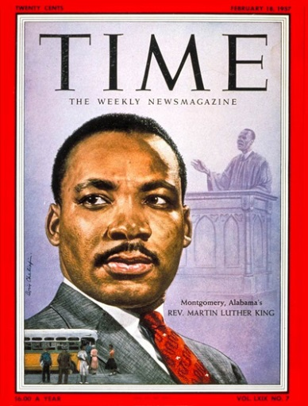Martin Luther King was born in 1929 in Atlanta Georgia, in America’s Deep South. His father was a Baptist preacher. His family were quite well off and he had a nice home. There was one problem; he lived in a town where most white people thought black people were not as good as them. His mother said to him, “don’t let it make you feel you’re not as good as white people, you’re just as good as anyone else – and don’t you forget it.”

When he was 17 he went to a college to become a church minister. It was while he was there that he came across the teachings of Mahatma Gandhi, who helped India gain independence. His ideas of peaceful protest appealed to Martin.

Visions & values

Martin wanted equal rights for black people and for them to live alongside white people without any segregation (being kept apart). He did not hate white people and worked alongside them in the campaign for equality. He was committed to non-violence and expected his followers to do the same. Many of his ideas came from the teachings of Jesus.

*‘We have to protest…but we must not be violent…our actions must be guided by our Christian faith. Remember the words of Jesus: Love your enemies, bless them that curse you, pray for them that use you badly.’*  (MLK).

He used peaceful protests, boycotts (where you refuse to be a customer of company and deprive it of money), public speeches, going on strike, media interviews, and the deliberate breaking of racist laws. This was difficult because it was dangerous and they were not fighting back when attacked. He and his followers managed to get a lot of racist laws changed. He was shot dead in 1968.