

**Jesus – Teacher?**

Group work.

*Complete the following tasks as a group;*

1. What qualities does a teacher need? What education and training does a teacher need?
2. Did Jesus have any of these qualities or qualifications?

*Complete the following tasks in pairs then bring your ideas and evidence back to the rest of the group;*

1. What did Jesus teach? Find examples of at least two different parables. Note down the main points of the parables, use pictures and symbols to outline your chosen parables.
2. What did/do people learn from Jesus’ parables? Are the parables easy to learn from?

|  |  |  |
| --- | --- | --- |
| **Parable** | **Clues about meanings** | **Where to find it** |
| The Good Samaritan | Helping others; Equality; who goes to heaven. | Luke 10:25-37 |
| The Friend at Midnight | Persistence; helping others; asking God. | Luke 11:5-10 |
| The Sheep and the Goats | Justice; judgement; helping others; afterlife. | Matthew 25:31-46 |
| The House Built on Rock and Sand | The important things in life; faith. | Luke 6:46-49 |
| The Mustard Seed | Growth; big things from small beginnings. | Mark 4:30-32 |

Group summing up;

Was Jesus a good teacher? Sum up and evaluate your evidence to conclude an answer to the question.

Write your answer in your exercise books.

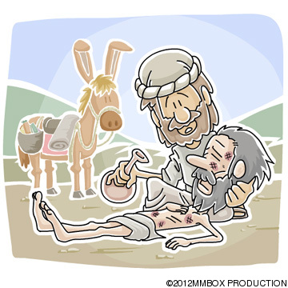

**Jesus – Miracle Worker?**



Group work.

*Complete the following tasks as a group;*

1. What are miracles? Discuss and write a definition. Give some general examples.

*Complete the following tasks in pairs then bring your ideas and evidence back to the rest of the group;*

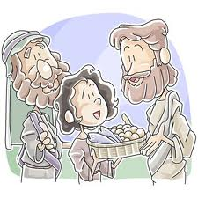

1. What miracles did Jesus perform? Find examples of at least two different miracles. Note down the main points of what happened, use pictures and symbols to outline your chosen miracles.
2. What was the purpose of Jesus’ miracles? Were the miracles credible in his time? Are they credible now?
3. Are there rational or scientific explanations for Jesus’ miracles today? Does this mean they are meaningless for meaningless Christians?

|  |  |
| --- | --- |
| **Miracle** | **Where to find it** |
| Healing Peter’s mother-in-law | Mark 1:29-31 |
| Casting out evil spirits | Mark 5:1-20 |
| Lazarus Raised from the dead | John 11:1-44 |
| Blind Bartimaeus | Luke 18:35-43 |
| The Paralysed Man | Mark 2:1-12 |

Group summing up;

Was Jesus a true miracle worker? Sum up and evaluate your evidence to conclude an answer to the question.

Write your answer in your exercise books.

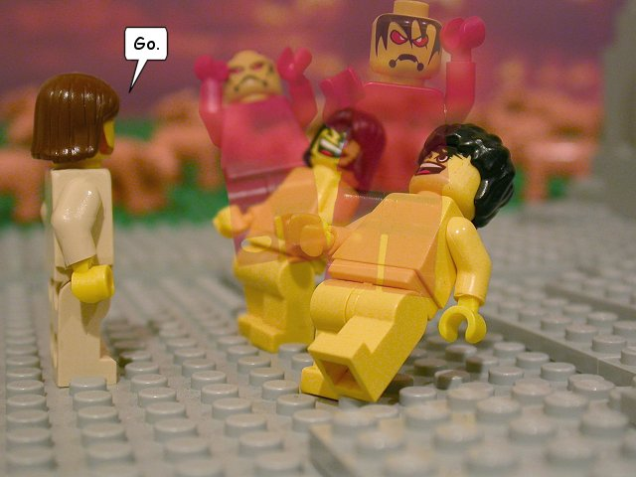



**Jesus – Leader?**

Group work.

*Complete the following tasks as a group;*

1. What are the qualities of a good leader?
2. What training or background should a good leader have?
3. Did Jesus have any of these qualities or qualifications?

*Complete the following tasks in pairs then bring your ideas and evidence back to the rest of the group;*

1. Who/What did Jesus lead? What is the evidence of Jesus as a leader? Find examples. Note down the main points of your evidence, using pictures and symbols.
2. What are the results of Jesus’ leadership for modern Christians? Does Jesus still lead today?

|  |  |
| --- | --- |
| **Examples** | **Where to find it** |
| The Boy Jesus in the Temple | Luke 2:41-52 |
| Healing the haemorrhaging woman | Mark 5:25-34 |
| Teaching in his home town | Mark 6:1-6 |
| Jesus Heals on the Sabbath | Luke 13:10-17 |
| Jesus enters Jerusalem | Matthew 21:7-13 |

Group summing up;

Was/is Jesus a good leader? Sum up and evaluate your evidence to conclude an answer to the question.

Write your answer in your exercise books.

