GCSE/IGCSE-FM Functions
Exercise 1 - Functions
- If $f\left(x\right)=2x+5$, find:
  - $f(3)$
  - $f(-1)$
  - $f\left(\frac{1}{2}\right)$
- If $f\left(x\right)=x^{2}+5$, find:
  - $f(-1)$
  - The possible values of $a$ such that $f\left(a\right)=41$
  - The possible values of $k$ such that $f\left(k\right)=5.25$
- [AQA Worksheet] $f\left(x\right)=2x^{3}-250$. Work out $x$ when $f\left(x\right)=0$
- [AQA Worksheet] $f\left(x\right)=x^{2}+ax-8$.
If $f\left(-3\right)=13$, determine the value of $a$.
- If $f\left(x\right)=5x+2$, determine the following, simplifying where possible.
  - $f(x+1)$
  - $f\left(x^{2}\right)$
- [AQA IGCSEFM June 2012 Paper 2]
$f\left(x\right)=3x-5$ for all values of $x$. Solve $f\left(x^{2}\right)=43$
- [AQA Worksheet] $f\left(x\right)=x^{2}+3x-10$
Show that $f\left(x+2\right)=x\left(x+7\right)$
- If $f\left(x\right)=2x-1$ determine:
(a) $f(2x)$
(b) $f\left(x^{2}\right)$
(c) $f\left(2x-1\right)$
(d) $f\left(1+2f\left(x-1\right)\right)$
(e) Solve $f\left(x+1\right)+f\left(x-1\right)=0$
- [Edexcel Specimen Papers Set 1, Paper 2H Q18]
$$f\left(x\right)=3x^{2}-2x-8$$
Express $f\left(x+2\right)$ in the form $ax^{2}+bx$

- [Senior Kangaroo 2011 Q20] The polynomial $f\left(x\right)$ is such that
$f\left(x^{2}+1\right)=x^{4}+4x^{2}$ and
$f\left(x^{2}-1\right)=ax^{4}+4bx^{2}+c$. What is the value of $a^{2}+b^{2}+c^{2}$?

Exercise 2 – Inverse Functions
- Find $f^{-1}(x)$ for the following functions.
- $f\left(x\right)=5x$
- $f\left(x\right)=1+x$
- $f\left(x\right)=6x-4$
- $f\left(x\right)=\frac{x+7}{3}$
- $f\left(x\right)=5\sqrt{x}+1$
- $f\left(x\right)=10-3x$
- [Edexcel IGCSE Jan2016(R)-3H Q16c]
$$f\left(x\right)=\frac{2x}{x-1}$$ Find $f^{-1}\left(x\right)$
- Find $f^{-1}(x)$ for the following functions.
- $f\left(x\right)=\frac{x}{x+3}$
- $f\left(x\right)=\frac{x-2}{x}$
- $f\left(x\right)=\frac{2x-1}{x-1}$
- $f\left(x\right)=\frac{1-x}{3x+1}$
- $f\left(x\right)=\frac{3x}{3+2x}$
- Find the value of $a$ for which $f\left(x\right)=\frac{x}{x+a}$ is a self inverse function.

Exercise 3 – Composite Functions
- If $f\left(x\right)=3x$ and $g\left(x\right)=x+1$, determine:
  - $fg\left(2\right)$
  - $gf\left(4\right)$
  - $fg\left(x\right)$
  - $gf\left(x\right)$
  - $gg\left(x\right)$
- If $f\left(x\right)=2x+1$ and $g\left(x\right)=3x+1$ determine:
  - $fg\left(x\right)$
  - $gf\left(x\right)$
  - $ff\left(x\right)$
- If $f\left(x\right)=x^{2}-2x$ and $g\left(x\right)=x+1$, find $fg(x)$, simplifying your expression.
- If $f\left(x\right)=x+k$ and $g\left(x\right)=x^{2}$ and $gf\left(3\right)=16$, find the possible values of $k$.
- If $f\left(x\right)=2(x+k)$ and $g\left(x\right)=x^{2}-x$ and $fg\left(3\right)=30$, find $k$.
- Let $f\left(x\right)=x+1$ and $g\left(x\right)=x^{2}+1$.
If $gf\left(x\right)=17$, determine the possible values of $x$.
- Let $f\left(x\right)=x^{2}+3x$ and $g\left(x\right)=x-2$.
If $fg\left(x\right)=0$, determine the possible values of $x$.
- [Based on MAT question]
$f\left(x\right)=x+1$ and $g\left(x\right)=2x$
Let $f^{n}(x)$ means that you apply the function $f$ $n$ times.
a) Find $f^{n}(x)$ in terms of $x$ and $n$.
b) Note that $gf^{2}g\left(x\right)=4x+4$. Find all other ways of combining $f$ and $g$ that result in the function $4x+4$.

Exercise 4 – Piecewise Functions
- [Jan 2013 Paper 2] A function $f(x)$ is defined as:
$$f\left(x\right)=\left\{\begin{matrix}4 & x<-2 \\ x^{2} & -2≤x≤2 \\ 12-4x & x>2\end{matrix}\right.$$
- Draw the graph of $y=f(x)$ for $-4≤x≤4$
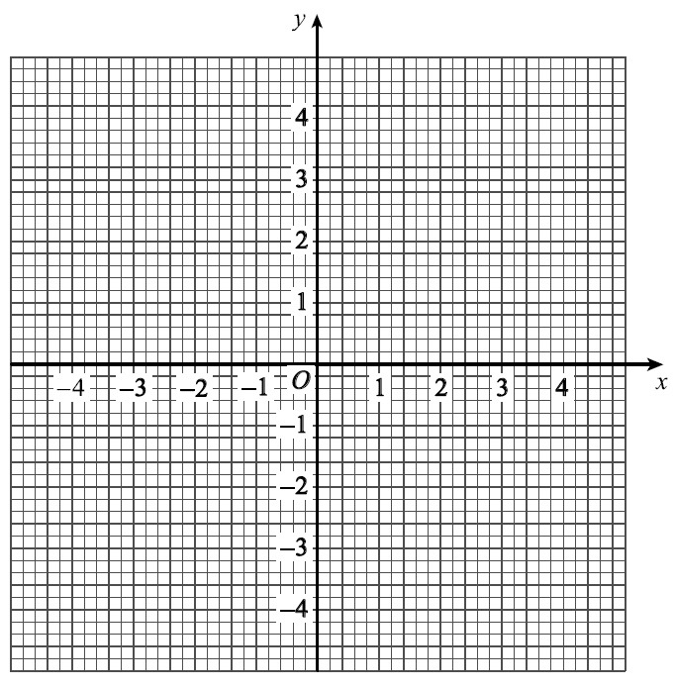
- Use your graph to write down how many solutions there are to $f\left(x\right)=3$
- Solve $f\left(x\right)=-10$
- [June 2013 Paper 2] A function $f(x)$ is defined as:
$$f\left(x\right)=\left\{\begin{matrix}x+3 & -3≤x<0 \\ 3 & 0≤x<1 \\ 5-2x & 1≤x≤2\end{matrix}\right.$$
Draw the graph of $y=f(x)$ for
$$-3≤x<2$$
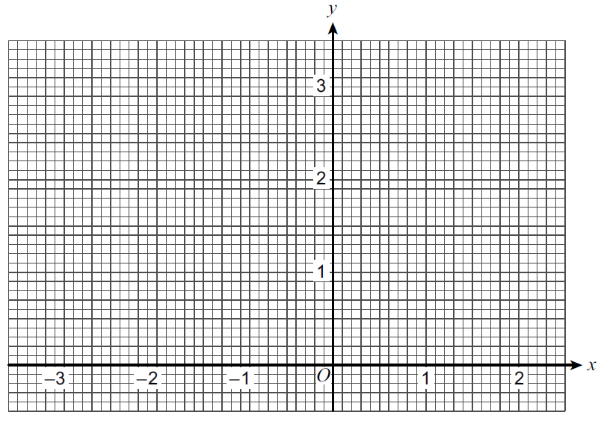

- [Set 1 Paper 1] A function $f(x)$ is defined as:
$$f\left(x\right)=\left\{\begin{matrix}3 & 0≤x<2 \\ x+1 & 2≤x<4 \\ 9-x & 4≤x≤9\end{matrix}\right.$$
Draw the graph of $y=f(x)$ for $0≤x≤9$.
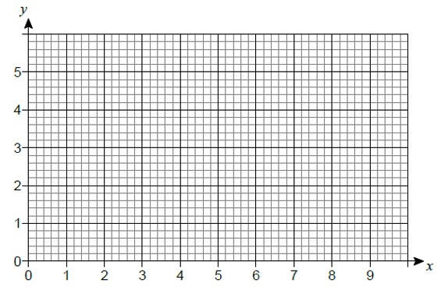
- [Specimen 1 Q4] A function $f(x)$ is defined as:
$$f\left(x\right)=\left\{\begin{matrix}3x & 0≤x<1 \\ 3 & 1≤x<3 \\ 12-3x & 3≤x≤4\end{matrix}\right.$$
Calculate the area enclosed by the graph of $y=f\left(x\right)$ and the $x-$axis.
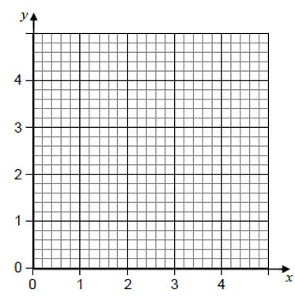
- [AQA Worksheet Q9] $$f\left(x\right)=\left\{\begin{matrix}-x^{2} & 0≤x<2 \\ -4 & 2≤x<3 \\ 2x-10 & 3≤x≤5\end{matrix}\right.$$
Draw the graph of $f(x)$ from $0≤x≤5$.
- [AQA Worksheet Q10]
$$f\left(x\right)=\left\{\begin{matrix}2x & 0≤x<1 \\ 3-x & 1≤x<4 \\ \frac{x-7}{3} & 4≤x≤7\end{matrix}\right.$$
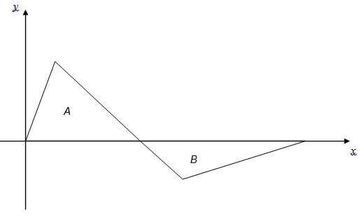
Show that $area of A:area of B=3:2$

Exercise 5 – Range/Domain
- [AQA Worksheet] Work out the range for each of these functions.
(a) $f\left(x\right)=x^{2}+6$ for all $x$
(b) $f\left(x\right)=3x-5, -2≤x≤6$
(c) $f\left(x\right)=3x^{4}, x<-2$
- [AQA Worksheet] (a) $f\left(x\right)=\frac{x+2}{x-3}$
Give a reason why $x>0$ is not a suitable domain for $f(x)$.
(b) Give a possible domain for $f\left(x\right)=\sqrt{x-5}$
- $f\left(x\right)=3-2x, a<x<b$
The range of $f(x)$ is $-5<f\left(x\right)<5$
Work out $a$ and $b$.
- [Set 1 Paper 2] (a) The function $f(x)$ is defined as:
$$f\left(x\right)=22-7x, -2≤x≤p$$The range of $f(x)$ is $-13≤f\left(x\right)≤36$
Work out the value of $p$.
(b) The function $g(x)$ is defined as
$g\left(x\right)=x^{2}-4x+5$ for all $x$.
(i) Express $g(x)$ in the form ${\left(x-a\right)}^{2}+b$
(ii) Hence write down the range of $g(x)$.
- [June 2012 Paper 1] $f\left(x\right)=2x^{2}+7$ for all values of $x$.
(a) What is the value of $f\left(-1\right)$?
(b) What is the range of $f(x)$?
- [Jan 2013 Paper 2]
$$f\left(x\right)=\sin{x} 180°≤x≤360° \\ g\left(x\right)=\cos{x} 0°≤x≤θ$$(a) What is the range of $f(x)$?
(b) You are given that $0≤g\left(x\right)≤1$.
Work out the value of $θ$.
- By completing the square or otherwise, determine the range of the following functions:
(a) $f\left(x\right)=x^{2}-2x+5,$for all $x$
(b) $f\left(x\right)=x^{2}+6x-2,$ for all $x$
- [AQA Worksheet] Here is a sketch of $f\left(x\right)=x^{2}+6x+a$ for all $x$, where $a$ is a constant.
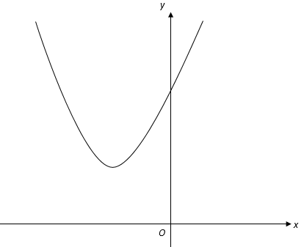
The range of $f(x)$ is $f\left(x\right)≥11$. Work out the value of $a$.
- [Set 3] The straight line shows a sketch of $y=f(x)$ for the full domain of the function.
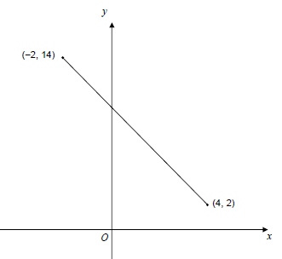
(a) State the domain of the function.
(b) Work out the equation of the line.
- [Set 3] $f(x)$ is a quadratic function with domain all real values of $x$. Part of the graph of $y=f\left(x\right)$ is shown.
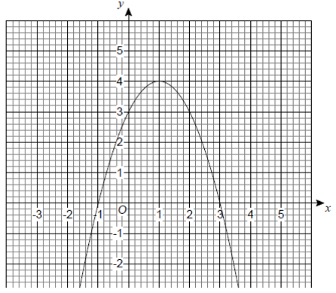
(a) Write down the range of $f(x)$.
(b) Use the graph to find solutions of the equation $f\left(x\right)=1$.
(c) Use the graph to solve $f\left(x\right)<0$.
- [Set 2] The function $f(x)$ is defined as:
$$f\left(x\right)=\left\{\begin{matrix}x^{2}-4 & 0≤x<3 \\ 14-3x & 3≤x≤5\end{matrix}\right.$$Work out the range of $f\left(x\right)$.
- The function $f(x)$ has the domain
$-3≤x≤3$ and is defined as:
$$f\left(x\right)=\left\{\begin{matrix}x^{2}+3x+2 & -3≤x<0 \\ 2+x & 0≤x≤3\end{matrix}\right.$$Work out the range of $f\left(x\right)$.
- [June 2012 Paper 2] A sketch of $y=g(x)$ for domain $0≤x≤8$ is shown.
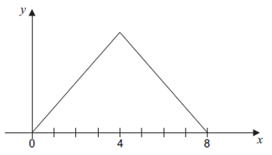
The graph is symmetrical about $x=4$. The range of $g(x)$ is $0≤g\left(x\right)≤12$.
Work out the function $g(x)$.
$$g\left(x\right)=\left\{\begin{matrix}? & 0≤x≤4 \\ ? & 4<x≤8\end{matrix}\right.$$

Exercise 6 – Forming Equations
Finding a suitable function (for which you may always use a straight line) that matches the following criteria.
- Domain is $1≤x<3$. Range $1≤f\left(x\right)≤3$. $f(x)$ is an increasing function.
- Domain is $1≤x≤3$. Range $1≤f\left(x\right)≤3$.
$f(x)$ is a decreasing function.
- Domain is $5≤x≤7$. Range $7≤f\left(x\right)≤11$. $f(x)$ is an increasing function.
- Domain is $5≤x≤7$. Range $7≤f\left(x\right)≤11$. $f(x)$ is a decreasing function.
- Domain is $-4≤x≤7$. Range $4≤f\left(x\right)≤8$. $f(x)$ is a decreasing function.

