**QQQ - Circle Theorems Name ________________ Score: ___/17**

**Question 1**

The diagram shows a different circle with centre *O*.

Work out the size of the angle marked *y*.   
  
 ___________________ *(1 mark)*



**Question 2**

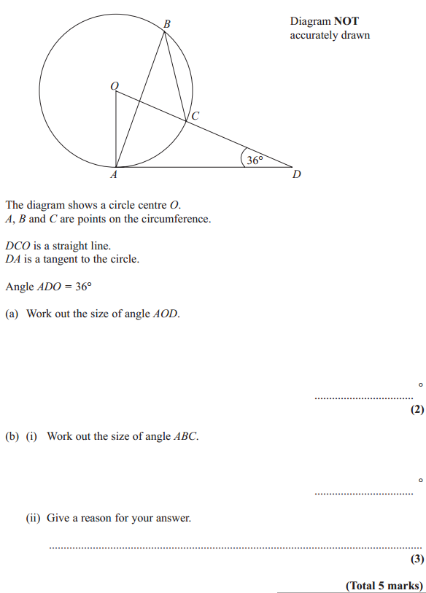

**Question 3**

The tangent *DB* is extended to *T*. The line *AO* is added to the diagram. Angle *TBA* = 62°



(i) Work out the value of *x*. *(2 marks)*

*___________________________*

(ii) Work out the value of *y*. *(3 marks)*

*__________________________*

**Question 4**

*ABCD* is a cyclic quadrilateral. *PAQ* is a tangent to the circle at *A*.  
*BC = CD*. *AD* is parallel to *BC*. Angle *BAQ* = 32°.



Find the size of angle *BAD*. You **must** show all your working. *(4 marks)  
  
_________________________________  
  
_________________________________  
  
_________________________________  
  
_________________________________*

**Question 5**  
Points *P*, *Q*, *R* and *S* lie on a circle. *PQ* = *QR* Angle *PQR* = 116°



Explain why angle *QSR* = 32°. *(2 marks)  
  
_________________________________  
  
_________________________________  
  
_________________________________  
  
_________________________________*

**Answers**

1) 130 (1 mark)

2a) 180 - 90 - 36 (M1) = 54 (A1) (2 marks total)

b) ABC = 1/2 AOC (M1) = 27 (A1)  
 "Angle at circumference is half angle at centre OR angle at centre is twice angle at circumference" (B1) (3 marks total)

3a) ABO = 90 - 62 = 28 (M1)  
 x = 180 - (2 x 28) = 124 (A1) (2 marks total)

b) BOC = 360 - 90 - 90 - 40 = 140 (M1)  
 AOC = 360 - 140 - 124 = 96 (M1)  
 y = (180 - 96)/2 = 42 (A1)

4) ABD = 32 (Alternate Segment Theorem) (M1)  
 CBD = 32 (Alternate Angles) (M1)  
 BCD = 180 - (2 x 32) = 116 (Base angles of isosceles triangle are equal) (M1)  
 DAB = 180 - 116 = 64 (Opposite angles of cyclic quadrilateral add to 180) (A1)

(4 marks total)

5) Angle QPR = (180 - 116)/2 = 32 (M1)  
 QSR = 32 as **angles in same segment** are equal. (B1) (2 marks total)

Awards:

Platinum: 17, Gold 15, Silver 14, Bronze 12