Circle Theorem Homework Questions
For each question:
- Work out the angles $x$ (and $y$ if applicable)
- You MUST give reasons for your answer (i.e. quote the circle theorems you used)
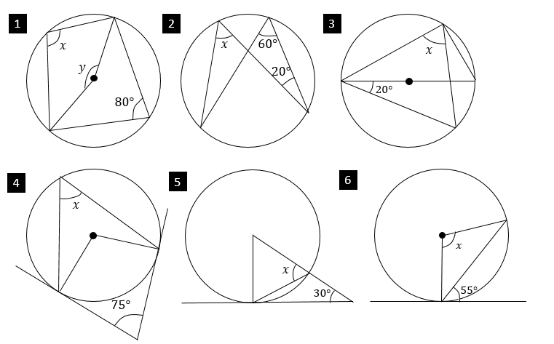
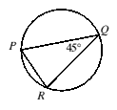
Bonus IMC Question: $P$, $Q$, $R$ are points on the circumference of a circle of radius 4cm. $∠PQR=45°$. What is the length of chord $PR$?
A 4cm B $3\sqrt{3}$cm C $4\sqrt{2}$ cm D $5$cm E $6$cm

Circle Theorem Homework Questions
For each question:
- Work out the angles $x$ (and $y$ if applicable)
- You MUST give reasons for your answer (i.e. quote the circle theorems you used)
Bonus IMC Question: $P$, $Q$, $R$ are points on the circumference of a circle of radius 4cm. $∠PQR=45°$. What is the length of chord $PR$?
A 4cm B $3\sqrt{3}$cm C $4\sqrt{2}$ cm D $5$cm E $6$cm

